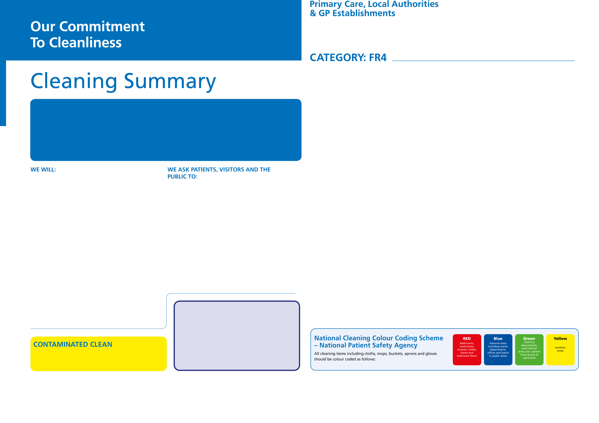
If you require further information regarding cleaning standards go to: www.england.nhs.uk/wp-content/uploads/2021/04/B0271-national-standards-of-healthcare-cleanliness-2021
If you wish to comment about the cleanliness of this facility, contact

(insert name & number)

- Follow good hygiene practices which are displayed in and around the building
- Tell us if you require any further information about cleanliness or prevention of infection
- Work with us to monitor and improve standards of cleanliness and prevention of infection
- Do not smoke or drop debris around the entrance doors to reduce likelihood of soil entering the building.
- Inform us if you or a member of your family spill drinks or where vomiting occurs to enable us to contain the spill and rectify the situation as promptly as possible for the comfort of the patient, visitors and staff.

Name / Signature

Practice Manager
All areas identified as contaminated areas are cleaned using yellow colour coded equipment in accordance with the Trust’s Infection, Prevention and Control Policy requirements.

- Treat patients in a clean, safe and pleasant environment
- Provide a well maintained, clean and safe environment, using the most appropriate and up to date cleaning methods and frequencies
- Aim to clean the building when patient appointments have finished for the day.
- Maintain fixtures and fittings to an acceptable condition to enable effective and safe cleaning to take place regularly
- Allocate specific roles and responsibilities for cleaning, linked to infection prevention and control.
- Constantly review cleanliness and rectify issues with cleaning provider or in-house team (delete as appropriate)
- Take account of your views about the quality and standards of cleanliness by involving patients and visitors in reporting and monitoring how well we are doing
- Provide the public with clear information on any measures which they can take, to raise awareness and educate the public in the prevention and control of healthcare associated infections
- Provide structured and pro-active education and training to ensure all our staff are competent in delivering infection prevention and control practices within the remit of their role
- Provide entrance matting to remove soil from shoes and reduce the dirt from entering the building especially in winter months.
- Design any new facilities with ease of cleaning in mind

Treatment rooms where non-invasive procedures take place, Receptions, Waiting areas, Consulting rooms

Keeping the NHS clean and preventing the spread of infection is everybody’s responsibility from the Chief Executive or equivalent to the healthcare cleaner. It is important for patients, visitors, the public and staff.

Cleanliness matters, and to ensure consistency throughout the NHS, and to support hospitals and healthcare services, this commitment has been adopted in every organisation.

This Charter sets out our commitment to ensure a consistently high standard of cleanliness is delivered in all of our healthcare facilities. It also sets out how we would like you to help us maintain high standards.

CLEANING TASK | CLEANING FREQUENCY | RESPONSIBILITY
Sanitary Areas
Toilets, urinals, sinks and taps | 1 x full daily | Healthcare Cleaning Professional (HCP)
Mirrors | 1 x full daily | HCP
Patient Areas
Chairs and couches | 1 x full weekly | HCP
Switches, sockets, data points, wall fixtures | 1 x full weekly | HCP
Walls (accessible up to 2m) | 1 x full annual, 1 x check daily | HCP
Ceilings and walls (not accessible above 2m) | 1 x full every 2 years | HCP
Doors, including ventilation grilles | 1 x full weekly | HCP
Ventilation grilles, extracts and inlets | 1 x full monthly | HCP
Windows | 1 x full every 6 months | External contractor
Internal glazing | 1 x full fortnightly | HCP
Radiators including cover | 1 x full fortnightly external only | HCP
Wheelchairs | 1 x full monthly | HCP
Low surfaces | 1 x full fortnightly, 1 check weekly | HCP
Middle surfaces | 1 x full fortnightly | HCP
High surfaces | 1 x full fortnightly | HCP
Curtains and blinds | As local protocol, 2 yearly minimum | HCP
Waste receptacles | 1 x full weekly, 1 x check daily | HCP and Clinical Team
Dispenser cleaning | 1 x full daily external (internal weekly) | HCP
Replenishment of consumables | Check and replenish daily | HCP and Clinical Team
Floors
Floors hard | 1 x full daily | HCP
Floors soft | 1 x full daily | HCP
Cleaning Equipment
All cleaning equipment including trolley | Full clean after each use | HCP



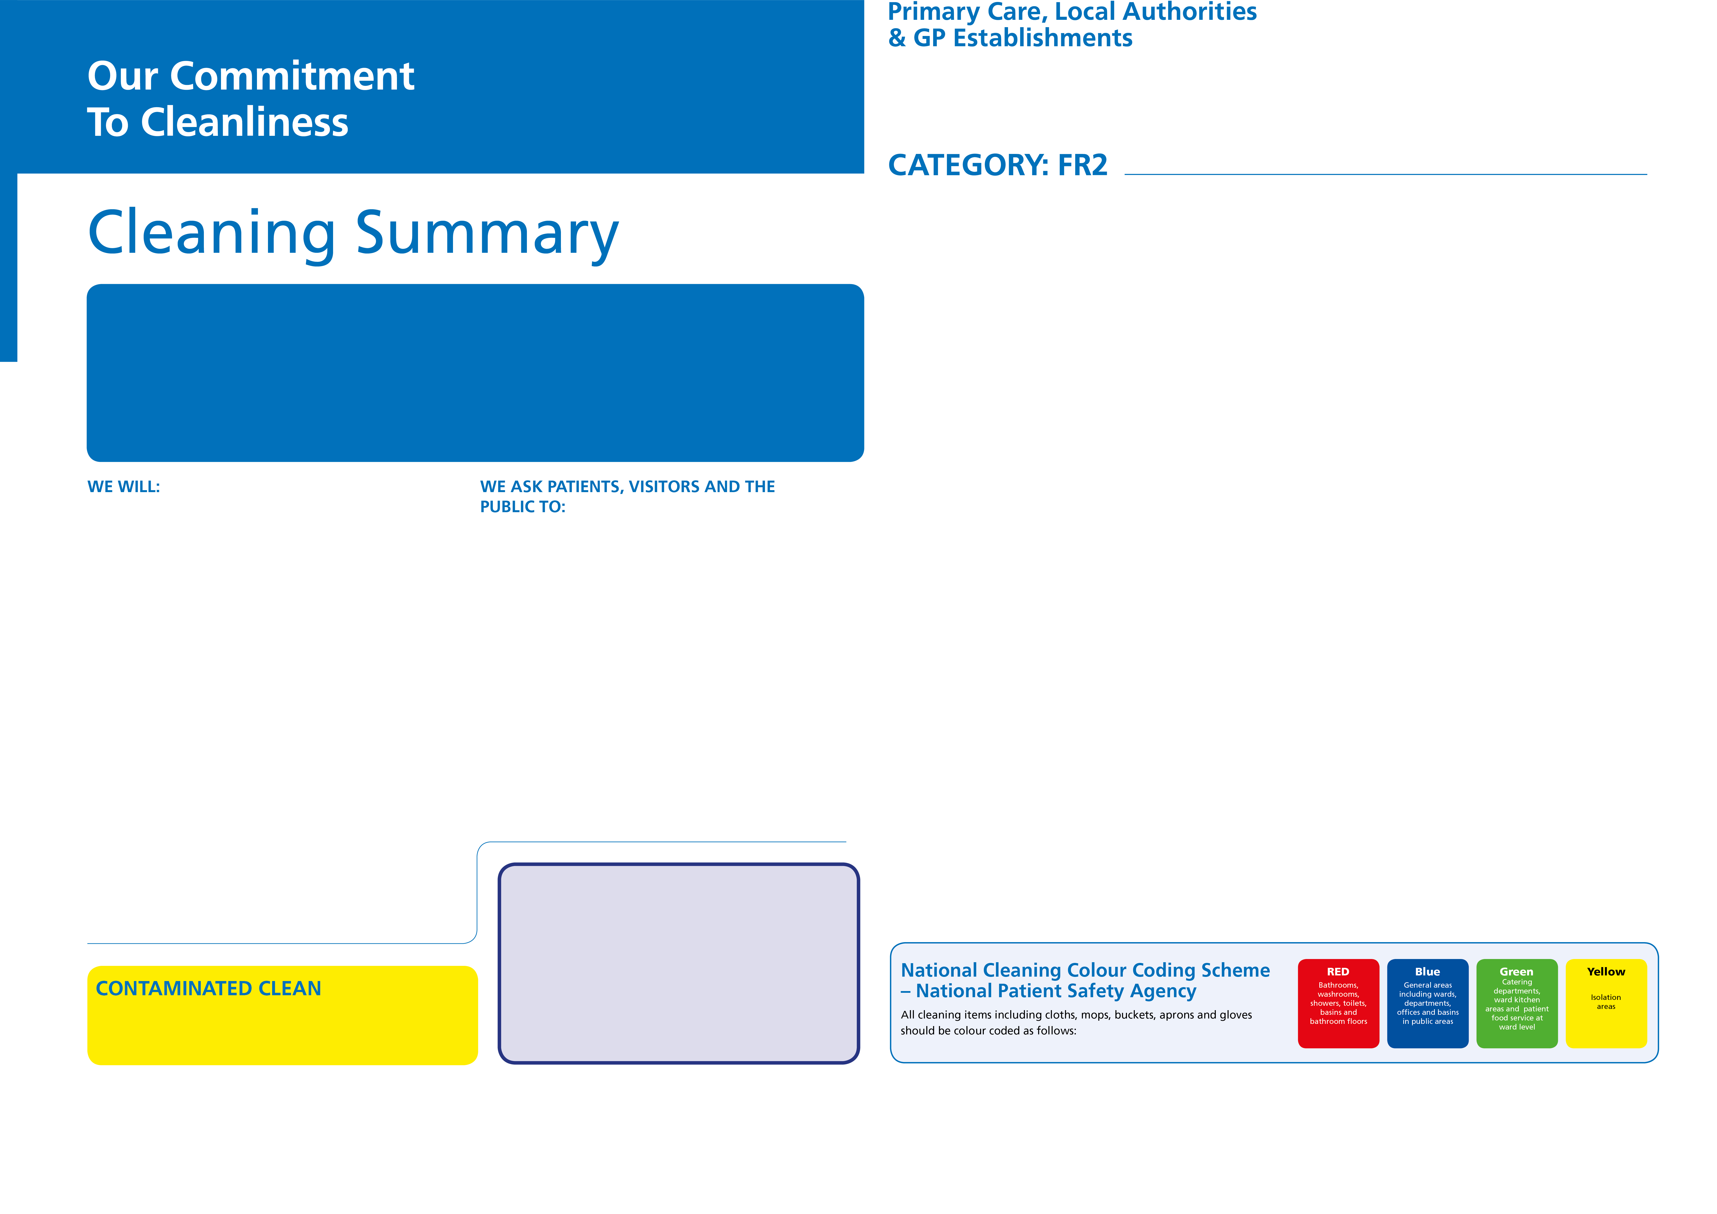


If you require further information regarding cleaning standards go to: www.england.nhs.uk/wp-content/uploads/2021/04/B0271-national-standards-of-healthcare-cleanliness-2021
If you wish to comment about the cleanliness of this facility, contact

(insert name & number)

Treatment rooms where invasive procedures take place

- Follow good hygiene practices which are displayed in and around the organisation
- Tell us if you require any further information about cleanliness or prevention of infection
- Work with us to monitor and improve standards of cleanliness and prevention of infection
- Do not smoke or drop debris around the entrance doors to reduce likelihood of soil entering the building.
- Inform us if you or a member of your family spill drinks or where vomiting occurs to enable us to contain the spill and rectify the situation as promptly as possible for the comfort of the patient, visitors and staff.

CLEANING TASK | CLEANING FREQUENCY | RESPONSIBILITY
Sanitary Areas (if connected to treatment room)
Toilets, sinks and taps | 1 x full daily, check between patients | Healthcare Cleaning Professional (HCP)
Showers | 1 x full daily, check between patients | HCP
Mirrors | 1 x full daily | HCP
Patient Areas
Patient beds | 1 x full daily, clean between patients | HCP and Practitioner
Patient mattresses | As above | HCP and Practitioner
Chairs | 1 x full daily | HCP
Tables, changing areas and lockers | 1 x full daily | HCP
Doors, including ventilation grilles | 1 x full daily | HCP
Windows | 1 x full every 6 months | External contractor
Internal glazing | 1 x full weekly | HCP
Radiators including cover | 1 x full weekly external only | HCP
Curtains and blinds | As local protocol, 6 months minimum | HCP
Low, middle and high surfaces | 1 x full weekly, 1 x check daily (low) | HCP
Waste receptacles | 1 x full daily, 1 x check daily | HCP and Clinical Team
Dispenser cleaning | 1 x full daily external (internal weekly) | HCP
Replenishment of consumables | Check and replenish 3 x daily | HCP and Clinical Team
Floors
Floors hard | 1 x full daily, 1 x check daily | HCP
Floors soft | 1 x full daily, 1 x check daily | HCP
Kitchen Areas
Fridges and freezers (except drugs & samples) | 1 x full weekly, 1 x check daily | HCP and Clinical Team
Cupboards | 1 x full monthly, 1 x check daily | HCP and Clinical Team
Medical Equipment
Medical equipment | Refer to local protocol | Clinical staff
Cleaning Equipment
All cleaning equipment including trolley | Full clean after each use | HCP

Practice Manager
- Treat patients in a clean, safe and pleasant environment
- Provide a well maintained, clean and safe environment, using the most appropriate and up to date cleaning methods and frequencies
- Aim to clean the building when patient appointments have finished for the day.
- Maintain fixtures and fittings to an acceptable condition to enable effective and safe cleaning to take place regularly
- Allocate specific roles and responsibilities for cleaning, linked to infection prevention and control.
- Constantly review cleanliness and rectify issues with cleaning provider or in-house team (delete as appropriate)
- Take account of your views about the quality and standards of cleanliness by involving patients and visitors in reporting and monitoring how well we are doing
- Provide the public with clear information on any measures which they can take, to raise awareness and educate the public in the prevention and control of healthcare associated infections
- Provide structured and pro-active education and training to ensure all our staff are competent in delivering infection prevention and control practices within the remit of their role
- Provide entrance matting to remove soil from shoes and reduce the dirt from entering the building especially in winter months.
- Design any new facilities with ease of cleaning in mind
Keeping the NHS clean and preventing the spread of infection is everybody’s responsibility from the Chief Executive or equivalent to the healthcare cleaner. It is important for patients, visitors, the public and staff.

Cleanliness matters, and to ensure consistency throughout the NHS, and to support hospitals and healthcare services, this commitment has been adopted in every organisation.

This Charter sets out our commitment to ensure a consistently high standard of cleanliness is delivered in all of our healthcare facilities. It also sets out how we would like you to help us maintain high standards.

Name / Signature
All areas identified as contaminated areas are cleaned using yellow colour coded equipment in accordance with the Trust’s Infection, Prevention and Control Policy requirements.

