GENDER PAY GAP Narrative

31 March 2026

Sophie Islington, Associate Director of Colleague Retention and Inclusion
GENDER PAY GAP NARRATIVE

CONTENTS

Section |  | Page
SECTION 1 | INTRODUCTION | 2
SECTION 2 | NHS SOMERSET GENDER PAY GAP RESULTS | 3
SECTION 3 | WORKFORCE PROFILE AND KEY DRIVERS | 5
SECTION 4 | CONcLUSIONS | 8
SECTION 5 | CURRENT MEASURES | 9
SECTION 6 | FURTHER ACTIONS TO ADDRESS THE GENDER PAY GAP (2026–2029) | 10

GENDER PAY GAP NARRATIVE

- INTRODUCTION

What is the Gender Pay Gap?

1.1 Gender pay gap (GPG) legislation requires all employers of 250 or more employees to publish their gender pay gap information each year. The aim of GPG reporting is to show the difference between what women get paid at a workplace and what men get paid at the same organisation, irrespective of their jobs.

1.2 The Gender Pay Gap (GPG) measures the difference in average pay between men and women across the organisation. It is important to recognise that this is not the same as equal pay.

1.3 Equal pay relates to men and women being paid the same for the same or equivalent work, which is a legal requirement under the Equality Act 2010. In contrast, the gender pay gap reflects the overall distribution of men and women across all roles and levels within the organisation. A gender pay gap can therefore exist even where pay and grading structures are applied consistently and fairly.

1.4 Although we are only required to report on pay differentials between men and women, we do recognise that gender is a spectrum that extends beyond the binary definition of male/female and men/women. We hope that national and local data gathering becomes more sophisticated and, as more people feel comfortable to define their non-binary status (to prevent identification of individuals) to include and analyse wider gendered pay gaps.

What Information is Reported

1.3 All public sector organisations with a headcount of 250 employees or more are required to publish gender pay gap information annually, both on their own website and on the government gender pay gap portal: www.gov.uk/genderpaygap

1.4 To comply they must calculate and publish the following information:

- Their mean gender pay gap, which is the difference between the average hourly earnings of men and women.

- Their median gender pay gap, which is the difference between the midpoints in the pay bands of hourly earnings of men and women.

- Their proportion of males and females in each pay quartile pay, where a list is drawn up of employee’s earnings, from the highest to the lowest, and split it into four even groups, or pay quartile.

Where bonuses are awarded, organisations must also share:

- Their mean bonus gender pay gap, which is the difference between the average bonus awarded to men and women.

- Their median bonus gender pay gap, which is the difference between the midpoints of bonuses awarded to men and women.

- The proportion of males and female receiving a bonus payment

This report is based on the snapshot date of 31 March 2025. The data for this report has been drawn from the organisation’s Electronic Staff Records (ESR) and payroll database.

- NHS SOMERSET GENDER PAY GAP RESULTS

Hourly Pay

2.1 Women’s median hourly pay was 23.7% lower than men’s – this means they earned 76p for every £1 that men earn when comparing median hourly pay.

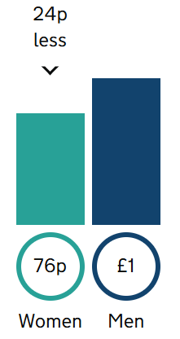

2.2 Women’s mean (average) hourly pay was 24.1% lower than men’s

Pay Quartiles

2.3 Women made up:
- 68.2% of employees in the upper hourly pay quarter (highest paid jobs)
- 78.9% of employees in the upper middle hourly pay quarter
- 91.5% of employees in the lower middle hourly pay quarter
- 84.2% of employees in the lower hourly pay quarter (lowest paid jobs)

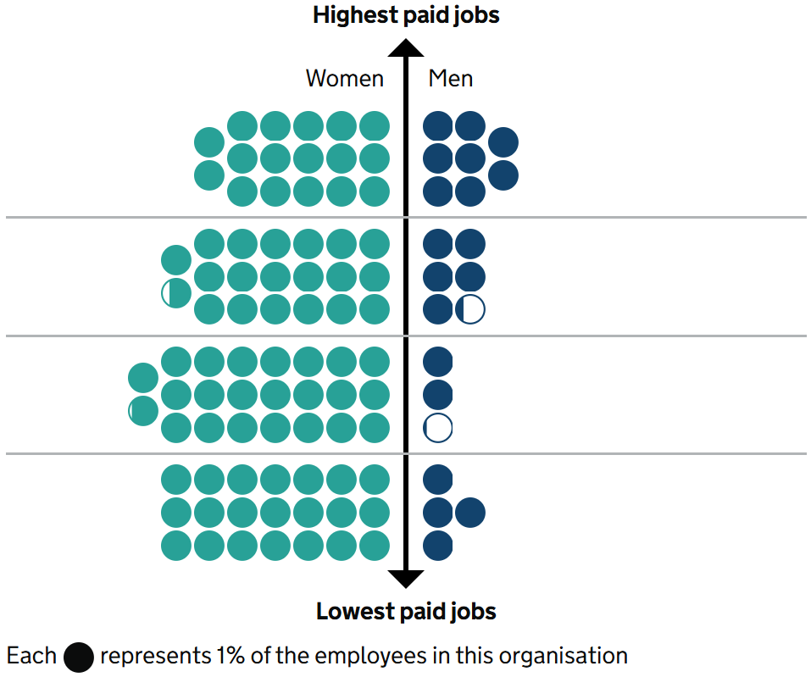

Bonus Pay

2.4 NHS Somerset did not pay any bonuses.

- WORKFORCE PROFILE AND KEY DRIVERS

NHS Somerset Gender Distribution

3.1 Like many NHS organisations, our workforce is predominantly female. Women are significantly represented across nursing and midwifery, administrative and support functions which are aligned to lower and middle pay bands under national NHS Agenda for Change arrangements.

3.2 As of 31 March 2025, NHS Somerset employed a total of 376 people with 308 females (81% of staff) and 68 males (19% of staff)

Table 1: Gender Distribution by Directorate

Note: this data relates to the workforce as of 31 March 2025

Directorate | Female (n) | Male (n) | Headcount | Female % | Male %
Clinical, Medicine & Primary Care | 46 | 21 | 67 | 69% | 31%
Corporate Affairs | 13 | 3 | 16 | 81% | 19%
Communications and Engagement | 11 | 1 | 12 | 92% | 8%
Continuing Healthcare | 46 | 8 | 54 | 85% | 15%
Finance, Performance and Contracting | 13 | 8 | 21 | 62% | 38%
Quality, Patient Safety and Improvement | 32 | 6 | 38 | 84% | 16%
Executive | 8 | 8 | 16 | 50% | 50%
People Directorate | 7 | 3 | 10 | 70% | 30%
Strategy, Digital & Integration | 49 | 10 | 59 | 83% | 17%

Key Drivers of Our Gender Pay Gap

3.3 Our gender pay gap is primarily driven by the uneven distribution of women across pay levels, we can analyse two trends within this driver:

  - the over-representation of women in lower-paid roles
  - the comparative under-representation of women in senior leadership

Trend 1: Under Representation at Senior Levels

3.4 Analysis of workforce composition by pay band shows that women make up the majority of staff at all Agenda for Change (AfC) bands, particularly in the lower and middle pay bands.

Table 2: Gender Distribution by Band

Note: this data relates to the workforce as of 31 March 2025

Band | Women | Men
Band 3 | 100% | 0%
Band 4 | 89% | 11%
Band 5 | 87% | 13%
Band 6 | 93% | 7%
Band 7 | 89% | 11%
Band 8a | 75% | 25%
Band 8b | 76% | 24%
Band 8c | 73% | 27%
Band 8d | 100% | 0%
Band 9 | 78% | 22%
Clinical Leads, Associate Clinical Directors, Deputy CMO and Designated Doctors | 45% | 55%
Non-Executive Directors and Chair | 20% | 80%
Very Senior Managers | 40% | 60%

3.5 At the lowest pay levels, representation is almost entirely female, with women comprising 100% of Band 3 roles, and remaining significantly over-represented in Bands 4–7 (ranging from 87% to 93%). This indicates that women are disproportionately concentrated in lower-paid roles across the organisation.

3.6 Although female representation remains high at senior AfC levels, there is a gradual increase in the proportion of men as pay bands rise:
- Women account for:
  - 75% of Band 8a
  - 76% of Band 8b
  - 73% of Band 8c
  - 78% of Band 9

3.7 This trend demonstrates that while women continue to form the majority of the workforce overall, their representation begins to decline relative to men in higher-paid roles.

3.8 A more marked shift in gender balance is observed in Very Senior Manager (VSM) and Board-level positions. In senior clinical leadership roles (including Clinical Leads, Associate Clinical Directors, Deputy Chief Medical Officers and Designated Doctors), men make up 55% of roles, compared with 45% women. At the most senior organisational level — Non-Executive Directors and Chair roles — men account for 80% of positions, with women representing only 20%.

3.9 Senior clinical leadership, non-executive director and executive director roles attract higher levels of remuneration and therefore have a disproportionate impact on mean pay calculations.
3.10 Increasing female representation in senior roles is key to reducing the pay gap over time.

Trend 2: Over Representation at Junior Levels

3.11 This is impacted by rates of flexible working and the impact on career progression. Nationally, women continue to be more likely to:

- work part-time
- take career breaks for caring responsibilities
- utilise flexible working arrangements

3.12 In addition to vertical segregation across pay bands, there is evidence of horizontal occupational segregation in working patterns. Of the 376 staff analysed, women account for the majority of both full-time and part-time roles; however, women are more likely than men to work part-time.

3.13 Approximately 38% of female staff work part-time compared with 25% of male staff. As part-time roles are associated with lower overall earnings, this further reduces the average hourly pay of women relative to men across the organisation.

3.14 Whilst these arrangements are vital in supporting work–life balance and staff retention, they can influence progression into senior leadership pathways and affect overall earnings averages across the organisation.

Table 3: Working Patterns by Gender

Note: this data relates to the workforce as of 31 March 2025

Gender | Full-time (number of all staff) | Full-time (% of all staff) | Part-time (number of all staff) | Part-time (% of all staff) | Total (number of staff)
Male Staff | 52 | 14% | 16 | 4% | 68
Female Staff | 190 | 52% | 118 | 32% | 308

4 CONCLUSIONS

4.1 This report highlights that NHS Somerset’s Gender Pay Gap is not the result of unequal pay for equal work but is primarily driven by patterns of occupational segregation across the organisation.

4.2 Women make up the majority of the workforce (81%) and are strongly represented across all Agenda for Change pay bands. However, they are disproportionately concentrated in lower and middle pay bands, as well as in part-time roles. Conversely, there is a relative increase in the proportion of men in senior clinical leadership, Very Senior Manager and Board-level positions, which attract higher levels of remuneration.
4.3 This vertical segregation, combined with the higher likelihood of women working part-time, has a structural impact on average earnings across the organisation. As a result, even where pay is applied consistently and fairly within roles, the overall distribution of men and women across grades, leadership positions and working patterns contributes to the Gender Pay Gap.

4.4 Addressing this gap will require a continued focus on improving the representation of women in senior leadership roles, supporting career progression opportunities, and enabling flexible working arrangements that do not disadvantage progression.

5 CURRENT MEASURES

5.1 NHS Somerset has implemented a range of measures aimed at supporting gender equality across the workforce and addressing the structural factors that contribute to the Gender Pay Gap.

5.2 Our recruitment processes incorporate anonymised application and shortlisting practices to help mitigate the risk of unconscious bias and ensure that candidates are assessed on merit. In addition, all roles at Band 8a and above are advertised externally to the ICB, supporting access to a broader and more diverse candidate pool for senior opportunities.

5.3 Flexible and accessible recruitment practices are also embedded within our approach. The use of online Microsoft Teams interviews for many roles enables greater flexibility for applicants, while executive-level vacancies are promoted through specialist recruitment platforms to reach a wider and more diverse audience. Where appropriate, flexible working options are actively offered for senior and board-level roles.

5.4 We are committed to promoting inclusive working practices from the point of appointment. Shared parental leave and flexible working arrangements are available to all staff from their first day of employment. Furthermore, the majority of ICB roles require between 40% and 60% on-site working, helping to support staff with caring responsibilities and improve access to progression opportunities.

5.5 All recruitment agencies engaged by NHS Somerset are expected to demonstrate their commitment to equality, diversity and inclusion, and mandatory workplace equality and diversity training is in place for all staff to promote inclusive behaviours and decision-making.

5.6 To ensure ongoing oversight and continuous improvement, workforce data is reviewed on a quarterly basis to monitor gender balance across roles and grades. In parallel, organisational policies are regularly reviewed and updated to ensure they remain inclusive, relevant and supportive of equality in career progression.

5.7 Together, these measures are intended to support a more balanced workforce and help reduce barriers to progression that may disproportionately affect women over time. However, we do recognise we have more to do and will explore the further steps we will be taking within the next paper section.

6 IMMEDIATE ACTIONS TO ADDRESS THE GENDER PAY GAP (2026)

6.1 The analysis within this report demonstrates that NHS Somerset’s gender pay gap is primarily driven by:
- the under-representation of women in senior leadership roles, particularly at VSM and Board level; and
- the over-representation of women in lower pay bands and part-time working patterns which may impact career progression

6.2 In the immediate term, with the context of a wide organisational change programme commencing in March 2026, there is a need to focus initially on reducing the impact of this programme on gender pay gap and ensuring proposals do not widen this gap.

1) Fair Change Management Procedures

6.3 NHS Somerset will ensure all change processes are fair, consistent, and compliant with equality legislation. Selection for redundancy or role changes will be based on clear, objective criteria such as skills, qualifications, and experience rather than subjective or personal opinion. Procedures will be reviewed regularly to avoid discrimination and to address the needs of staff with protected characteristics, including making reasonable adjustments where required. This may involve considering suitable alternative roles or providing additional support throughout the process. Trade Union representatives will be engaged throughout to maintain transparency, uphold fairness, and ensure that employee rights are respected at every stage of organisational change.

2) Commitment to Equality Impact Assessments (EQIAs)

6.4 Equality Impact Assessments will be completed at local and cluster level to ensure that proposed organisational changes are fair, inclusive, and legally sound. EQIAs will help identify any disproportionate or negative effects on staff with protected characteristics and ensure that due regard is given to these impacts during decision‑making. Findings will be used to shape planning, guide adjustments, and strengthen compliance with equality obligations. By integrating EQIAs into the change process, NHS Somerset aims to prevent inequality, support vulnerable groups, and promote responsible, transparent, and evidence‑based decision-making.

3) Meaningful Consultation

6.5 NHS Somerset will ensure that all affected staff have genuine opportunities to provide feedback before decisions are finalised. The consultation process will be open, accessible, and transparent to help employees understand the reasons for change and the potential implications. Staff views will be considered carefully, and consultation outcomes will contribute to shaping final decisions wherever possible. Clear information will be provided throughout, helping to maintain trust, reduce uncertainty, and ensure that employees feel heard and supported during periods of organisational change.

This will include engagement with underrepresented and vulnerable staff, helping to highlight concerns that might otherwise be overlooked. Their input will support EQIAs, guide reasonable adjustments, and ensure that proposed changes reflect a genuinely inclusive approach.

4) Flexibility

NHS Somerset will prioritise ensuring that colleagues have options for flexibility in their working environment, which is known to support women with caring responsibilities remain in the workplace. Considerations may include active consideration to flexible working models, part time working, and mitigation of travel impacts associated with serving a larger geographical footprint that help women to engage fully in work.

Wellbeing services will also remain available at all stages to support employees in managing stress, maintaining resilience, and navigating the transition with confidence and clarity.

5) Transparent and Compassionate Communication

Communication during organisational change will be honest, regular, and empathetic. Staff will receive clear updates explaining why changes are required, how fairness and equality are being protected, and what support is available. This approach aims to reduce anxiety, build trust, and ensure that employees understand how decisions are made. Information on how to raise concerns, seek guidance, or appeal outcomes will also be made readily available. The overall focus will be on maintaining dignity, openness, and clarity at every stage of the process.

6) Development and Support for New Roles

NHS Somerset will support staff who move into new or revised roles by providing appropriate training, development opportunities, and guidance.

Redeployment pathways will be strengthened to help employees transition successfully, ensuring that skills and experience are retained within the organisation. Staff will be supported not only during implementation but also beyond it, with ongoing development opportunities that build confidence, competence, and long-term career stability. The aim is to ensure that staff feel equipped, valued, and supported as they take on new responsibilities.

7 FURTHER ACTIONS TO ADDRESS THE GENDER PAY GAP (2027–2029)

7.1 Further to change, we will be able to implement more advanced actions to address these structural factors and support improved gender representation across higher-paid roles.

7.2 It will be necessary for these measures to be further developed as a cluster however they are likely to include:

- Programmes to increase female representation in the most senior leadership roles
- Improvement of career progression routes for colleagues working flexibly and in part time roles.
- Specialised career development approaches for those returning from career breaks
- Talent Management for colleagues within bands 3-6 and creation of pipelines and placements into Band 7+ roles
- Strengthening monitoring, accountability and transparency across a wider staffing group, as clustering takes place.

