- Do not attempt to take the inhaler apart to clean it or for any other purpose.
- Do not use water or wet wipes to clean the inhaler, if necessary wipe the mouthpiece with a clean, dry tissue.
- Do not insert sharp objects into the any part of the inhaler as this could damage it.
- Speak to your nurse or pharmacist if you experience problems using your inhaler.

Notes

For video demonstrations on how to use your inhaler visit:
Add link to your CCG website here

Please make an appointment to reassess your inhaler technique in:
3 months |  | 6 months |  | 12 months

How to use your Forspiro inhaler
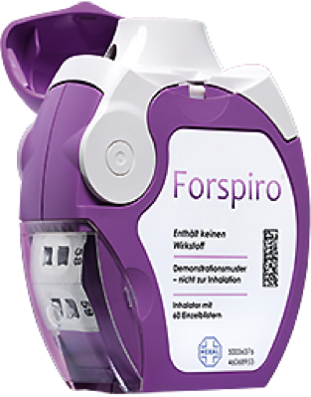
Inhalers are commonly prescribed for patients with asthma and chronic obstructive pulmonary disease (COPD) as they are very effective at delivering the medication straight to the lungs where it is needed.
Using your inhalers correctly is an important part of asthma or COPD treatment. You should be shown how to use inhalers properly by a healthcare professional when they are first prescribed.
You may occasionally experience problems using your inhalers, especially if it has been a while since you were shown the correct technique. This is very common and your healthcare professional can help you improve your inhaler technique.

Why is inhaler technique important?
- It allows the correct dose of medication to reach your lungs.
- It gives you better control of your condition.
Examples of Forspiro inhalers | Airflusal Forspiro
There are several steps to prepare the inhaler for use:
- Open the transparent side chamber door of the inhaler.
- Remove the foil strip from the side chamber by carefully tearing away the full length of strip against the ‘teeth’ of the side chamber.
- Do not pull or tug on the strip.
- Close the side chamber door and dispose of the used strip.

Checklist for Forspiro use
1 | Stand or sit upright when using your inhaler.
2 | Hold the inhaler horizontally with the protective cap facing towards you.
3 | Open the protective cap downwards to reveal the mouthpiece and the dose counter. Check to see how many doses are left.
4 | Make sure the side chamber is closed and then prepare the dose by lifting up the edge of the white lever.
5 | Move the white lever fully over as far as it will go and until it clicks, this moves a new dose into position; fully close the white lever so it clicks back into its original position.
6 | The inhaler is now ready for immediate use.
7 | Breathe out gently as far as is comfortable away from mouthpiece do not breathe in again yet.
8 | Hold the inhaler level with the protective cap pointing downwards.
9 | Place the mouthpiece between your teeth without biting and form a good seal around it with your lips.
10 | Breathe in steadily and deeply through the inhaler. Not through your nose.
11 | Remove the inhaler from your mouth and hold your breath 10 seconds or as long as is comfortable, then breathe out slowly, but not through the inhaler.
12 | Close the protective cap over the mouthpiece.

Common problems
Common mistakes that people make with Forspiro include:
- Not standing or sitting upright when using the inhaler.
- Not holding the inhaler horizontally while loading and inhaling the dose.
- Not loading a dose before using the inhaler.
- Not inhaling steadily and deeply enough to draw the medication out of the inhaler and in to your lungs.
- Not holding your breath long enough after breathing in the contents.
- Breathing out through the inhaler, remove the inhaler form your mouth first.
- Getting moisture inside the inhaler.
- Not replacing the protective cap over the mouthpiece after use.

Useful tips
- As you use the inhaler the side chamber will gradually fill up with used foil strip.
- The foil strips with black bars do not contain any medication.
- Eventually the numbered sections of the strip will appear in the side chamber.
- It’s important not let more than three sections of foil strip build up in the side chamber as they may cause the inhaler to jam. Tear the strip away carefully and dispose of it safely.
- When the number of doses left appears on a red background, re-order a new inhaler.
- Always check that nothing is blocking the mouthpiece.
- Always rinse your mouth with water and spit it out after using the inhaler.
- Always replace the protective cap on the mouthpiece after use.

