Notes

For video demonstrations on how to use your inhaler visit:

http://formulary.somersetccg.nhs.uk/?page_id=3964

Please make an appointment to reassess your inhaler technique in:
3 months |  | 6 months |  | 12 months

How to use your metered dose inhaler (MDI)
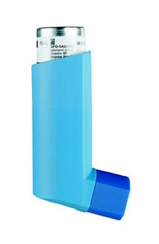
Inhalers are commonly prescribed for patients with asthma and chronic obstructive pulmonary disease (COPD) as they are very effective at delivering the medication straight to the lungs where it is needed.
Using your inhalers correctly is an important part of asthma or COPD treatment. You should be shown how to use inhalers properly by a healthcare professional when they are first prescribed.
You may occasionally experience problems using your inhalers, especially if it has been a while since you were shown the correct technique. This is very common and your healthcare professional can help you improve your inhaler technique.

Why is inhaler technique important?
- It allows the correct dose of medication to reach your lungs.
- It gives you better control of your condition.
Examples of metered dose inhalers
Daily steroid preventer | Daily steroid combination preventer | Rescue treatment for breathlessness
Qvar inhaler | Fostair inhaler | Salbutamol inhaler
Clenil Modulite inhaler | Flutiform inhaler | Salamol inhaler
Flixotide inhaler | Seretide inhaler | Ventolin inhaler
 |  | If using more than 3 times a week make an appointment for review.
.

Checklist for metered dose inhaler use
1 | Stand or sit upright when using your inhaler.
2 | Remove the inhaler cap.
3 | Hold the inhaler upright and shake 4 or 5 times.
4 | Breathe out fully.
5 | Place the mouthpiece between your teeth without biting and form a good seal around it with your lips.
6 | Breathe in through your mouth and press the canister down at the same time to release a puff of medicine.
7 | Continue to breathe in slowly and deeply for 3-5 seconds, or as long as you can sustain.
8 | Hold your breath and take the inhaler from your mouth.
9 | Continue to hold your breath for 10 seconds or as long as is comfortable. Breathe out slowly.
10 | If your doctor has told you to take two puffs, wait 30 seconds then repeat steps 3 to 9.
11 | Replace the cap straight away to keep out dust.

Common problems
Common mistakes that people make with metered dose inhalers include:
- Not standing, sitting or holding the inhaler upright.
- Not shaking the inhaler before using it.
- Inhaling too sharply, at the wrong time or not deeply enough.
- Not holding your breath long enough after breathing in the contents.
- Taking several puffs without waiting between them.
- It can be difficult to tell when the inhaler is empty.

Useful tips
- Practice in a mirror, if you see a ‘mist’ from the top of the inhaler or the sides of your mouth you should start again.
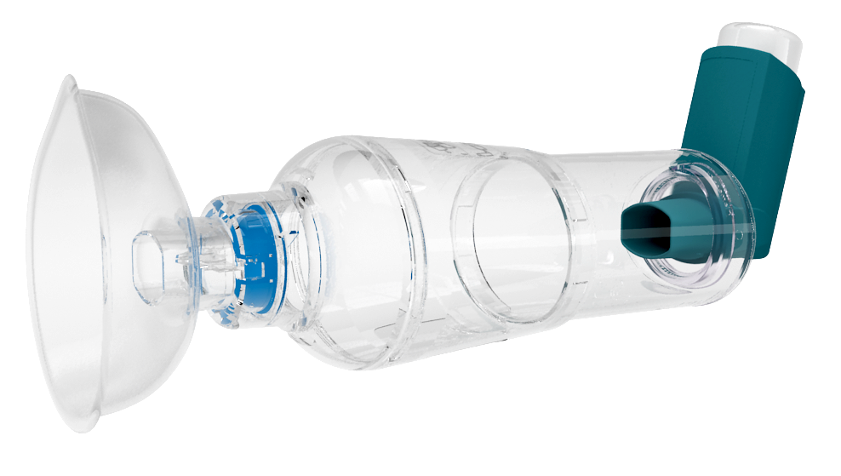
- If your inhaler contains a steroid (daily steroid preventer as table above) rinse your mouth out with water after your dose.
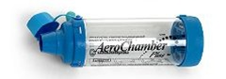
- A spacer device used with your inhaler will help with any co-ordination problem, help the medication reach the lungs and reduce any side effects.
- Always read the patient leaflet provided with your inhaler for any specific instructions.
- Speak to your nurse or pharmacist if you experience problems using your inhaler.

