 | Learning from the Lives and Deaths of People with Learning Disabilities and Autism (LeDeR)
Newsletter – 8th edition – November 2022
National LeDeR Report 2021
‘Learning from lives and deaths – People with a learning disability and autistic people’
First report from the new academic partners of the LeDeR programme led by Kings College London building on previous work by the University of Bristol. It shows there continues to be significant learning to be drawn from the deaths of people with learning disabilities.

Key Findings
- 3,304 deaths were reported to LeDeR during 2021
- An increase in the number of deaths reported during the COVID-19 pandemic
- On average males with a learning disability died 22 years younger than males in the general population, and females 26 years younger
- 6 out of 10 people died before they were 65
- Over 50% of people died came from some of the most deprived areas in England
- Most commonly recorded causes of death were:
  - COVID-19
  - diseases of the circulatory system
  - diseases of the respiratory system
  - cancers and diseases of the nervous system
Other than the effects of COVID-19 there was little change in data since before the pandemic.
- About half of all deaths (49%) were thought to be avoidable, compared to 22% in the general population. Avoidable deaths are defined as preventable and treatable causes of death.

The main report and accessible information can be viewed here:
Main Report | Accessible Report | Accessible Video
Movember! Focus on men’s health and raise awareness of the importance of checking for prostate and testicular cancer.

Movember.com

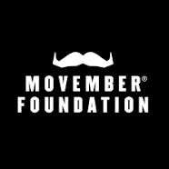
Also take a look at the latest Ralph and Katie episode: ‘Ralph’s Balls’
BBC iPlayer - Ralph & Katie - Series 1: 5. Ralph’s Balls

 | Somerset LeDeR Report 2021-2
Key Points
- During 2021-2022 52 LeDeR reviews were carried out, nearly half were from the previous year due to the changes to the LeDeR system (more detail in Annual Report).
- The largest proportion of deaths occurred in those aged 56-65
- Local data reflects national causes of death in a similar way except for COVID-19, as we did not see any deaths directly from COVID-19 in Somerset. In 2 cases COVID-19 was mentioned on the death certificate, it may also have impacted on the care some people received.

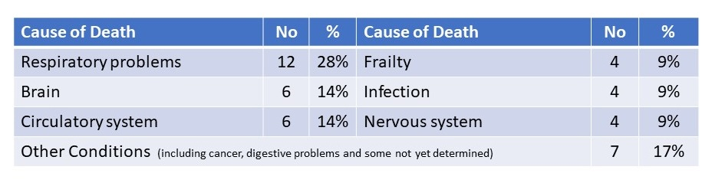

To find out more, including what we are doing to make a difference; read about good practice that was found; read people’s stories and how we are working with people with learning disabilities and autism go to Somerset-LeDeR-Annual-Report-2022-Final.docx (live.com)
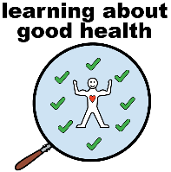 | Action from Learning
NHS England have published their latest LeDeR Action from Learning Report. This highlights some of the national and local action that has taken place in response to LeDeR reviews.

The key areas include:
- COVID-19 vaccinations and treatment
- Management of medical conditions such as respiratory conditions
- Identifying and managing deterioration
- Changing how we work / changes identified in the LeDeR policy

For more information on local and national initiatives you can view the reports here:
Action from Learning Report | Easy Read Report
 | The NHS produces Easy Read Newsletters. The most recent one Getting your health checked encourages people to make sure they have their Annual Health Checks, screening, and dental, ear and eye checks - and not being scared because of the COVID-19 pandemic.
Check out the other issues which have looked at smoking and how to stop, sepsis, vaccinations, diabetes and epilepsy. You can find all of them here NHS England » Easy Read Newsletters.
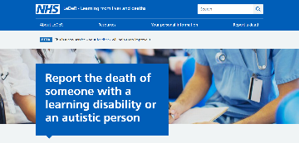 | We need YOU to notify LeDeR when someone dies
It helps us all to have a better understanding of the needs of people with a learning disability and autistic people; helps improve services in Somerset and provides an opportunity to shout about good practice!

It’s very simple to do and will only take about 10 minutes. Here is the link to the form Report the death of someone with a learning disability (leder.nhs.uk).

If you provide care or support to someone with a learning disability, or an autistic person, are a GP or other health professional, a family member, friend or carer we need you to notify us if someone dies. Here is the link again https://leder.nhs.uk/report.
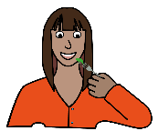 | LeDeR Learning Briefs – issue 1: Dysphagia (or difficulty swallowing)
Many of the people with learning disabilities who die have a diagnosis of dysphagia, which is difficulty with eating, drinking and swallowing. Having dysphagia may contribute to the deterioration in a person’s health and/or a change in a person’s physical or mental health may affect their dysphagia. We have started a series of Learning Briefs, and issue 1 looks at dysphagia.
LeDeR Learning Brief 1.1 - Dysphagia

The risks associated with dysphagia can often be reduced with careful multi-disciplinary management involving carers, Speech and Language therapy, Physiotherapy, GP and other health and care professionals.

It has been found that sometimes carers do not have sufficient training to help them understand fully the importance of following eating and drinking care plans provided by Speech and Language Therapy. NHS Somerset is looking at how to improve available dysphagia training and support for carers.
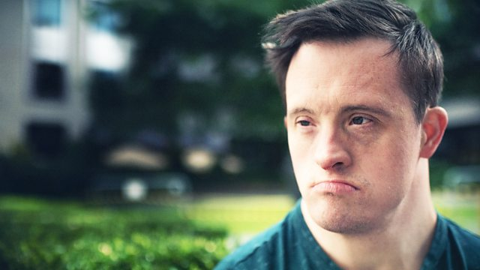 | Will the NHS Care for Me?  BBC Panorama 10 October 2022  Click here BBC One - Panorama, Will the NHS Care for Me?
This programme again highlighted the inequalities that people with learning disabilities can experience when accessing health care. Presented by Tommy Jessop, an actor (Line of Duty) and campaigner with a learning disability, it looked at the deaths of some people with a learning disability. It highlights the difficulties people with learning disabilities can experience when in hospital and how this can impact on health and lead to premature death.

The programme mentions LeDeR and makes some recommendations for improvement, much of which is very relevant in Somerset.

We would encourage everyone to watch it and do get in touch if you want to find out what LeDeR is doing in Somerset to learn from deaths of people with learning disabilities and autistic people.
 | LeDeR Team Away Day
In August the whole team attended an Away Day. We used the time to reflect on what was working well for the team but also to learn from the challenges. We looked at our Governance processes and our priorities for the next year.  Helen Stobbs from Yeovil District Hospital joined us in the afternoon to facilitate a communication exercise which as well as being a lot of fun, was very thought-provoking.  We didn’t get our Wellbeing Walk as planned because of the weather but put our energy into some competitive fun. From left: Carolyn Arscott (Lead Reviewer), Julie Ticehurst (Team Administrator), Eelke Zoestbergen (Deputy LAC) and Mel Axon (Reviewer) are pictured trying their hand at Cobra Paw. |  | 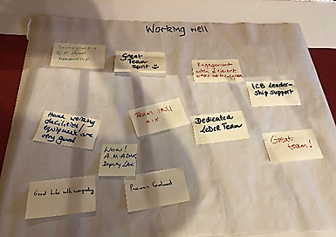
 |  | 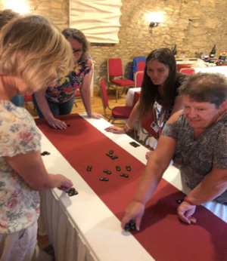
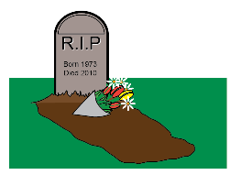 | Talking about Death and Dying
We are really excited to be working with Biggerhouse film on a media project exploring the topic of death and dying. Biggerhouse film work with people with learning disabilities and autistic people to make award winning dramas, documentaries and animations.  They make films with people not about them, as this empowers participants and has a greater impact for the intended audience. |  | 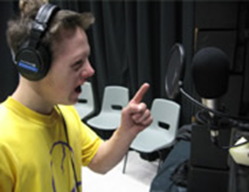
LeDeR reviews show that conversations about death and dying often don’t happen when they should and are something that people with learning disabilities are protected from. This project will help us understand more about how people with learning disabilities and autistic people view death and dying and we are looking forward to working with Biggerhouse.

If you would like to know more about this project or know someone who would like to take part in the film, please do get in touch with us at somicb.leder@nhs.net.
Contact Us

If you would like to contact our LeDeR team with any questions or queries, please do so using the email address somicb.leder@nhs.net - we would love to hear from you.

And if there is anything you’d like to see included in a future newsletter, please let us know.

Images used in this newsletter are Copyright Leeds and York Partnership NHS Foundation Trust 2017

