**The Role of Infection Prevention & Control Lead in Primary Care**

The Health and Social Care Act 2008 (Code of Practice on the prevention and control of infections and related guidance) (updated July 2015), requires every Primary Care Provider to have an Infection Prevention & Control Lead.

The IPC Lead is responsible for leading and maintaining an effective local infection prevention & control programme. This involves identifying infection risks to the practice, its patients, visitors and staff, and taking responsibility for implementing and monitoring actions to minimise and manage those risks.

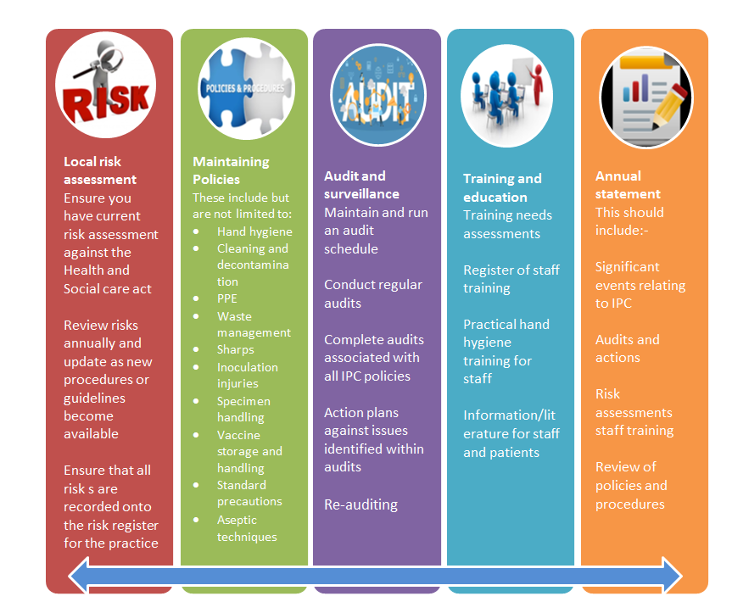The IPC Lead can be anyone in the organisation provided they receive the necessary training and have the authority to challenge inappropriate practice. The role of IPC Lead should be included in the person’s Job Description and they should be supported to undertake the role.

**Useful resources for the IPC Lead include:**

* Somerset ICB IP&C Good Practice Guide

<https://nhssomerset.nhs.uk/for-clinicians/infection-control/infection-control-in-primary-care/>

* Infection Prevention Society: <http://www.ips.uk.net/>
* Royal College of Nursing Infection Prevention: <http://www.rcn.org.uk/clinical-topics/infection-prevention-and-control>
* CQC guidance on what they look for when inspecting GP Surgeries/Medical Centres: <http://www.cqc.org.uk/content/gp-practices-and-out-hours-service-providers> and <http://www.cqc.org.uk/content/examples-outstanding-practice-gps#safe> and <http://www.cqc.org.uk/content/what-does-inadequate-practice-look-examples-our-gp-inspections>
* Public Health England, Antimicrobial Resistance Hand book: <https://assets.publishing.service.gov.uk/government/uploads/system/uploads/attachment_data/file/768999/PHE_AMR_resource_handbook.pdf>
* NHS England and Improvement - Healthcare associated infections

<https://www.england.nhs.uk/patient-safety/healthcare-associated-infections/>

* National Infection Prevention and Control Manual

<https://www.nipcm.hps.scot.nhs.uk/chapter-1-standard-infection-control-precautions-sicps/>

* ICB Infection Prevention & Control Team

Email: somicb.infectionpreventioncontrolteam@nhs.net

**IPC Lead (text for insertion into standard Job Description):**

Nominated Infection Prevention and Control (IPC) Lead

Perform the role of designated Infection Prevention and Control Lead for ----------------- Surgery/Medical Centre in compliance with the ‘Code of Practice on the prevention and control of infections and related guidance’ (2008).

The IPC Lead will have:

* The appropriate knowledge and skills to take responsibility for infection prevention or be given suitable training to perform the role
* Have the authority to challenge inappropriate practice.

The IPC Lead will develop and manage the Annual IPC Programme, to include:

* leading the practice’s collective responsibility for preventing and controlling infection and assessing the measures needed to reduce such risks
* review and adapt Infection Prevention & Control policy and procedure documents to match the Surgery’s Services
* Manage the audit programme to demonstrate adherence to policies and guidelines and compliance with clinical procedures
* Coordination of staff induction and ongoing training updates for all staff in infection prevention and control.

The IPC Lead will produce an Annual Statement for placement on the Surgery’s Website covering the following list of activities:

* significant events related to infection prevention & control
* IPC audits, outcomes and subsequent actions
* Completed IPC risk assessments
* IPC training of staff (both induction and annual updates)
* Reviewed and updated policies, procedures and leaflets/posters.