Somerset LEDER Annual Report 2021-22

lEARNING FROM THE lIVES AND DEATHS OF PEOPLE WITH LEARNING DISABILITIES AND AUTISTIC PEOPLE

22nd June 2022

SOMERSET LEDER ANNUAL REPORT 2021-22

CONTENTS

 |  |  | Page
1 | EXECUTIVE SUMMARY …………………………………………… |  | 1
2 | INTRODUCTION …………………………………………………….. |  | 2
 | National ………………………………………………………………..  Local …………………………………………………………………...  Patient Engagement …………………………………………………  Quality Assurance and Governance Processes ………………….. |  | 2  2  4  4
3 | LEARNING FROM DEATHS IN SOMERSET ……………………. |  | 5
 | Notifications, Numbers of Deaths, Key Performance Indicators …  About the people who died …………………………………………..  Causes of death ………………………………………………………..  Learning from COVID-19 …………………………………………….  Reflections from Reviewers ………………………………………… |  | 5  8  11  12  12
4 | PEOPLE’S STORIES …………………………………………………. |  | 14
 | Celebrating Good Practice ………………………………………….  Areas for Improvement ……………………………………………… |  | 14  15
5 | LEARNING INTO ACTION …………………………………………. |  | 17
 | Themes from 2021-22 reviews………………………………………  Update on Learning into action ………………….…………………. |  | 17  19
 | CONCLUSIONS ……………………………………………………… |  | 28
 | References …………………………………………………………… |  | 29
APPENDICES
A 1 |  | LeDeR Easy Read Report | 30

- EXECUTIVE SUMMARY

This report covers the period April 2021 – March 2022. There is an easy read summary of the report which can be found in Appendix 1.

Learning from deaths of people with Learning Disabilities and Autistic People (LeDeR) is a national service improvement programme that was set up with the aim of reducing health inequalities and premature mortality by making changes to services both locally and nationally.

The aim of this report is to share learning from the LeDeR programme in Somerset in order to promote change across the health and social care system. This report will summarise what we have found out from the LeDeR reviews carried out in the reporting period, highlighting good practice and areas for improvement. It will discuss key themes that have emerged from reviews and highlight work the LeDeR team have already done with system colleagues to promote change and improve outcomes for people with learning disabilities and autistic people. Lastly the report will identify key improvement priorities for the LeDeR team and colleagues across the Integrated Care System for implementation in the next year.

The report has been written by Dr Rachel Donne-Davis, Local Area Contact for the LeDeR Team, with contributions from a number of system partners including BiggerHouse Film, OpenStoryTellers and Somerset NHS Foundation Trust. The LeDeR Team have provided reflections and case studies for the report and discussions by the LeDeR Governance Group have been incorporated in this report.

- INTRODUCTION

2.1 National
LeDeR is a national service improvement programme looking at deaths of people with learning disabilities and autistic people. The programme was established in 2017 and is funded by NHS England (NHSE) and NHS Improvement (NHSI).

The LeDeR programme aims to achieve the following:
- Improve care for people with a learning disability and autistic people
- Reduce health inequalities for people with a learning disability and autistic people
- Prevent early deaths of people with a learning disability and autistic people

Prior to 2022 the LeDeR programme only included people with Learning Disabilities. From February 2022 Autistic people were also included within the scope of the LeDeR review process.

Everyone with a Learning Disability aged four and above who dies, and every adult (aged 18 and over) with a diagnosis of autism, is eligible for a LeDeR review. Notifications of a death of someone with a Learning Disability or Autistic People can be made by anyone on the LeDeR website.

Every person with a learning disability that LeDeR are notified of will have an Initial Review. Reviewers will then use their professional judgement to determine whether a Focused Review (a more in-depth level of review) is required. Focused Reviews can also be requested by the family of the person who has died.

In certain situations a Focused Review will automatically be carried out:
- Where the person is from a black, Asian or Minority ethnic group
- Where the person has a clinical diagnosis of autism but not a learning disability. This is being piloted while the reviews for Autistic People are introduced.

Local priorities for Focused Reviews can also be determined if a particular theme is recurring frequently in reviews locally.

2.2 Local
Within Somerset CCG the LeDeR Team sits within the Quality and Nursing Directorate. The LeDeR Team consists of a Local Area Contact (LAC), Deputy Local Area Contact, one Senior Reviewer, two Reviewers and a Team Administrator.

Once a notification of a death is received by the team locally, it is reviewed by the LAC and Senior Reviewer and allocated to one of the LeDeR Reviewers for action.
This report describes the implementation of the LeDeR programme in Somerset in 2021-22 highlighting key activity.
The report looks at the causes and contributing factors to people’s deaths and discusses implemented and planned service improvements in order to share learning, improve health outcomes, reduce health inequalities and prevent premature mortality for people with Learning Disabilities and Autistic People.

2021-22 has been a significant year of growth for the LeDeR team in Somerset and one area we have been particularly proud of is increased engagement from people across the health and social care system. The following are some comments from people in the Somerset system about their involvement in the LeDeR Programme and the importance of it locally:
The implementation of the new LeDeR policy from September 2021 has enabled a shift in focus for Somerset LeDeR work. The move to a systemwide focus – overseen and championed by the Somerset multi-agency Governance Board – aligns well to the move into an Integrated Care System. As a LeDeR Team we have worked hard to connect LeDeR to other system developments, such as the new Medical Examiner process and the system-wide Learning from Deaths meetings.
Eelke Zoestbergen
Quality Lead for LD, MH and Community Services
Deputy LeDeR Local Area Contact
NHS Somerset CCG
The LeDeR process helps shine a light on our need to continue measuring, monitoring, and assessing our improvements, keeps reminding us to make adjustments to the way we work, and make changes identified from learning.
Paul Townsend
Director of Mental Health and Learning Disability Care
Somerset Foundation Trust

The LeDeR programme is a valuable tool in highlighting areas for improvement and identifying good practice across the Somerset system. The LeDeR Governance Group draws in partners from across the ICS and will be a key mechanism for generating and monitoring sustainable change to improve outcomes for people with learning disabilities and autistic people going forward.
Jonathan Higman
Chief Executive Designate
NHS Somerset Integrated Care Board

I am delighted to see the reach of the LeDeR programme growing in Somerset, with a substantive team being appointed in the last year. LeDeR reviews are a really powerful way of learning from people’s experiences of the system locally and ensuring there are good outcomes for people with learning disabilities and autistic people.
James Rimmer
Chief Executive & System Lead
NHS Somerset CCG

2.3 Patient Engagement
Patient Engagement is at the heart of LeDeR both nationally and locally. Meaningful engagement of people with learning disabilities, and autistic people is key to LeDeR being effective as a service improvement tool.

It is important to remember that this report is about the deaths of people with learning disabilities and autistic people. Whilst the case studies and data are anonymised these are real people’s stories. Their lives were important and of significant value and the impact their deaths have had on their family and loved ones will doubtless be substantial.

We would like to thank families and carers who have taken the time to speak to us at what has often been a really difficult time in their lives. Their insight and candour has been invaluable and we are grateful we are able to share some of those stories here.

We have been very lucky in Somerset to work with some wonderful groups of people with learning disabilities and autistic people on some of our Learning into Action workstreams. However, we recognise that we could do more to ensure that meaningful engagement is central to all we do as a LeDeR Team. We are excited to tell you about some future plans and in particular share with you Dan’s story, which will give some idea of how we intend to work going forward.

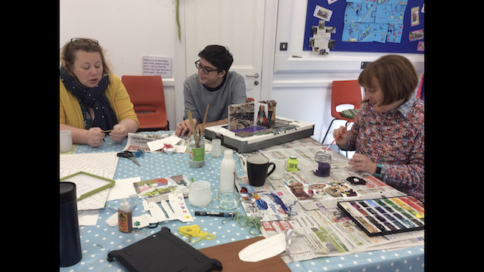

2.4 Quality Assurance and Governance Processes
The LeDeR programme sits within the Quality and Nursing Directorate and as such reports to the Patient Safety and Quality Assurance Group (PSQAC) and Somerset System Quality Group (SSQG).

The diagram below outlines the LeDeR Governance Process in Somerset and other key relationships.
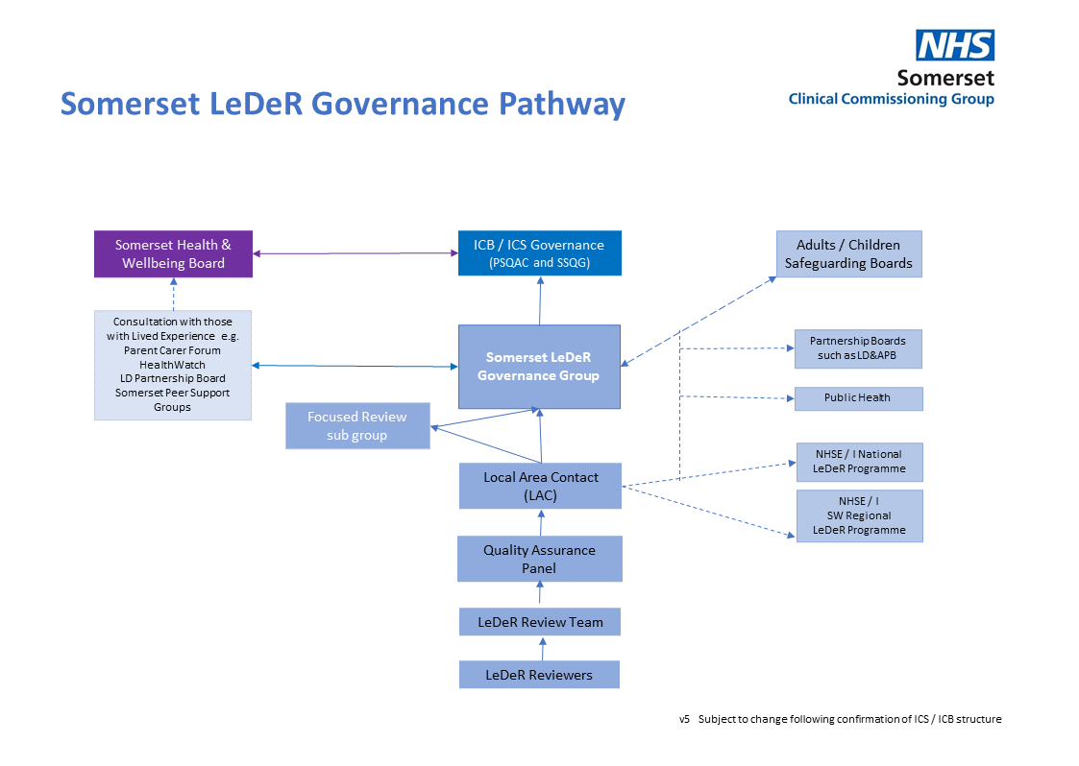

All reviews are informally quality assured via peer review and formally via our Quality Assurance Panel. Initial Reviews are signed off by the LAC following the Quality Assurance Panels. Focused Reviews are signed off by a sub group of the LeDeR Governance Group.

The LeDeR Governance Group replaces the previous LeDeR Steering Group and meets bi-monthly. It contains representation from across the Integrated Care System (ICS) and its main purpose is to ensure that learning from reviews leads to sustained system change and better outcomes for people with a learning disability and autistic people.

Where significant risks are identified the Governance Group can escalate these via PSQAC and SSQC to Governing Body.

3. LEARNING FROM DEATHS IN SOMERSET

3.1 Notifications
In 2021-22 45 notifications were received by the Somerset LeDeR Team, an average of three or four notifications received per month. Chart 1 gives a breakdown of notifications per month.

Chart 1
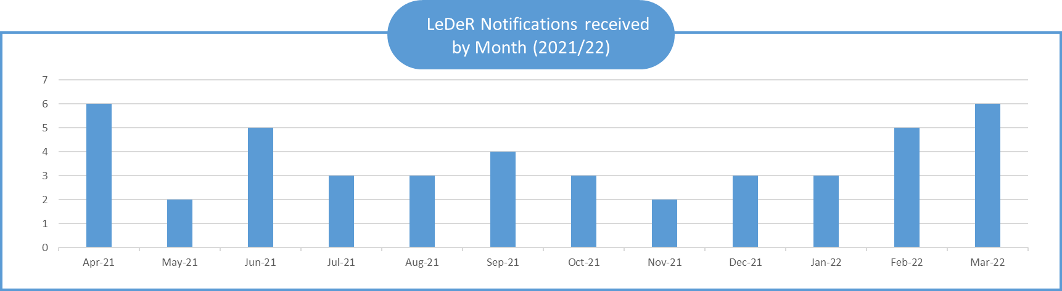

3.2 Notifiers of Death
The largest proportion of notifications came from individual’s working in a hospital setting which is in line with the largest number of deaths nationally being reported in acute / community hospital settings. Chart 2 details the full breakdown of where our notifications came from in 2021-22 and Chart 3 the location of death.

Chart 2
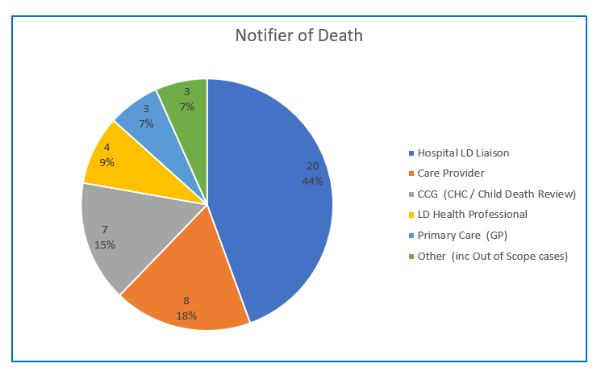

3.3 Completed Reviews
In 2021-22 52 reviews were completed by the LeDeR Team in Somerset. This number included 25 reviews which had been carried over from the previous financial year.

The highest proportion of deaths (44%) were in acute or community hospital settings which is in line with the trend nationally. Chart 3 details the breakdown of location of death.

Chart 3
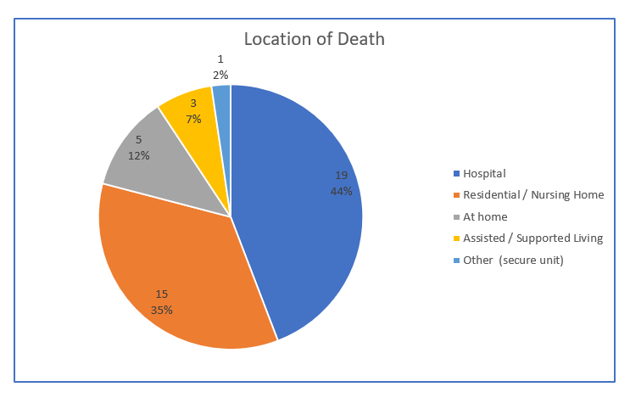

3.4 Key Performance Indicators.
NHSE set two key performance indicators for LeDeR teams:
- that all notifications will be allocated within three months of receipt, and
- all reviews will be completed within six months of notification.
Our performance against these two key performance indicators is set out in charts 4 and 5.

Chart 4
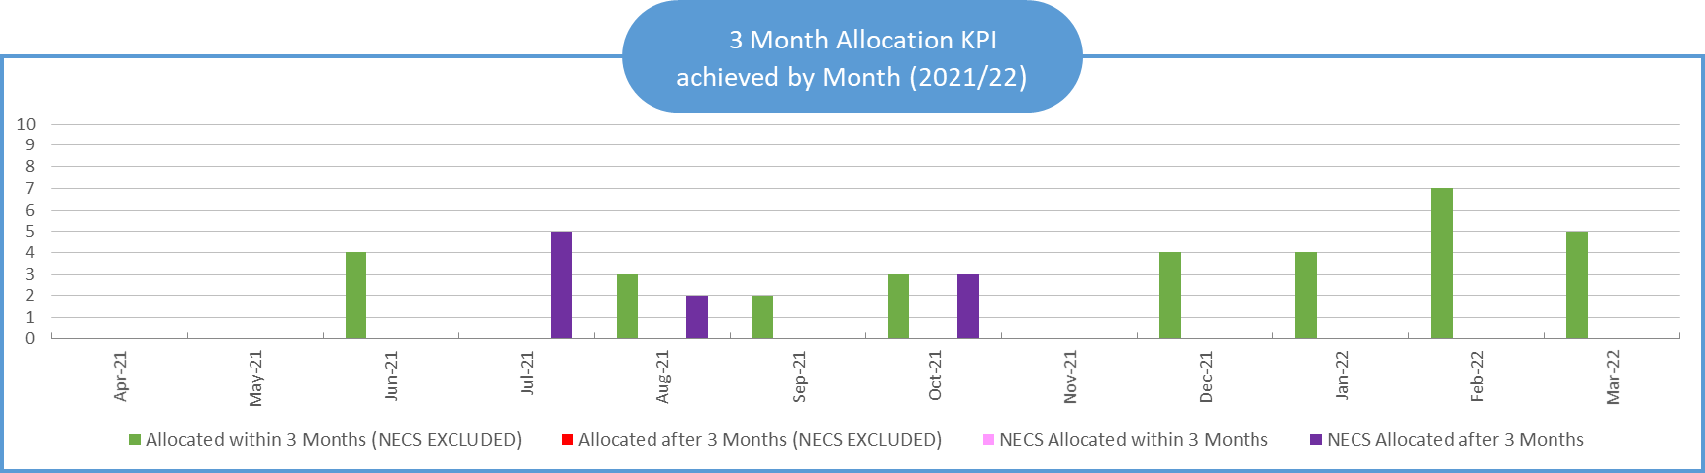

Chart 5
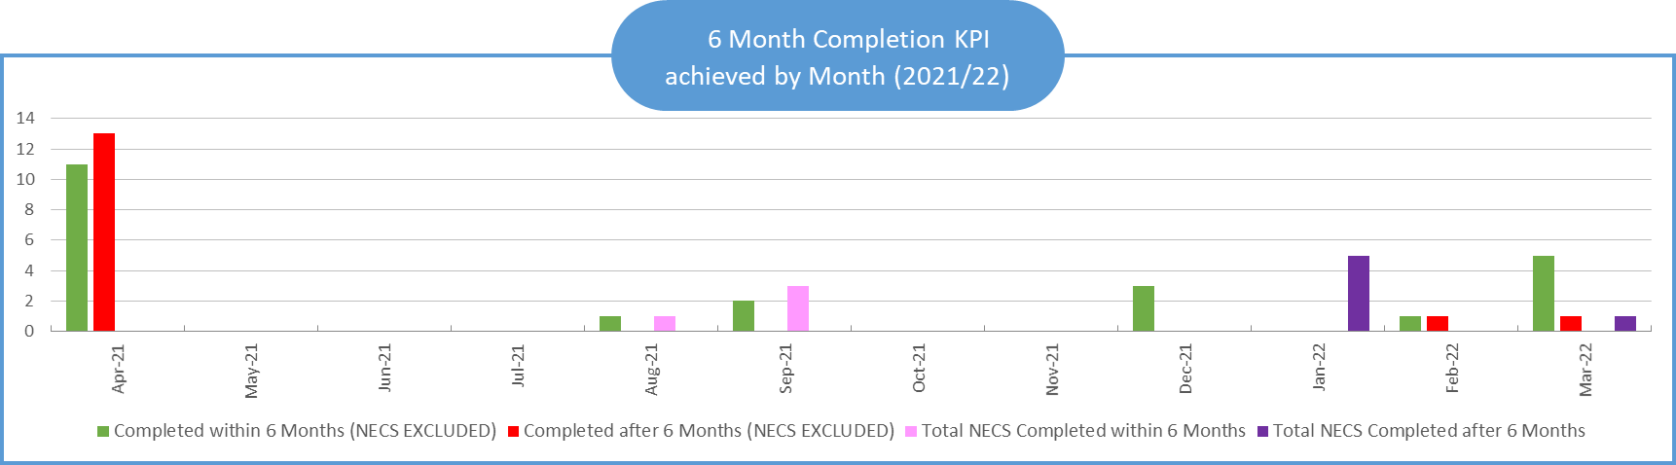

It should be noted that in early 2021-22 the North of England Commissioning Support Unit (NECS) were contracted by NHSE to support local teams with review completion. This was due to a delay following the University of Bristol online platform closing and the new NHS online platform being established which created a back-log of reviews during this period. Data in chart 4 and chart 5 is separated out so the impact of reviews being allocated to NECS is clear.

Additionally it should be noted that recruitment to the local Somerset LeDeR Team was not complete until part way through the reporting period, with recruitment to reviewer posts being finalised in the Summer of 2021 and the Local Area Contact being appointed in October 2021. Going forward barring any exceptions this should mean that completion within KPI is achieved even more regularly than in the current reporting period.

3.5 About the people who died

Gender
Over half of the people who died in 2021-22 were female. Comparator national data for 2021-22 is not yet available but LeDeR national data from 2018-2020 (LeDeR 2021*1) indicates that males accounted for 57% of deaths of people with a learning disability and females 43% with less than 1% recorded as ‘other’. The national data showed little variation across the three years.

Comparable data for the general population is due to be published on 1st July 2022 and so can’t be referred to in the current report. However national data from 2020 (ONS 2021 *2) indicated that unusually for the general population there were more male deaths than female deaths. This was the first reported occurance of this since 1981 and as the 2021 data is not yet available it is not possible to establish whether this will be a continuing trend.

Chart 6 shows that females accounted for 53% of deaths reported locally. This differs from the picture nationally. However due to the numbers involved (52) and the lack of comparable national data from the same reporting period it is difficult to draw too much from this information. We will continue to monitor this data via our local tracker and compare with national data once available.

Ethnicity
Chart 6 shows our ethnicity data for 2021-22. A majority of people who died were reported as being ‘White British’ (96%), with 2% reported as being ‘Mixed British’ and 2% ‘Jewish’.

According to the 2011 census (ONS 2012*2) 94.6% of Somerset residents are ‘White British’ and this is typical of what is reported in Somerset’s neighbouring Local Authorities although higher than the national average for England and Wales of 80.5%. This suggests that the local LeDeR data is broadly representative of the general population in Somerset. However it should be noted that the 2021 census results are yet to be released and further consideration of the 2021-22 data may be needed in the light of this.

The 2011 census data also indicated a large increase in Polish born residents and an increase in the Portuguese population in Somerset. Whilst we don’t have the 2021 census data yet it is clear that the population of Somerset is changing.

Additionally it should be noted that nationally LeDeR has identified a concern regarding the under reporting of deaths of people from minority ethnic backgrounds (LeDeR 2021 *1).

More work is needed to understand whether this is the case in Somerset, particularly with the changing nature of the local population. We are working with our Equality, Diversity and Inclusion Lead at the CCG to explore this, who is also part of the Governance Group and our named LeDeR representative for Equality, Diversity and Inclusion.

Chart 6

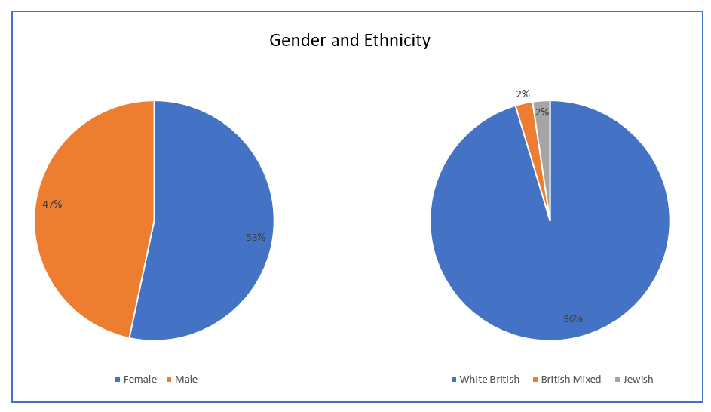

Age
The largest proportion of deaths were in the 56-65 age range, followed by the 66-75 category. The detailed breakdown can be found in chart 7. This fits with nationally reported data from 2018 and 2019 which indicates the median age of death for people with a learning disability notified to the LeDeR programme was 60.

Chart 7
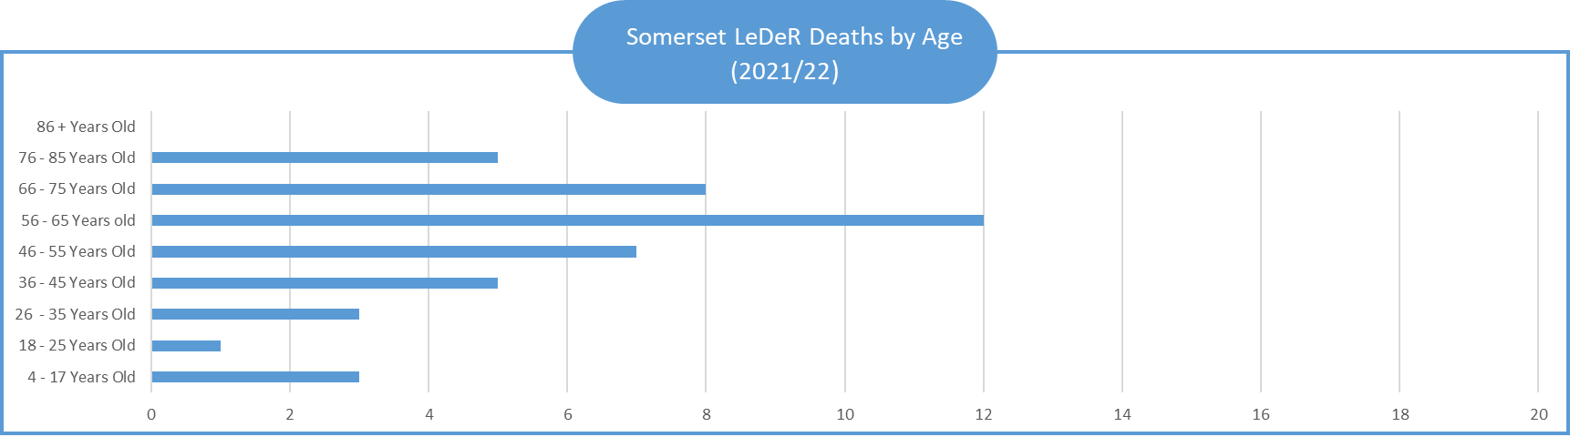

Where they lived
Usual place of residence is recorded, as nationally it is known to have an impact on certain inequalities and health outcomes. The most common place of residence in Somerset was own or family home, closely followed by residential home. The detailed breakdown can be found in chart 8.

Chart 8

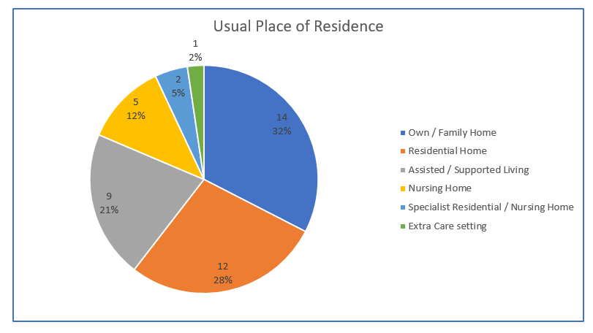

3.6 Cause of Death
Chart 9 details the main Cause of Death for each of the deaths we were notified of. This data is drawn from the Certificate of Cause of Death (MCCD). However some causes are grouped together into one overall category to enable ease of analysis as the numbers involved are so small e.g brain to include all references to brain, cerebral stroke, cerebral haemorrhage/infarction, cerebrovascular accident.

The definitions of each of these categories can be found in this document

In 2021-22 the most common cause of death related to the respiratory system. This included conditions such as bacterial and aspiration pneumonia, as well as other respiratory conditions.
This shows a similar prevalence to national data which in 2018 and 2019 showed that bacterial pneumonia followed by aspiration pneumonia were the most commonly cited cause of death in Part 1 of the Certificate of Cause of Death.

3.7 Learning from COVID-19
COVID-19-related deaths are not included within the respiriatory conditions category. In 2021-22 we were notified of two deaths where COVID-19 was mentioned on the MCCD; once as a conributing cause and once under ‘Other Conditions’. We were not notified of any deaths during the reporting period where COVID-19 was listed as the main cause of death. That is not to say that COVID-19 did not have an impact on the care that people received, with many appointments taking place remotely as per national guidance at the time, which may have had an impact on the care people received.

Chart 9

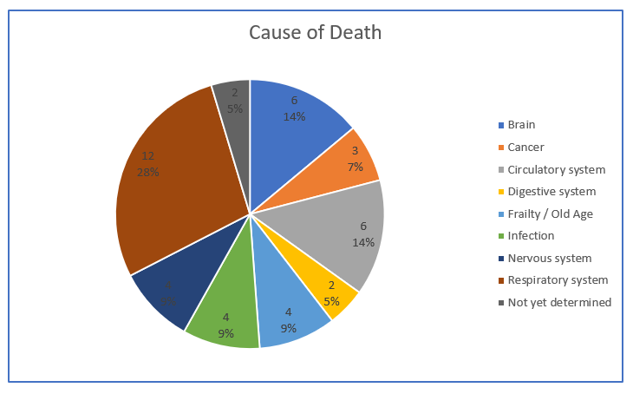

3.8 Reflections from Reviewers
As our team of reviewers has grown and become established in Somerset we have been keen to include regular peer supervision and opportunities for reflection so the reviewers can learn from each other and the diversity of reviews they have been carrying out. The following is a selection of comments from reviewers reflecting on their experiences of acting as LeDeR reviewers:

There can be a tendency when looking at a LeDeR review to focus on the last two years of life, the cause and circumstances surrounding the individual’s death and the support being provided. The Pen Portrait should be used as an important insight into the life of that individual, the care and support needed and provided and to gain a fuller idea of what that individual achieved. By focussing on the cause and circumstances of the death, the fullness of the life they had can at times seem to be lost.

When services have worked really well for an individual it feels satisfying and important to feed that back to them too – we know there are times when things aren’t as good as they should be but there are also situations where as a reviewer I can see people have really gone “above and beyond” to ensure the person they care for gets the support and end of life care they need or have asked for in their end of life care plan. The challenge is to make good practice like this the norm rather than the exception.

The support and love that is given by family members cannot be over emphasised. Many examples have been seen where the care, support and attitudes of the family have given individuals a full, inclusive and much-loved life. It is also important that those families that are struggling should be identified more quickly, and support structures put in place where required.
Why is it so difficult for people with a learning disability to access main stream services and have health treatments like everyone else in 2022?
It feels a real privilege to be a LeDeR reviewer and to have the time to talk and really listen to the people involved in caring for and loving the person who has died, whether that is paid carers or family carers or both.
- PEOPLE’S STORIES

At the heart of LeDeR are people, real people with real stories and we are uniquely privileged to be able to hear these stories and learn from them as we conduct LeDeR reviews. Spending time with family members and other people important to the person who died gives us a unique insight into that person and we are so grateful to all the people who have given their time to speak to us. Here are just a few examples of some of the stories we have had the privilege of sharing as a team. Names and other identifiable details have been changed to enable the stories to be shared anonymously.

4.1 Celebrating Good Practice

Dave’s Story
Dave was born in east London and lived there with his parents and older brother. In 1958, the family moved away from London as their father became Asthmatic and it was felt that the air would be better there.

When his father died, Dave and his mother moved in with his brother, his brother’s wife and their children and they lived very happily as one large family for many years.

Dave enjoyed writing and would always ask for pens and exercise books for Christmas and Birthdays. At one stage of his life each day he would get a copy of the local newspaper and copy out the television programmes for that day. He would only use the first line of the page before turning over!!

He loved anything to do with Bournemouth Football Club and was really happy when they were promoted. He enjoyed 60's music, especially Chas and Dave and had a significant knowledge about it. He liked motor racing, snooker and enjoyed playing ten pin bowling.

His religious beliefs were very important to him, he attended Church weekly and served at Mass. As his condition deteriorated and he was unable to attend Church, clergy visited weekly and took communion with him.

Following the death of his mother it was suggested that it may be a good time for Dave to gain some independence and to try out supported living.

When he was nearly fifty years old, he moved into a house with three other people. Dave was really very happy living there and remained living there until his poor mobility meant that he was unable to manage the stairs. He then moved into a residential home. He loved it there and it was good that he already knew some of the residents from previous activities he had joined in. He had been so excited on the day that he was due to move there, that he left all the doors open and unlocked when he went. This was not discovered until his brother returned home in the evening.

Dave had had a very full life and took a course at college and gained a certificate for a Diploma in Computer Studies which he was proud of. He had also in his younger days worked at a cafe, although he spent most of his time there leaning up against the counter chatting to people!

For one of his birthdays a huge surprise party at a local hotel to celebrate was arranged and over 50 people attended. Despite his poor mobility, he managed to enjoy his favourite music and there are lots of lovely photographs of the event.

Dave gradually became less mobile and following a hospital admission despite attempts to get him back to his home, he sadly required more specialist care than they were able to provide, and an alternative care provider was found.

He moved to live in a Care Home near his family for approximately the last two years. He had large patio doors in his room so he could have visitors see him from outside during the COVID-19 Pandemic.

His brother and his wife were with Dave when he died at the home. They sat with him, said prayers, prayed the Rosary and following that he sighed and then peacefully died.

4.2 Areas for Improvement

Both Susan’s and Lucy’s stories show clear areas where services could have worked together differently to improve outcomes and whilst there may not have been a direct impact on the cause of death, it can be argued that these circumstances diminished quality of life and wellbeing in the period leading up to death. That said, both these stories also highlight areas of good practice, such as meaningful involvement in end of life care planning, and those should be noted alongside the areas where improvements are clearly needed.

Susan’s Story
Susan was a 70 year old lady with a moderate learning disability who lived in a supported living setting. She communicated with signing, pointing and single words. Susan was able to make simple day to day decisions herself, however a Best Interests decision making process was required for more complex decisions concerning her health and wellbeing. Susan’s sister was involved with decision making. Susan disliked any physical interventions and sometimes did not wish to take her medication, receive personal care, or have basic observations carried out; blood tests were undertaken when she had a general anaesthetic for dental work. Annual Health Checks were very limited as a result. Susan took time to get to know people and build up trust, any change was extremely stressful for Susan and was reflected in the behaviours she displayed. Some desensitisation methods had been tried in the past few years, however these had little effect.

Susan became very unwell and although her care provider and her social worker were pressing for a Best Interests meeting and a behaviour support plan if she should require hospital admission, this did not happen.

Discussions were held led by the GP and a multi-disciplinary meeting, but no decision was reached. As it was Susan was admitted in an emergency, this was distressing for her, however she was very unwell at this time. After a few weeks in an acute hospital she was transferred to a community hospital for rehabilitation. Again, no agreed process/plan was in place to facilitate this transfer, on this occasion she experienced a degree of restraint from six people to transport her by ambulance. Her carers who knew her well had not been informed of the transfer. Initially the community hospital had not received sufficient information to enable them to understand Susan’s needs; this was resolved; however it took time for her to build trust with staff.

Susan’s story became more complicated as to return home required staff to be trained in administering insulin via injection following new diagnosis of Type 1 diabetes and there was not a clear commissioning pathway to facilitate this. Unfortunately Susan died of septicaemia about a month later due to complications of her leg ulcers not healing.

Lucy’s Story
Lucy was a 64 year old female who lived in Supported Living Accommodation. Prior to that she lived in the family home with her parents who she was very close to.

Lucy had a hysterectomy in 2012 due to cancer. Her cancer reoccurred in 2014 which was managed surgically but there was a further recurrence in 2015. Lucy found treatment hard to tolerate and it was agreed with her and her family that further occurrences would be managed pragmatically with some hormone treatment but no further intervention. Lucy was supported really well by her Mum and then her brother to make decisions relating to her own health and health care.

Lucy presented in primary care with a painful stomach in April 2020 however due to COVID-19 restrictions in place at the time she was not seen in person till November 2021. At this appointment the GP felt her stomach and discovered a mass. Previous decisions made by Lucy and her family meant that no further medical intervention was appropriate. However, the delay in being seen in person may have led to a delay in accessing support from the Palliative Care Team and/or impacted on her overall wellbeing. Lucy was referred to the Palliative Care Team in March 2021. Lucy’s Cause of Death was Metastatic Endometrial Carcinoma and Lucy died in her home which is what she had requested and was documented in her Treatment Escalation Plan

- LEARNING INTO ACTION

5.1 Themes from 2021-22 Reviews

An essential focus of the LeDeR programme is on improvement and learning into action. To facilitate this the new LeDeR system created 10 core themes which are applied to all Focused Reviews as part of the review template. In Somerset we have extended this to cover the SMART actions (Specific, Measurable, Achievable, Relevant, Timely) from Initial Reviews to create uniformity and assist in identifying patterns where improvements can be made. This also allows us to triangulate our SMART actions with themes coming out of other review processes such as Serious Incidents and Safeguarding Section 42 Enquiries.

The core themes are:
- Learning Disability awareness
- DNACPR recommendations and End of Life care
- Deterioration
- Care pathways
- Involving the Coroner
- Family and carer awareness of available support
- Transition
- Safeguarding
- Training for specific conditions
- Professional practice and provision of care

Additionally we have added some locally identified themes to highlight common situations identified within reviews in Somerset. These are:
- Commissioning
- Health Passports
- Impact of COVID-19.

Chart 10 illustrates the most commonly occurring themes emerging from reviews in 2021-22. Analysing the themes across all LeDeR reviews carried out within the new system provides an overview in addition to specific actions for individual reviews which are being taken forward locally. Using the above core themes as well as our locally identified ones; the biggest proportion of reviews had issues falling under the categories: ‘Professional practice and provision of care’; ‘Care pathways’ and ‘Impact of COVID-19’.

Chart 10

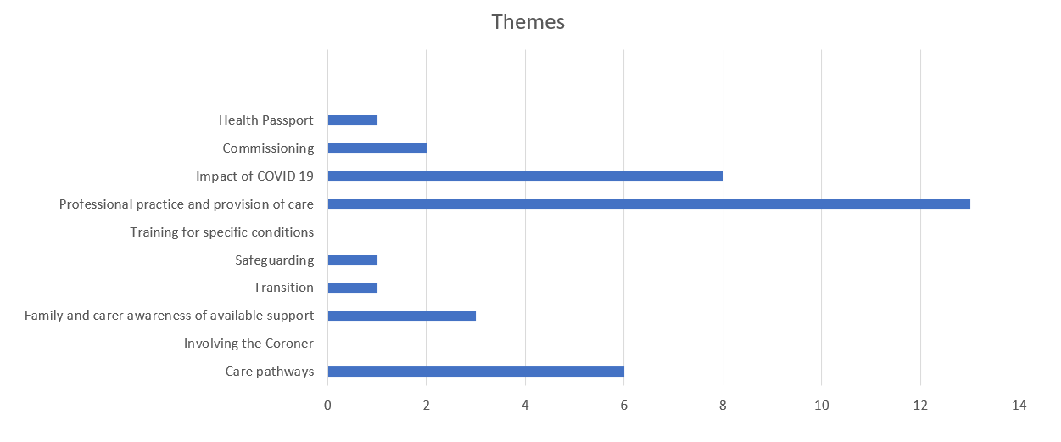

Professional practice and provision of care
A number of different learning areas are encapsulated within this theme. This ranged from a lack of understanding and misapplication of the Mental Capacity Act to services not understanding the need to provide reasonable adjustments (such as the use of health passports in acute care), to recording issues which led to patients not being identified on the LD register when they moved into the area. Susan’s story provides an example of where the Mental Capacity Act was not appropriately followed. Whilst there were some examples of positive practice within her care, the lack of involvement of people who knew Susan well ultimately led to a very distressing hospital transfer with a level of restraint that could have been avoided.

Care pathways
A common thread within the care pathway theme was that of communication between services. People with learning disabilities and autistic people often have involvement from multiple services, from within health, social care and education and there were a number of incidents where communication between services, particularly different elements of health care provision was poor, resulting in delays to treatment provided. Gaps in knowledge of appropriate referral routes resulted in individual’s not receiving timely specialist learning disability support and discharge summaries lacked key information leading to delays in onward referrals as Primary Care were not fully aware of what investigations had already been carried out.

Additionally the high proportions of deaths due to respiratory issues, particularly pneumonia, has highlighted the need for robust multi-agency care pathways and also the need for existing commissioning arrangements to be reviewed locally.
Impact of COVID-19
Cutting across many of the reviews the impact of COVID-19 is acknowledged due to its impact on the way care and support within health and social care had to be provided during periods of restriction. Lucy’s story gives a powerful illustration of the potential impact non face to face appointments could have on someone’s health and wellbeing. Lucy experienced a significant delay before she was seen face to face and it is possible that the identification of the reoccurrence of her cancer was delayed due to this. Whilst this didn’t change her treatment plan or the eventual outcome, due to her choice not to have further invasive treatment, it may well have had an impact on her overall wellbeing due to the delay in involving the Palliative Care Team.

  - Update on Learning into Action

Somerset Strategic Vision

The three year strategic vision for Somerset (in line with the NHS Long Term Plan) and as detailed in our 2020/21 annual report remains focused on supporting people with learning disabilities and / or autism to look after their health and lead healthier lives. We see the LeDeR programme as a key enabler in continuing to shape our emergent strategy and to inform local commissioning, planning, learning and continuous improvement; it is not a standalone process and aligns closely with the principles set out in the wider Somerset Learning Disabilities commissioning three year road map.

Our strategic aims will help ensure people receive timely and appropriate health checks and have better access to health services whilst improving the level of awareness and understanding across the NHS and wider stakeholders of how we can best support each individual in a person-centred way.
We want people with learning disabilities and / or autistic people to be able to say that:

- I will have a fulfilling life as a Somerset citizen, including having equal opportunities and choice of where to work, study, enjoy leisure and social activities as well as have meaningful relationships and friendships.
- I will be able to have and / or remain in my own home.
- I will have access to good quality mainstream services when needed.
- I will have timely access to good quality and safe specialist services as close to home as possible.
- I will have access to specialist bed provision when needed and this would be for the shortest possible time required.

Our ambition in delivering on these key priorities will mean that more people with learning disabilities and / or autism who live in Somerset are able to live their lives in the way that they choose.

Learning into Action Priorities
We have been refining our Learning into Action Improvement Priorities for 2021 - 2024 in light of reviewing the themes emerging from our most recent reviews and also by working alongside colleagues in the CCG to identify areas of overlap where we can work together to improve outcomes across the system. Whilst the core priorities remain the same the way we are operationalising this has changed and the LeDeR Three Year Strategy is being updated to reflect this. We have also identified an additional priority relating to Meaningful Engagement as we recognise this is an area we can improve upon in Somerset.

The Learning into Action Improvement Priorities are as follows:

- Improvement Priority 1: The Annual Health Check (AHC) Programme
Aim 1: Increase the uptake of annual health checks in Somerset.
Aim 2: Improve the quality of annual health checks in Somerset.

- Improvement Priority 2: Mental Capacity Act (MCA)
Aim: To promote positive practice in relation to the Mental Capacity Act and its application in health and health care of people with a learning disability and autistic people.

- Improvement Priority 3: Effective Joint Commissioning
Aim: To develop a joint health and social care approach to commissioning and quality contract management that supports holistic care to individuals. This will support effective management of a range of health and care needs in any setting such as epilepsy, dementia, mental health, and reduce the potential need to move an individual from the place and care givers who are familiar to them.

- Improvement Priority 4: Meaningful Engagement of people with learning disabilities and autistic people
Aim: To build on the existing good engagement work that has taken place in relation to the LeDeR programme and wider Learning Disability and Autism workstreams in Somerset. We want people with learning disabilities and autistic people to be meaningfully engaged with and involved with all elements of the LeDeR programme, including our Governance processes.

What we have done in 2021-22 and what we plan to do in the future
We are very proud of the work that we have done to begin to take forward our Improvement Priorities and are excited to share what we have planned for the future.

General Improvements

Annual Health Checks
There has been a substantial amount of work related to Improvement Priority 1 culminating in 77% of those in Somerset on the Learning Disability Register receiving an Annual Health Check (AHC) in 2021-22. The full details of all the work carried out to support this outcome can be found in the Project Achievements and Future Scope document.

The following is a summary celebrating key achievements to date:

The full copy of the AHC Principles of Expectation document can be found here

We recognise that there is more we can do to improve the quality of LD AHCs in Somerset and also to ensure that everyone who is entitled to a check is receiving one. As such we are planning the following:
- Pilot of a Primary Care Liaison Role with a focus on register validation and support of the AHC process.
- Identifying pilot sites for AHC for Autistic people as and when these come online.
- Continuing to maintain forums for collaborative working around AHC across the Integrated Care System.
- Developing a network of Learning Disability Champions across our practices in Somerset.

Mental Capacity Act
A lack of knowledge of and misapplication of the Mental Capacity Act is a theme that runs through a significant number of reviews. In the last year we have carried out work to being to identify in more detail where those gaps are and to look at the best way we can have influence across the system to improve this going forward. 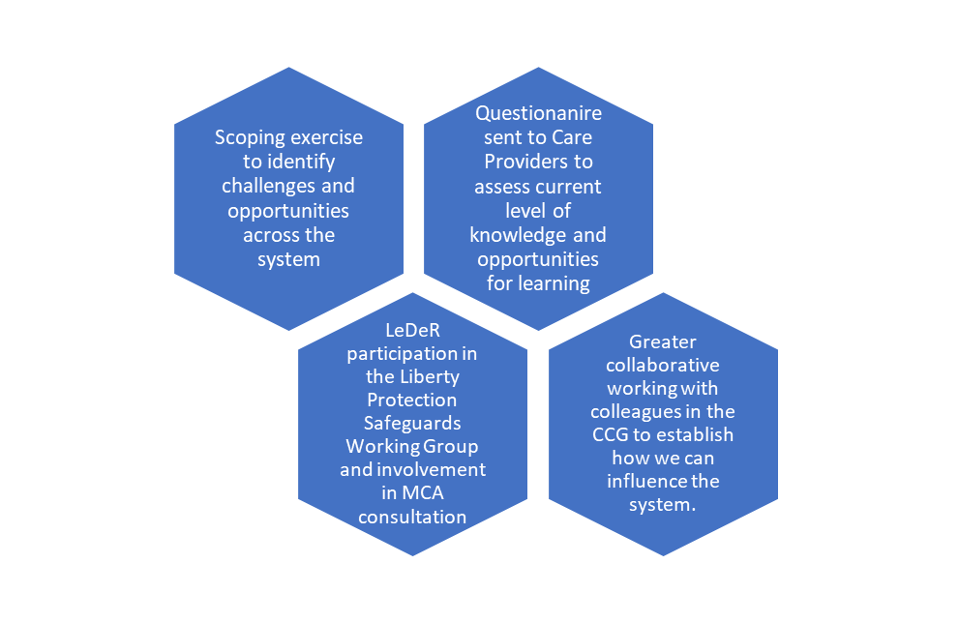

LeDeR is part of a system wide Task and Finish Group which is hoping to develop a single Mental Capacity Act competency framework and training offer for use in Somerset. We are working with colleagues to bring together existing work and pilot a consistent approach with a number of providers which will be reviewed using a Quality Improvement Methodology.

Effective Joint Commissioning
Holistic person-centred commissioning is a key part of Somerset’s strategic approach, and where there are gaps in commissioning or perhaps things aren’t approached in the best way, as sometimes evidenced in LeDeR reviews, we are keen to learn from this so the system can produce better outcomes for people going forward. The following is a summary of work LeDer has participated in regarding this work stream. 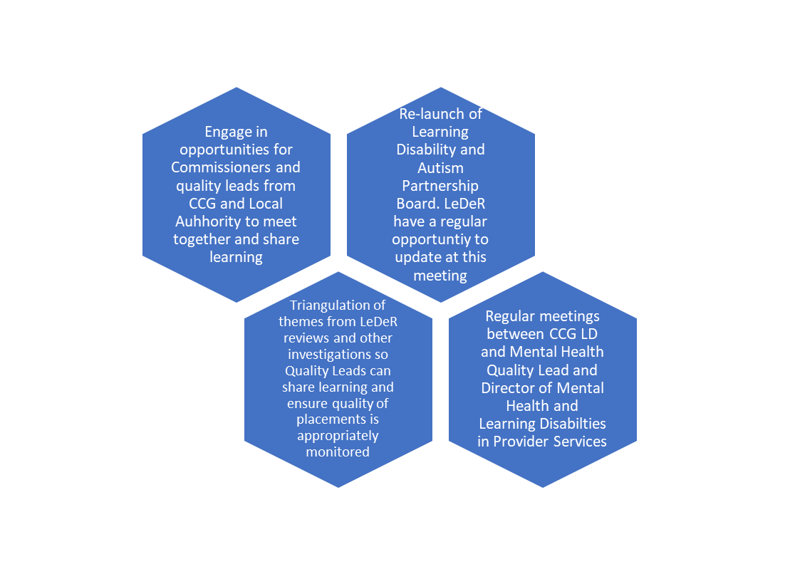
We recognise there is further work to do here and as themes emerge from LeDeR reviews we will continue to progress work in this area via the LeDeR Governance Group. Some examples of current work planned include:

- System wide Task and Finish Group to look at emergency funding for those being discharged from hospital.
- Piece of work looking at Accident and Emergency discharge information and communication between services.
- System wide review of commissioning arrangements for Respiratory Physiotherapy in the community and the need for a multi-agency care pathway for secretion management.

Meaningful Engagement of people with learning disabilities and autistic people
We are proud of how we have engaged with people with learning disabilities and autistic people to take forward areas of work and to understand the impact of the LeDeR programme. However, we are keen to take a more strategic approach in how we do this and are conscious that our new Governance Process in particular does not currently involve sufficient people with learning disabilities and autism.

The following is a summary of the work carried out in the last year and the exciting project plans we have for the future.

During the last year, we have actioned our commitment to develop relevant and effective relationships with people who have learning disabilities and autistic people. We developed two project proposals which went out for expressions of interest. The first proposal was to support us in developing a meaningful engagement strategy, in particular looking at how we can engage with a wide range of people and facilitate engagement in our Governance processes.

The second proposal was for a film-based engagement project working with people with learning disabilities and autistic people to explore the work of LeDeR and facilitate conversations about death and dying.

OpenStoryTellers
In the coming year we will be working with OpenStoryTellers to explore how people would like to be involved, informed or included in our work. OpenStoryTellers is a community arts organisation founded by and for people with a learning disability.

Their vision is to help people find their voice and then provide opportunities to get that voice heard. They have made this short film specially to introduce themselves and their work to the Somerset LeDeR programme. This is Ben’s story. The film can be viewed here https://vimeo.com/718485025

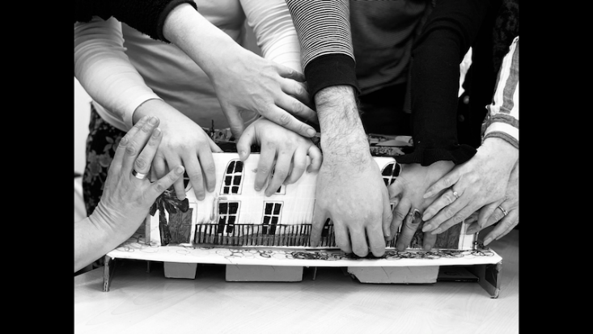

Simon Blakeman, on behalf of OpenStoryTellers, explains what the Memory People project is and why it is such a good way of illustrating the OpenStoryTellers approach. We are excited to work with OpenStoryTellers to create meaningful engagement and inclusion in the LeDeR Programme.

Memory People is an ongoing project at Openstorytellers.

The work involves people pathfinding ways to explore memories and memorialise them through arts and objects. Some memories are individual and some are shared; some memories are about people who have been lost, either through death or dementia; some memories are about sunny days out at the beach; we always find ways to adapt our way of working to fit.

Someone will bring a memory of their own, and the group will work on making something for that person.

While they are working on it, other people remember things too, that they had not thought about for a while. The group may then centre something new around them, and so it goes on...

In the case of the Memory Dragon, we made something which embodies the person’s qualities of joyfulness and community. What was particularly interesting was that in the making of it, people were brought together. The positive influences of Dan’s grandma were felt here in the workshop as the dragon slowly came to life.

Biggerhouse Film

We are also excited to be working with Biggerhouse Film on a media project exploring themes relevant to LeDeR. Through our LeDeR reviews we have become aware that conversations about death and dying often don’t happen when they should and are something that people with learning disabilities in particular are protected on. We want to understand more of how people with learning disabilities and autistic people view death and dying and we are looking forward to working with Biggerhouse to engage with people on these issues.

Biggerhouse Film work with people with learning disabilities and autistic people to make award winning dramas, documentaries and animations. Biggerhouse make films ‘with’ people not ‘about’ them and believe this way of working empowers not only the participants but also has greater impact for the intended audience.

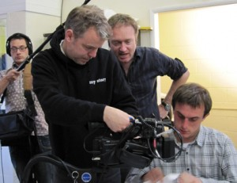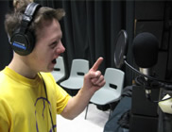

We are looking forward to working with Biggerhouse over the next year to engage with people with learning disabilities and autistic people to promote inclusion within the LeDeR programme and to encourage important conversations about death and dying.

CONCLUSIONS

2021-22 has been a significant time of growth for the LeDeR team in Somerset. We have learnt a lot and refined and developed our processes accordingly as we have got used to working with the new national systems launched in 2020-21.

We have seen examples of good practice but also sadly many examples of poor practice which have resulted in poor outcomes for people with a learning disability and autistic people. The LeDeR Team and the wider CCG are committed to improving outcomes for people with a learning disability and autistic people and we intend to continue working with our system partners to ensure this happens in practice.

We are entering a time of significant transition across organisations and whilst this brings with it some challenges, it also provides significant opportunity for learning into action to be embedded across the system. Working alongside people with learning disabilities and autistic people we are committed to continue to raise the profile of LeDeR and its associated work streams to effect change and improve outcomes for people.

References

- Learning Disabilities Mortality Review (LeDeR) Programme Annual report 2020. University of Bristol 2021. Accessed online LeDeR-bristol-annual-report-2020.pdf (england.nhs.uk)
- Deaths registered in England and Wales:2020 Office for National Statistics 2021. Accessed online Deaths registered in England and Wales - Office for National Statistics (ons.gov.uk)
- Census 2011. Office for National Statistics 2012. Accessed online. http://www.ons.gov.uk/ons/guide-method/census/2011/index.html

Appendix 1 Easy Read Report Summary

Easy Read Report

Learning from the Lives and Deaths of People with Learning Disabilities and Autistic People in Somerset, 2021.

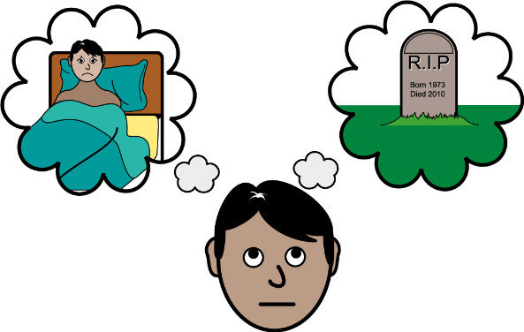
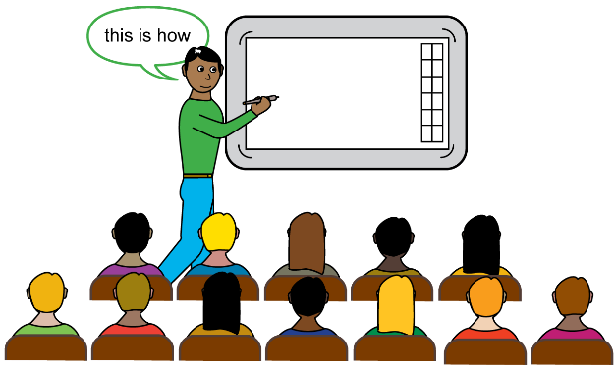

Symbols used in this document Copyright Leeds and York Partnership 2022
Index

1 | 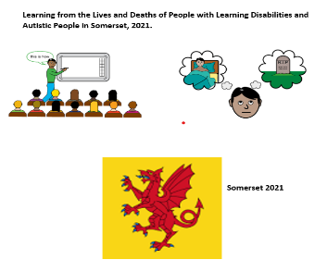  Introduction
2 | Learning from deaths
3 | 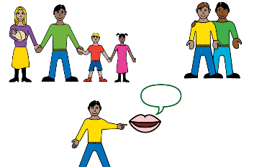  Real people’s stories
4 | What could be better?
5 | What we are doing to make things better
6 | 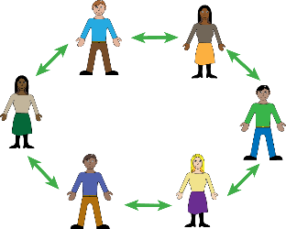  Working with people with learning disabilities and autistic people
- Introduction

- We know people with learning disabilities die younger than other people.

- We want to make changes to our services to improve care for people with learning disabilities.

- In Somerset we carried out reviews of everyone with a learning disability who died between April 2021 and March 2022.

- This helps us understand why people are dying and what we need to do to improve our services.

- We want to work with people with learning disabilities to make things better.

- The NHS calls this the LeDeR programme.

- From February 2022 the LeDeR programme also includes autistic people.

- Learning from deaths

We completed 52 reviews.

We found:

- A lot of people died in hospital.

- Slightly more women died than men.

- Most people were over 55 years old.

- A lot of people died from problems with their breathing.

- People also died from problems with their heart, their brain and infection.

- COVID-19 did not cause any deaths but in some cases it did make a difference to the person’s end of life.

- Real people’s stories

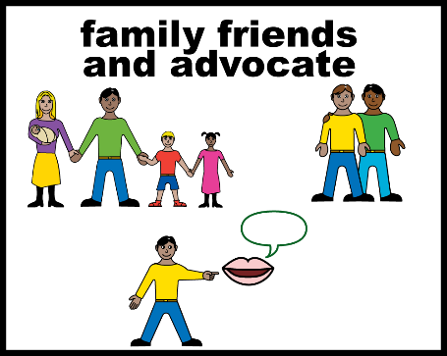 | - The LeDeR programme is about improving people’s lives.  - We are very grateful to all parents, friends and family as well as carers for talking to us about their loved one’s lives.  - Some people’s stories really show when care is good.  - Unfortunately sometimes the care a person gets is not as good as it should be.

- What could be better?

We found

- People often get their support from lots of different teams and services. Sometimes those services do not talk to each other or work well together.

- Sometimes important decisions were made without the right people being properly involved.

- Lots of people are having annual health checks at the GP. Some are very good and helpful but many are not as good as we would like.

- During COVID-19 a lot of people could not go to see the GP. Carers spoke to the GP on the phone instead. This might have affected the person’s care.

- Some health staff did not know how to get help from the learning disability specialist health team when the person needed it.

- What we are doing to make things better

- We are working on 3 main things:

- Doing more work with health staff to make sure the right people are having an Annual Health Check.

- We want to be sure the check is thorough for each person.

- Offering training to health and care staff so they always know how to support people in the best way with making decisions about their health.

- Different parts of the NHS are working together to agree on the best ways to pay for a person’s care. This will help everyone have the right support, in the right place, and at the time when they need it most.

- Working more closely with people with learning disabilities and autistic people.

- Working with people with learning disabilities and autistic people

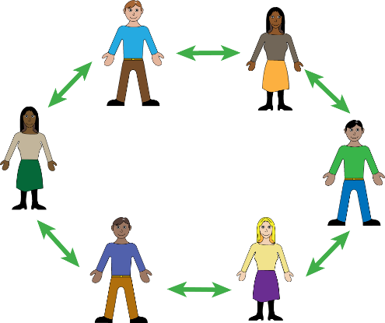 | - We want people with learning disabilities and autistic people to be more involved.  - We are excited to be working with OpenStoryTellers to find out how people with learning disabilities want to be involved with our work.  - This is a short video about the work of Open Storytellers. It is Dan’s story  https://vimeo.com/718485025  - We are also working with Biggerhouse Film to see if people want support to talk about end of life and dying.  - We know there is a lot more we need to do but these projects are an exciting start!

