REPORT TO: |  | NHS SOMERSET INTEGRATED CARE BOARD  Choose an item. | ENCLOSURE:
 |  |  | Enter Enc No
DATE OF MEETING: |  | 2 October 2024
REPORT TITLE: |  | ICB Children Looked After and Care Leavers Annual Report
REPORT AUTHOR: |  | Emma Clothier, Designated Nurse for CLA and Care Leavers
EXECUTIVE SPONSOR: |  | Shelagh Meldrum, Chief Nursing Officer and Director of Operations
PRESENTED BY: |  | Sarah Ashe, Associate Director of Safeguarding, Mental Health, Learning Disability and Autism
PURPOSE | DESCRIPTION |  |  | SELECT
Approve | To formally receive a report and approve its recommendations, (authorising body/committee for the final decision) |  |  | ☐
Endorse | To support the recommendation (not the authorising body/committee for the final decision) |  |  | ☐
Discuss | To discuss, in depth, a report noting its implications |  |  | ☐
Note | To note, without the need for discussion |  |  | ☒
Assurance | To assure the Board/Committee that systems and processes are in place, or to advise of a gap along with mitigations |  |  | ☐
LINKS TO STRATEGIC OBJECTIVES
(Please select any which are impacted on / relevant to this paper)
☐ Objective 1: Improve the health and wellbeing of the population
☐ Objective 2: Reduce inequalities
☐ Objective 3: Provide the best care and support to children and adults
☐ Objective 4: Strengthen care and support in local communities
☐ Objective 5: Respond well to complex needs
☐ Objective 6: Enable broader social and economic development
☐ Objective 7: Enhance productivity and value for money
PREVIOUS CONSIDERATION / ENGAGEMENT
Meeting statutory Children Looked After and Care Leavers requirements is a shared responsibility. The Designated Professionals for Children Looked After and Care Leavers work closely with ICS/ICB colleagues, the services commissioned by the ICB and all key partners of the Somerset Corporate Parenting Board to ensure these are met.

REPORT TO COMMITTEE / BOARD
Annual report on the work of the Designated Professionals for Children Looked After and Care Leavers in the ICB
- Details the arrangements in place for Children Looked After and Care Leavers in the NHS Somerset Integrated Care System (ICS), and the services commissioned by NHS Somerset (ICB).
- Sets out the context for Children Looked After and Care Leavers arrangements in the Somerset ICS/ICB.
- Demonstrates how the ICS/ICB is fulfilling the statutory Children Looked After and Care Leavers responsibilities.
- Reports on governance and accountability arrangements within the ICS/ICB, and the ICS/ICB role in the Somerset Corporate Parenting Board and the Health and Wellbeing subgroup.
- Highlights achievements and identifies current Children Looked After and Care Leavers risks in provision within health services.
- Identifies the ICBs 2024/2025 Children Looked After and Care Leavers objectives.
- Provides assurance that the Children Looked After and Care Leavers 2023/2024 objectives were completed.
The Somerset Designated Professionals for Children Looked After and Care Leavers will continue to work collaboratively at a local, regional, and national level to improve the quality of, and strengthen, Children Looked After and Care Leavers arrangements, where necessary mitigating organisational and partnership risk.
IMPACT ASSESSMENTS – KEY ISSUES IDENTIFIED
(please enter ‘N/A’ where not applicable)

Reducing Inequalities/Equality & Diversity | Commissioning and delivery of high quality and accessible statutory health services to meet the needs of Children Looked After and Care Leavers will ensure this cohort will not be disadvantaged in comparison with their peers who do not experience the same vulnerabilities
Quality | This report reflects on the quality and impact of practice Children Looked After and Care Leavers
Safeguarding | Statutory Children Looked After and Care Leavers responsibilities of the ICS/ICB and the services it commissions are considered throughout this report.
Financial/Resource/  Value for Money | Resources required to implement and support statutory Children Looked After and Care Leavers requirements are in place.
Sustainability | Working with all our partners in the local, regional and national system, the Designated Professionals for Children Looked After and Care Leavers aim to deliver a sustainable and effective healthcare system for Looked After Children in Somerset.

Governance/Legal/  Privacy | The provision of statutory Children Looked After and Care Leaver requirements are governed by the following legislation and statutory guidance:  - Children Act 1989  - Children Act 2004  - The Children and Families Act 2014  - The Children and Social Work Act 2017  - Data Protection Act (2018)  - Children (Leaving Care) Act 2000  - Adoption and Children Act 2002  - Working Together to Safeguard Children 2023  - Promoting the Health and Wellbeing of Looked After Children 2015  - Intercollegiate Document: Looked After Children: roles and competences of health care staff, (RCPCH) 2020
Confidentiality | Information sharing processes are already established; there are no breaches of privacy are expected.
Risk Description | Risk 318 - Children looked after health services not being delivered within statutory time frames – Score 12  Risk 547 – Risk of poor dental access for CLA and Care Leavers – Score 12  Risk 567 – Risk that UASC and Care Leavers may not have their health needs met due to lack of services as number of children/young people increasing- Score 8  Risk 576 - Risk of IG breaches in relation to adoption – Score 12  Risk 606 – Risk that Somerset Council Public Health Nurses may give notice on completion of statutory health assessments – Score 4




CHILDREN LOOKED AFTER and Care Leavers ANNUAL REPORT
2023/2024

September 2024
CHILDREN LOOKED AFTER AND CARE LEAVERS
ANNUAL REPORT 2023/2024

CONTENTS

Section |  | Page
SECTION 1 | foreward | 1
SECTION 2 | statement of intent | 1
SECTION 3 | statutory responsibilities | 2
SECTION 4 | purpose of the report | 2
SECTION 5 | children looked after (CLA) and care leavers characterists and context | 3
SECTION 6 | governance and statutory arrangments | 8
SECTION 7 | somerset corporate parenting board | 9
SECTION 8 | monitoring activity and performance of somerset providers | 12
SECTION 9 | regulatory irregularies in adoption | 17
SECTION 10 | risks and areas of challenge | 18
SECTION 11 | progress against objectives 2023/24 | 19
SECTION 12 | objectives for 2023/24 | 20
SECTION 13 | conclusion | 21

Author | Emma Clothier
Developed in conjunction with | Dr Carol Smith
Roles | Designated Professionals for Children Looked After and Care Leavers
Sponsor | Shelagh Meldrum
Role | Chief Nursing Officer
Date | September 2024

CHILDREN LOOKED AFTER and Care Leavers
ANNUAL REPORT 2023/2024

- FOREWORD

1.1 This is the second NHS Somerset Integrated Care Board, (hereafter known as ICB), Annual Report for Children Looked After and Care Leavers), covering April 2023 – March 2024. This is a public report which sets out the work of the ICB in relation to Children Looked After, (CLA), and Care Leavers (CL), as lead commissioner for healthcare services within Somerset and as a member of the Somerset Corporate Parenting Board. The report forms part of Somerset ICBs’ assurance arrangements, in relation to Children Looked After, Care Leavers and wider Safeguarding Children arrangements.

1.2 Under the Children Act 1989, a child is Looked After by a Local Authority if he or she falls into one of the following:

- is provided with accommodation, for a continuous period of more than 24 hours (Children Act 1989, Sections 20 and 21)is subject to a care order (Children Act 1989, Part IV), or
- is subject to a placement order

1.3 Wherever possible, the Local Authority, Somerset Council will work in partnership with parents to ensure children and young people who become CLA retain strong links with their families and many eventually return home. A child will cease being Looked After by the Local Authority when they are adopted, return home or reach the age of 18 years.

1.4 Care Leavers are those children and young people who have previously been Looked After by the Local Authority and are now being supported to live independently. Following the publication of the Children and Social Care Act, (2017), Local Authority responsibility for Care Leavers changed from 18 to 21 years to an age range of 18 to 25 years, enabling Care Leavers to request support up to the age of 25, regardless of whether they are in education.

2 STATEMENT OF INTENT

2.1 NHS Somerset Integrated Care Board, and our system partners are committed to improving health outcomes for Children Looked After and Care Leavers, and we will do this by ensuring we commission and provide high-quality, responsive services. To achieve this NHS Somerset ICB will continue to work closely with its Provider, (Somerset NHS Foundation Trust), Somerset Council, NHS England, service users, and other key partners to ensure Children Looked After and Care Leavers have timely access to high-quality health care, as and when they need it. We will ensure robust management of action plans to improve performance and outcomes and are actively working with our partners to ensure service redesign is effective at improving performance and outcomes.
3 STATUTORY RESPONSIBILITIES

3.1 NHS Somerset ICB is the Responsible Commissioner for health services provided to Somerset Children Looked After whether they are resident within Somerset or outside. The ICB endeavours to meet the health needs of Children Looked After and Care Leavers as illustrated in the Statutory Guidance Promoting the health and well-being of looked-after children, (DoH, DfE, 2015).

3.2 A vigorous and robust system of quality assurance and performance monitoring has been developed with health and social care partners to ensure that a seamless service is delivered. This function is embedded within the main roles and workstreams of the ICB’s commissioned Designated Doctor and Nurse for Children Looked After, (hereafter known as CLA), and Care Leavers. The ICB maintains its statutory duty to cooperate with Local Authorities to ensure health assessments are undertaken and support and services are provided to CLA without undue delay.

3.3 ICBs must ensure that any changes in healthcare provider due to CLA placement move do not disrupt the objective of providing high quality, timely healthcare to the child.

3.4 ICBs must ensure that plans are in place to enable children leaving care continue to obtain the healthcare they need.

3.5 NHS Somerset ICB gains assurance that its healthcare services to CLA meet the standards laid down in the Statutory Guidance by ensuring that high quality Statutory Initial and Review Health Assessments and associated Health Care Plans and Health Leaving Care Summaries are delivered to CLA and Care Leavers in a timely way. Similarly robust key performance indicator monitoring of CLA access to dental services and immunisation rates and completed Strengths and Difficulties Questionnaires, (SDQs), provide assurance that CLA health needs are identified and met.

3.6 The ICB also has a statutory role and functions for fostering and adoption as defined in the Children Act 1989, Guidance and Regulations Volume 4 Fostering Services, the Care Standards Act 2000, and the Adoption and Children Act 2002.

4 PURPOSE OF THE REPORT

4.1 This annual report covers the period 1st April 2023 to 31st March 2024.

4.2 The report will inform the NHS Somerset ICB Board of the arrangements in place for all children who are in the care of Somerset Council, (589 on 31st March 2024 compared to 552 on 31st March 2023) or are Somerset Care Leavers, (332 on 31st March 2023 compared with 370 on 31st March 2024).

4.3 This report is an updated overview and summary of the previous CCG Annual Report and will:

- update the context for CLA and Care Leavers in Somerset
- provide an overview of the arrangements in place to provide health services to CLA and Care Leavers in Somerset
- demonstrate how Somerset ICB is fulfilling its CLA and Care Leaver statutory responsibilities
- report on governance and accountability arrangements within the ICB, and the ICB role in the Corporate Parenting Board and sub-groups
- highlight achievements and identify current risks in provision of health services to CLA and Care Leavers
- provide assurance that the CLA and Care Leaver 2023/2024 objectives were completed
- identify the ICB’s 2024/2025 CLA and Care Leaver objectives

5 CHILDREN LOOKED AFTER AND CARE LEAVERS CHARACTERISTICS AND CONTEXT

5.1 Characteristics

5.1.1 During 2023/2024 there has been little change in the characteristics of Somerset children who become looked after. The reason most children and young people become looked after in Somerset is because they are victims of abuse or neglect.

5.1.2 During 2023/2024 Somerset initially saw a steady increase in the number of children becoming looked after which gradually increased again towards the end of the period as per Table 1 below. There was a slight peak in children becoming looked after in the winter of 2023, prior to the school holidays. Somerset Council are unable to explain the reason for this being the case, although several large sibling groups became CLA in that period.

Table 1: Number of Somerset Looked After Children 2023/2024

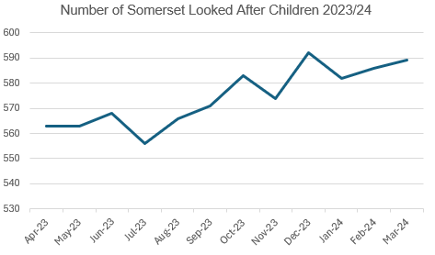

5.1.3 This data corresponds with the national trend whereby the number of children who are looked after has increased every year since 2008. For example, on 31 March 2023 the number of Children Looked After in England increased to 83,840, from 82,170 on 31st March 2022, an increase of 2%. This equates to a rate of 71 per 10,000 children. By comparison Somerset’s rate on 31st March 2023 stood at 51.4 children per 10,000 so significantly lower than the national picture. Unfortunately, the national data for 2023/2024 has not yet been released but may well illustrate similar trends influenced by the pandemic as has been noted locally.

5.1.4 National rising trends of unaccompanied asylum seekers and children, (UASC), who have been trafficked and/or exploited, entering the care system has fluctuated in Somerset throughout 2023. UASC and Care Leaver numbers in Somerset have increased as part of the national transfer scheme as well as receiving spontaneous arrivals into the county. There were 46 UASC in Somerset on 31st March 2023, 8% of Somerset’s CLA population. On 31st March 2024 there were 35 UASC, 5.9% of Somerset’s population. Numbers of UAS Care Leavers are rising within Somerset, there are 52 UAS young people open to Leaving Care Teams, over the age of 18.

5.1.5 Looked after children have many of the same health risks and problems as their peers but the extent of those issues is often exacerbated by their experiences of poverty, abuse and neglect leading to significant and often lifelong trauma. For example, prevalence of social, emotional and mental health, (SEMH), problems is estimated to be between 45% and 72% compared to 10% in their non-looked after peers. On 31st March 2024, 161 CLA who had been looked after for more than one year were found to have a Strengths and Difficulties questionnaire score of above 17, indicating high social, emotional and mental health need. This equates to 49.8% of the Somerset CLA population and illustrates the need for a continued strong focus on CLA when commissioning SEMH services.

5.1.6 Nationally two thirds of looked after children have been found to have developmental and physical health issues such as speech and language problems, continence issues, coordination difficulties and sight problems. Eleven percent have been found to be on the autism spectrum. Furthermore, the health and wellbeing of young people leaving care has consistently been found to be poorer than that of young people who have never been in care, with higher levels of teenage pregnancy, drug and alcohol abuse. Care experienced children and young people are also significantly overrepresented in the criminal justice system.

5.1.7 Children and young people with Special Educational Needs and Disability, (SEND), are also over-represented in the care system. As a group CLA are nine times more likely to have an Education and Health Care Plan, (EHC plan) than the general pupil population.

5.1.8 In Somerset there has been an increase of 303 CLA who are supported with EHC plans and have SEN support, (Table 2).

Table 2: SEND Comparative Data 2023/2024

 | 2023 | In Somerset | Outside Somerset | Blank
Number of CYP with CLA and CLA CP (Child protection) marker | 303
Number of above with EHCP | 186 | 111 | 75
Number of above with SEN Support | 113 | 78 | 35
Number of above with Blanks | 4 |  | 3 | 1

 | 2024 | In Somerset | Outside Somerset | Blank
Number of CYP with CLA and CLA CP (Child protection) marker | 292
Number of above with EHCP | 169 | 103 | 65 | 1
Number of above with SEN Support | 117 | 74 | 43
Number of above with Blanks | 6 |  | 6

5.1.10 Data also illustrates that all Somerset CLA, both those with an EHC plan and those in receipt of SEN support, have up-to-date statutory health assessments on file and are accessible to the SEND case worker team. Work is planned for 2024/2025 to align the completion of Review Health Assessments alongside the EHC plan.

5.1.11 Somerset CLA and their support networks benefit from access to the Local Authority’s Emotional Health and Wellbeing Team in addition to Child and Adolescent Mental Health Services and the Eating Disorder Service. Approximately 111 looked after children were open to the Emotional Health and Wellbeing Team on 31st March 2024 and 15 Care Leavers. Seventy-nine CLA were open to CAMHS. There is also a strong health response to multi-agency requests for involvement with complex children’s meetings and conferences. The Designated professionals have regularly attended the Multi-Agency Children’s Complex Cases Panel throughout 2023/2024 and provided expert advice and support to escalations involving children with delayed discharges requiring therapeutic placements and often repatriation back to Somerset.

5.2 Policy Context

5.2.1 There has been no new published statute relevant to CLA and Care Leavers in 2023/2024.

5.3 Local Context

5.3.1 Data from the 2021 Census records the population of Somerset was 571,600, an increase of around 41,600 people since 2011. This is a rise of 7.8% since 2011 and a 36.9% rise in 40 years since 1981. Of the 110,000 children under the age of 18 living in Somerset, between 5,000 and 10,000 are defined as in need, the majority living in the most deprived urban wards. About 14,300 Somerset children live in low-income households. Whilst not all will be ’vulnerable’, poverty is a strong indicator of poor wellbeing and lack of opportunity.,(JSNA, 2022).

Health services for the whole population of Somerset are commissioned by Somerset Integrated Care Board (ICB), NHS England and Somerset Council. Somerset ICB have responsibility for commissioning most healthcare services for the Somerset population.

5.3.2 The highest number of children becoming looked after continues to be those in the 10-15 years age range, followed by older teenagers and then those aged from birth to four years as illustrated in Table 3 below. The 16- and 17-years age group has decreased in 2023/2024 compared to the previous year.

Table 3: Children Looked After by age as of 31st March 2024
(Somerset Council data)

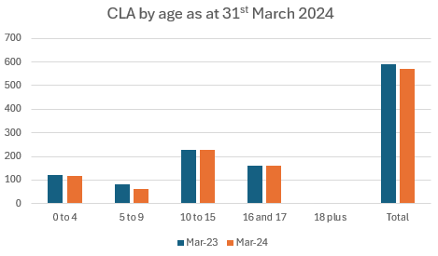

5.3.3 Somerset had 281 young people defined as Care Leavers on 31st March 2024, compared with March 2023 when there were 332 Care Leavers. Two hundred and seventy-seven, (98.6%), were in touch with the Local Authority. One hundred and twenty-one Care Leavers, (43.1%), were classified as Not in Education, Employment or Training, (NEET), an increase of 22 since 31st March 2022. Three hundred and twenty Care Leavers were deemed to be suitably accommodated (96.4%). Thirty six Care Leavers had remained in their CLA placement as part of a “Staying Put” arrangement, a decrease of twelve since March 2023.

5.4 Children Looked After Professionals

5.4.1 The ICB employs a Designated Doctor and a Designated Nurse for Children Looked After and Care Leavers. The former is provided with 2 Programmed Activities to deliver this role and the latter is a full-time position.

5.4.2 The Designated Professionals for CLA and Care Leavers are part of the ICB’s Safeguarding Team along with the Designated Professionals for Safeguarding Adults and Children, their Deputies and the Named Professional for Primary Care for Safeguarding Adults and Children.

The ICB also employ a GP who provides 2 Programmed Activities a month to review the GP medicals of prospective Somerset foster carers and adopters.

5.4.3 The Somerset Foundation Trust Health Service is commissioned by the ICB and consists of medical and nursing professionals as well as administrators.

CLA Health Service Structure Chart

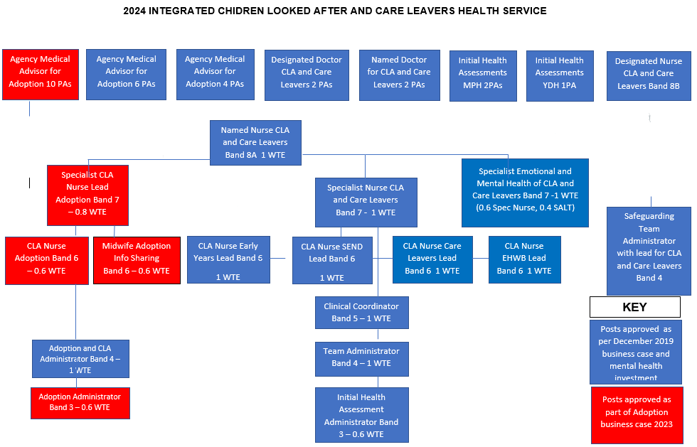

6 Governance and Statutory Arrangements

6.1 NHS Somerset ICB are the lead commissioner for local health services and are responsible for safeguarding quality assurance, including assurance for CLA and Care Leaver health services through contractual arrangements for the services which they commission.

6.2 Designated Professionals, as clinical experts and strategic leaders are a vital source of advice to the ICB, NHS England, the Local Authority and to partners through the Somerset Corporate Parenting Board and its subgroups which in turn reports into the Somerset Safeguarding Children Partnership. They also provide advice, support and supervision to multi-agency professionals across Somerset and engage in regional professional networks and assurance groups to share good practice and develop wider best practice initiatives.

6.3 In common with safeguarding children the ultimate accountability for CLA and Care Leavers sits with the Chief Executive Officer of the ICB. The Chief Executive Officer of the ICB has formally delegated authority for safeguarding, (including CLA and Care Leavers) to the Chief Nurse who is also the Executive Lead for Safeguarding. The Chief Nurse is responsible for ensuring that the health services’ contribution to safeguarding and promoting the welfare of children is discharged operationally and effectively across health via local commissioning arrangements, although ultimate responsibility remains with the Chief Executive Officer of the ICB.

6.4 The Designated Nurse for CLA and Care Leavers continues to report quarterly to the ICB Quality Committee, which has delegated powers from the ICB’s Board.

6.5 Throughout 2023/2024 the Designated Nurse for CLA and Care Leavers has provided clinical supervision to the Named Nurse for CLA. Both the Designated Nurse and Designated Doctor for CLA have accessed safeguarding children and CLA supervision from the Designated Doctor for Safeguarding Children and the Designated Doctor and Designated Nurse CLA have met regularly for peer supervision. The Designated Nurse also receives peer supervision from the Designated Nurse in Dorset.

6.6 Both Designated professionals have also provided ad hoc advice and supervision to members of the wider CLA and Care Leavers multi agency system in respect of health needs, health outcomes, signposting to health services and escalating individual cases on an ad hoc basis.

7 Somerset corporate parenting board

7.1 The role of the Somerset Corporate Parenting Board, (CPB), is to ensure that Somerset Council, as a unitary authority, fulfil its duties towards CLA and Care Leavers corporately and in partnership with other statutory agencies, including the NHS and Police. The existing Corporate Parenting Strategy 2022 - 2025 sets out how Somerset intends to fulfil its responsibilities against the Seven Principles of Corporate Parenting in a way that puts children and young people at the centre of improvements in the planning, delivery and evaluation of services. The seven principles are:

- Listening, informing
- Where I live
- Contact with important people
- Care planning, information and health
- Looked after reviews
- Leaving care and preparation for independence
- Sorting out problems and making complaints

7.2 The Somerset Corporate Parenting Board feeds into the Somerset Safeguarding Children Partnership, (SSCP), via the CPB Business Manager’s attendance at the SSCP Business Planning Group

7.3 The Somerset Corporate Parenting Board met four times in 2023/2024. The Designated Nurse for CLA and Care Leavers attended each meeting, providing a report and progress on the overarching Health and Wellbeing Subgroup Action Plan. The CPB reviews the work plan and feedback from each of the following subgroups:

    - Leaving Care
    - Health and wellbeing
    - Education
    - Voice of the Child
    - SICC (Somerset in Care Council)
    - SLCC (Somerset Leaving Care Council)

7.4 Corporate Parenting Board Health and Wellbeing Sub Group

7.4.1 The CPB Health and Wellbeing Sub Group is chaired by the Designated Nurse for CLA and Care Leavers. The function of this group is to facilitate multi-agency collaboration in meeting the health and wellbeing needs of CLA and Care Leavers. The sub-group objectives are as follows:

- Maintain a multidisciplinary forum to monitor operational and strategic performance in the provision of better outcomes for Children Looked After and Care Leavers, including unaccompanied asylum-seeking children.
- Receive and analyse information in relation to Children Looked After and Care Leavers, mapping progress against national standards and performance indicators.
- Work together to agree and implement a multi-agency action plan to meet the health and wellbeing needs of Children Looked After and Care Leavers.
- In relation to the health and wellbeing of Children Looked After and Care Leavers ensure new statutory requirements are implemented.
- Consider the views of Children Looked After, Care Leavers, and their parents or carers in how their health and wellbeing needs are being met.
- Disseminate and celebrate good practice in relation to Children Looked After and Care Leavers’ health and wellbeing.
- Influence partnership commissioning decisions by identifying needs and gaps in services that safeguard and promote health and well-being for Children Looked After and Care Leavers

7.4.2 The Health and Wellbeing Sub Group action plan is aligned with the Somerset Children and Young People’s Plan 2022-2024. The plan has been created with significant input from children and young people through the Somerset Youth Parliament and Advisory Group, the SSCP Youth Forum, Young Somerset, 2BU, local youth groups and specific workshops and events. Young people wanted priorities that were important to them to be central to the plan, these include key issues such as mental health, climate change, sexual health, discrimination and learning opportunities. The plan sets out a shared vision to keep children and young people in Somerset safe and ensure they can grow up in a child friendly county that supports them to be happy, healthy and prepared for adulthood.

7.4.3 During 2023/2024 the following Health and Wellbeing Subgroup action plan workstreams have been facilitated and progressed:

- Ensure that all Children Looked After have robust statutory health assessments which are completed in a timely way by the right Health professional, are included in the child’s care plan and are considered at each CLA Review meeting. In 2023 an Initial Health Assessment deep dive was undertaken to review the actions taken by both Health partners and Somerset Council to facilitate the Initial Health Assessment of children and young people, with the aim of addressing the notification, consent, booking and attendance issues that account for delayed assessments. Following the deep dive a multi-agency task and finish group was established to revise and refresh the Initial Health Assessment paperwork, which will ensure that the correct consent is gained and that paediatricians have access to the most relevant information about the child prior to an Initial Health Assessment taking place. It is anticipated that these new documents will be rolled out in Summer 2024.
- Ensure that the emotional and mental health needs of Children Looked After and Care Leavers are recognised, prioritised and addressed. Work was undertaken in 2023 to review the 15 hours a week Speech and Language Therapy post, placed within the Emotional Health and Wellbeing team as part of the Children Looked After and Care Leavers Mental Health investment. Evaluation reports were completed, which demonstrated the excellent work undertaken in the first year of the role and potential opportunities for development if the post was to continue. In recognition of the contributions the post has made Somerset NHS Foundation Trust have contributed a further 7.5 hours a week to the post and the ICB have agreed ongoing permanent funding for the remaining 15 hours. In February the Health and Wellbeing subgroup hosted a thematic workshop with a focus on emotional and mental health. Delegates received presentations from the CLA Health team, CAMHS, Young Somerset, NHS Somerset Commissioning Team, Somerset Council’s Emotional Health, and Wellbeing team and SiCC and SLCC. The workshop was very well attended, and the feedback received was positive. Outcomes reported were greater awareness of the roles and contributions that partners have in relation to young peoples mental health.
- Ensure the Health elements of the Adoption Pathway are compliant with statutory responsibilities and are adequately resourced to provide sufficient Adoption Medical Advisor, nursing, and administration capacity. A revised process was agreed in relation to the provision of Foster Carer medicals. It was recognised that there has been an increase in the number of medicals required, in part due to a successful recruitment drive in Somerset for new Foster Carers in addition to medical requests for Kinship Carers and Supervision Order applications. There have also been significant challenges for GPs undertaking this work due to ongoing pressures in Primary Care. System partners worked together to scope requirements and scrutinise alternative models. Following a tender and evaluation process the external provider Every Medical was successfully contracted to support the provision of medicals alongside the existing Somerset GPs service.
- Look at the learning from Child Safeguarding Practice Reviews and other reviews, ensuring all actions are addressed and embedded. In 2023 a Children Looked After Thematic Analysis was undertaken following a request from the Dorset and Somerset Child Death Overview Panel (CDOP). Four cases which had been subject to statutory safeguarding reviews were further scrutinised to determine if there was additional learning required or further exploration by multi-agency partners. The work was undertaken by Designated Nurses for Safeguarding Children and Children Looked After in Somerset and Dorset. There was no evidence found of any additional learning not previously identified. The common themes were that all four children were known to be Children Looked After and had varying degrees of emotional health and wellbeing needs. It was also clear that practice relating to Children Looked After has changed significantly since the first review took place in 2020. Whilst there was no additional learning identified there were areas that all Designated Nurses felt required ongoing scrutiny - joint work with multi-agency colleagues to look at education provision for Children Looked After and the use of unregulated placements. The ongoing work outlined was reviewed and scrutinised through the Health and Wellbeing Subgroup
- Monitoring of the impact of Unaccompanied Asylum-Seeking Children (UASC) on Health Services in Somerset. This continued throughout 2023. To date the number of UASC have remained in small numbers and the existing commissioned health services have been able to meet their needs. The Designated Nurse and Named Doctor for Children Looked After are active participants in the UASC network and one of the Paediatricians in the CLA Health Service presented in the multi-agency UASC conference held in November 2023. The CLA health service also now have two UASC champions in place. Work is ongoing in developing a UASC Initial Health Assessment pathway.

8 MONITORING ACTIVITY AND PERFORMANCE OF SOMERSET PROVIDERS

8.1 All health providers are required to have safe and effective arrangements in place to safeguard and protect children, including those who are looked after by the Local Authority and those young people who have left care. Commissioning arrangements for providers must include appropriate systems and processes to support safeguarding duties and responsibilities.

8.2 Improving the robustness of commissioning arrangements for Children Looked After and Care Leaver health services continues to be a priority workstream for the Designated Nurse, working closely with ICB Finance, Contracts and Commissioning colleagues. This work has included:

- Ensuring contractual arrangements accurately reflect the services required to be provided and delivering relevant Service Development and Improvement Plans to further drive effective change
- Attendance at the six weekly Operational Management Committee with both Health and wider multi-agency Operations Managers to scrutinise and challenge performance data and monitoring for quality assurance
- Working with health providers and contracts colleagues to gain consensus for an extensively updated Integrated CLA Service Specification and a new integrated Service Specification for CLA Medical Services
- In partnership with health providers refining and embedding the comprehensive Activity and Performance Dashboard
- Providing detailed briefings for both the ICB Board and Directors meetings to ensure Executive Leads are fully cited on commissioning gaps and risks
- Progress is monitored at the Health and Wellbeing subgroup, the ICB Quality Committee, and the ICB Safeguarding Assurance meeting.

8.2 Children Looked After and Care Leavers element of contractual arrangements

8.2.1 There is no specific Schedule in standard NHS contracts for CLA and Care leavers as these vulnerable groups are covered by the overarching Safeguarding Children and Young People Standards:

Standard 1: Governance and Commitment to Safeguarding Children & Young People
Standard 2: Policies, Procedures and Guidelines Adults
Standard 3: Training, Skills and Competences
Standard 4: Supervision and Reflective Practice
Standard 5: Multi-Agency Working
Standard 6: Reporting Serious Incidents
Standard 7: Engaging in Serious Case Reviews
Standard 8: Safe Recruitment and Retention of Staff, including Volunteers
Standard 9: Managing Safeguarding Children Allegations against Members of Staff

8.2.2 However, a number of local requirements for CLA and Care Leaver services are included in Schedule 4C of Provider contracts:

- Provision of evidence to demonstrate Service User Experience: Children Looked After satisfaction and experience of the service
- Provision of annual Provider audit of documentation including assessments to an agreed set of quality standards to evidence the quality of the Children Looked After health service
- Annual report, to include issues of planning, strategy and an audit of quality standards in relation to health services for Children Looked After
- Performance data in respect of Initial and Review Statutory Health Assessments, dental assessments, immunisations and Strengths and Difficulty Questionnaires

8.2.3 Designated Professionals are continuing to work with Providers and Contracts Teams to continuously improve contractual arrangements and to ensure a robust service specification is agreed for 2024/2025.

8.3 Clinical Audit

8.3.1 The Somerset NHS Foundation Trust Named Doctor for CLA quality assured 41 completed Initial Health Assessments in 2023/2024 using an agreed benchmarking tool. The CLA Nurse Team quality assured 185 completed Review Health Assessments via peer review, (this is compared to 137 in the previous year 2022/2023 using an agreed benchmarking Quality Assurance Tool, (Somerset CCG 2019) and their clinical expertise. Service Specification negotiations agreed that 20% of Initial and Review Health Assessments would be quality assured in 2023/2024. This process has illustrated a steady improvement in assessment quality during the year evidenced in the improved quality of health information available for other related processes including the Multi-Agency Children’s Complex Case Panel, Education and Health Care Plan statutory reviews, and for the adoption process.

8.3.2 In 2023 an audit was undertaken entitled ‘Compliance of Initial Health Assessment (IHA) report available for Children’s Social Care Review’. The purpose was to measure the availability of the IHA report to the first care review meeting. Several actions have been taken as a result of the audit including improved booking of appointments, provision of additional clinics and increased capacity for transcribing.

8.3.3 A second audit completed in this annum was ‘Compliance of form M and PH forms available for the IHA’. The purpose of this audit was to evidence the performance of this statutory expectation that obstetric, neonatal and parental health information will be available for the IHA. Collaborative working has been undertaken with Somerset Council in 2023/2024 to revise and refresh the IHA paperwork, with a focus on improving the process for consent to ensure timely consent is gained at the point a child comes into care.

8.3.4 A third audit completed was ‘Review Health Assessment Standards’ a reaudit from the previous year. The purpose was to establish the compliance of completing RHA’s to expected quality standards. The audit demonstrated that the Somerset CLA Nurses met the required quality standards, however Public Health Nursing required some improvements to standards around gaining consent, voice of the child, care planning, analysis and grammatical correctness. As a result of this audit the CLA Health service have reviewed and refreshed their training offer to the Public Health Nurses with a focus on completion of Review Health Assessment’s.

8.4 Year-end performance

8.4.1 Tables 4-7 illustrate the performance recorded by the Local Authority in respect of CLA and Care Leaver Health activity in 2023/2024.

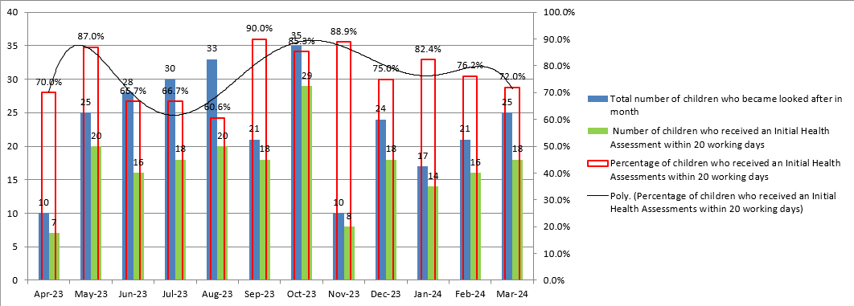
Table 4: Number and percentage of children who became Looked After and received an Initial Health Assessment within 28 days, (20 working days), in 2023/2024 (Target 90%)

Table 5: Number and percentage of children who received a Review Health Assessment in 2023/2024 (Target 90%)

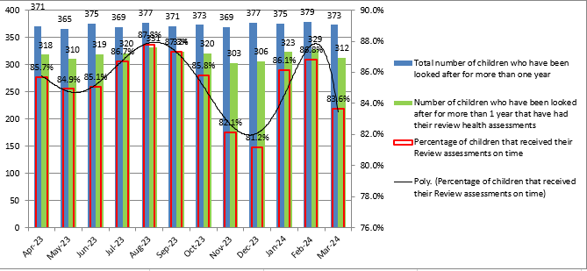

Table 6: Number and percentage of children who have been looked after for more than one year who received a dental assessment in 2023/2024 (Target 90%)

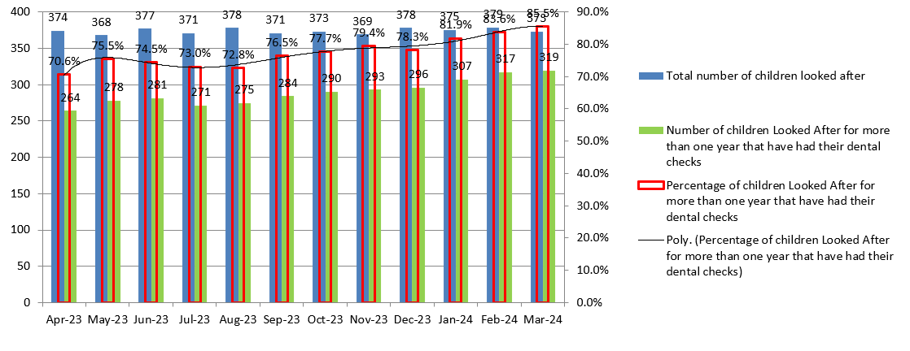

Table 7: Number and percentage of children aged 4 years plus who have been Looked After for more than one year who have an SDQ score recorded (Target 90%)

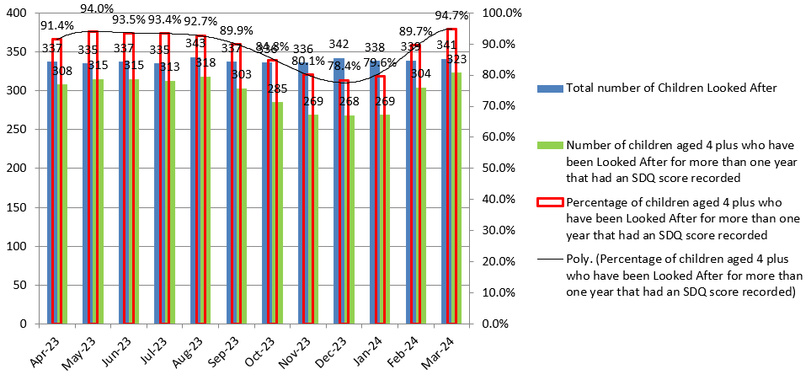

8.4.2 October 2023 saw a peak in the number of children who became looked after, (Table 4), before dipping again in November. There did not appear to be any pattern to this and although there were some larger family groups included in these figures Somerset Council are unable to categorically explain why.

8.4.3 Initial Health Assessment performance also fluctuated throughout the year. Performance was impacted by workforce challenges, late notifications and in particular children not being brought to their agreed appointments. Work was undertaken in 2023/2024 to review the actions taken by both Health and Somerset Council to facilitate the Initial Health Assessments. This is with the aim of addressing the notification, consent, booking, and attendance issues that continue to account for most delayed assessments. Paperwork has been revised and refreshed and it is anticipated that this will be rolled out in Summer 2024.

8.4.4 Review Health Assessment performance, (Table 5), was stable throughout 2023/2024 remaining in the 80% performance range throughout the year.

8.4.5 Dental assessment performance, (Table 6), had suffered significantly due to the COVID-19 pandemic which saw dental practices shut for all but emergency work for long periods of time. Two dental deep dives were completed in 2023 by the Designated Nurse to better understand the reasons that children do not have an up-to-date dental assessment. The deep dives reported the challenge of very few Somerset NHS Dental practices taking on new patients which has been exacerbated by the higher workload and backlog caused by the Covid-19 pandemic. There has also been an increase in the number of Dental practices which have become private, which has also impacted Children Looked After who largely rely on NHS services to meet their dental needs. The deep dive data illustrated that most escalations to the Designated Nurse relate to difficulties accessing NHS dental care, including after treatment has started elsewhere in the dental system, for example when a child has had a hospital dental procedure or had orthodontic services started whilst placed out of Somerset. Performance data suggests there has been continued improvement overall with up to 86.6% of children who have been in care for more than one year having an up-to-date dental assessment recorded.

8.4.7 The Designated Nurse is in regular contact with the Local Dental Committee for Somerset and the situation is being managed through escalation locally with the ICB. The Designated Nurse is also working with Somerset NHS Foundation Trust and all other agencies involved with Children Looked After and Care Leavers and has been raising awareness with Somerset dental practices of the need for dental assessments for looked-after children to be prioritised.

8.4.8 Strengths and Difficulties Questionnaires, (SDQs), (Table 6), performance has fluctuated throughout 2023/2024. Scores dipped to 78.4% in January but by year-end had risen to 94.7%. Support for children with high SDQ scores is available through CAMHS and the Somerset Council Emotional Health and Wellbeing team.

9 REGULATORY IRREGULARITIES IN ADOPTION

9.1. In April 2022, following a year of legal hearings and quality improvement work, the High Court proceedings in relation to Somerset adoption regulatory irregularities came to an end. The President of the Family Division handed down a judgment that included a route that ensured all existing placement and adoption orders remained valid and enforceable.

9.2 Work to improve the Adoption process continued and in March 2023 the system approved the formal business case to secure the temporary additional adoption roles. The Health Adoption team now consists of 20 Programmed Activities of Agency Medical Advisor time, 30 hours of Specialist Nurse, 22.5 hours of Adoption Nurse, 22.5 hours of WREN Team Midwife time, 37.5 hours of senior administrator time and 22.5 hours of administrator time. The permanent provision of these posts has ensured the continuation of the excellent service which is now in place for children with a care plan for adoption.

9.2 As part of the ongoing work to improve the health offer to the adoption pathway NHS Somerset ICB has taken forward the following actions in 2023/2024:

  - Delivery of AAR 15 and 17 compliant Medical Reviews
  - Implementation of Medical Reviews for non-agency adoptions
  - Commissioning of Medical Examinations and health reports where indicated.
  - Medical Advisor attendance at Adoption Panels
  - Provision of obstetric and neonatal information
  - Support to Somerset Council to facilitate the provision of parental health information to both the Children Looked After and adoption pathways.
  - Updating of the Medical Advisor Job Description to ensure it reflected the wider roles now being undertaken by the Medical Advisors in line with the Adoption Statutory Guidance
  - The identification of risks in relation to adopted children; data breaches due to multiple data systems used in health, (see also 10.1 below),. Mitigations to these risks are in place in Somerset NHS Foundation Trust and Primary Care.

10 RISK AND AREAS OF CHALLENGE

10.1 Risks and challenges were identified and addressed in 2023/2024 as per Table 8 below. Those listed on the ICB’s Corporate Risk Register include the risk score calculated on 31st March 2024:

CHALLENGE | solution
Children looked after health services not being delivered within statutory time frames  Risk 318  Score 12 | Responsibility for the arrangement of both initial and review health assessments transitioned from Somerset County Council to Somerset NHS Foundation Trust from 1st April 2021. Since then significant improvement work has taken place to streamline both the booking system and the information gathering process which takes place as preparation for the assessment. As a result of the improvements made health assessment performance has increased. Assessment quality has also improved following the development of new report templates
Risk that UASC and Care Leavers may not have their health needs met due to lack of services as number of children/young people increasing  Risk 567  Score 8 | There is a risk that due to an increase in numbers of Unaccompanied Asylum Seeking Children and Care Leavers in Somerset and the complexity of their health needs Unaccompanied Asylum Seeking Children and Care Leavers may not have their health needs met. Ongoing monitoring of numbers of UASC and UAS in Somerset, participation in multi-agency UASC network meetings to identify unmet health needs for this cohort and identifying solutions.
Risk of poor dental access for CLA and Care Leavers  Risk 547  Score 12 | Dental assessment performance had suffered significantly due to the COVID-19 pandemic which saw dental practices shut for all but emergency work for long periods of time. By the end of 2023/2024 there had been a significant improvement to 86.6 %. Ongoing work underway with the ICB Dental Commissioning team to develop a bespoke CLA service specification.
Risk of IG breaches in relation to adoption  Risk 576  Score 12 | When a patient/service user is adopted, they are given a new NHS number and must be provided with a new clinical record which records their new number, but which contains all previous medical information. However, their entry on the NHS spine still illustrates their biological parents details. This has led to IG breaches whereby the wrong parent has been sent confidential health information about a child that they have given up for adoption.  The ICB Digital team are reviewing the processes currently in place to determine whether a digital solution can be found, potentially using redaction software. Mitigations in place include the escalation of risk to the national NHS England Safeguarding team as well as the NHS Somerset digital team reviewing the processes in place to determine whether a digital solution is possibly. Information and advice has been given to Primary Care colleagues in relation to the safe management of records relating to adoption.
Risk that Somerset Council Public Health Nurses may give notice on completion of statutory health assessments  Risk 606  Score 4 | If the Public Health Nursing Service give notice on undertaking statutory Review Health Assessments for Children Looked After, then the Somerset NHS Foundation Trust Children Looked After Health Service will be required to complete them. This will then have an impact on their capacity and as a result Children Looked After may not receive their Review Health Assessment within statutory timescales. There will be an impact on the Somerset Foundation Trust Children Looked After Health service who will be required to undertake an increase in statutory Review Health Assessments for Children Looked After. Work is underway to improve the allocation of Health Assessments based on the needs of the child and the most appropriate professional delivering the assessment.

11 progress against Objectives for 2023/2024

11.1 The following objectives were identified for completion 2023/2024:

- Undertake a dental deep dive to understand the reasons that children do not have an up-to-date dental assessment and continue work with regional Specialist Commissioners for dental services to improve access to dental assessment and treatment for Children Looked After and Care Leavers – ACHIEVED AND ONGOING
- Progress work to ensure that Children Looked After and Care Leavers are considered in the Children and Young People’s Mental Health Transformation plan – ACHIEVED
- Review the provision of additional Speech and Language Therapist resources to improve the Emotional and Mental Health of Children Looked After and Care Leavers to determine whether this investment should be provided on a substantive basis – ACHIEVED
- Progress work with Integrated Care System partners to identify the best use of the remaining Mental Health transformation investment – ACHIEVED
  - Progress work, through the Integrated Care System Safeguarding workstream, to improve transitions for Children Looked After transferring to adult services – ACHIEVED AND ONGOING
  - Review the Adoption Service Specification and develop a formal Adoption Strategy for Somerset based on the statutory guidance and regulations – ONGOING
  - Develop a system wide UASC Somerset network alongside the establishment of an Initial Health Assessment pathway for the UASC cohort – ACHIEVED AND ONGOING

12 OBJECTIVES FOR 2024/2025

12.1 The following objectives have been identified for completion 2024/2025:

- Progress work to ensure Children Looked After and Care Leavers receive an up-to-date dental assessment and continue work with Somerset ICB Commissioners to improve access to dental assessment and treatment for Children Looked After and Care Leavers.
- Strengthen the CLA Health Service’s offer to children with emotional and mental health needs.
- Recruit into a Specialist CLA Nurse post for Mental and emotional health.
- Undertake a Review Health Assessment deep dive to review the actions taken by both Health partners, Somerset Council and Public Health Nursing to facilitate the Review Health Assessments of children and young people with the aim of addressing any issues in relation to notification, booking and attendance issues that might account for delayed assessments.
- Strengthen the partnership working between Health and Education partners to meet the needs of Children Looked After.
- Continue to monitor the health needs of Unaccompanied Asylum-Seeking Children and ensure that these health needs are met. Finalise the Unaccompanied Asylum pathway.
- Develop a local plan to allocate the NHS England Universal Family Programme investment to implement the Care Leaver Covenant within the Somerset system.

13 CONCLUSION

13.1 Commissioners of health services have a duty to ensure that all NHS Trusts recognise the importance of robust and effective arrangements in place to safeguard and protect children and young people across Somerset, and to provide assurance that they are fulfilling their statutory responsibilities for Safeguarding Children under Section 11 of the Children Act 1989 (2004).

13.2 Given the complexity of the systems and processes in place across the system to provide timely, high quality, and responsive health services to CLA and Care Leavers, it is perhaps not surprising that the pace of improvement can often appear to be frustratingly slow. However significant progress has been made in 2023/2024 to ensure this most vulnerable cohort of children achieve their full potential and leave the care system physically and emotionally well to meet the challenges of the next stages of their lives. It is hoped that the planned 2024/2025 objectives will continue to take forward the progress that has been made this year to fulfil our statutory and strategic objectives.

13.3 NHS Somerset Integrated Care Board are requested to note the contents of this report.

