REPORT TO: |  | NHS SOMERSET INTEGRATED CARE BOARD  Choose an item. | ENCLOSURE:
 |  | NHS SOMERSET INTEGRATED CARE BOARD  Choose an item. | Enter Enc No
DATE OF MEETING: |  | 15 October 2025
REPORT TITLE: |  | ICB Children Looked After and Care Leavers Annual Report
REPORT AUTHOR: |  | Emma Clothier, Designated Nurse for CLA and Care Leavers
EXECUTIVE SPONSOR: |  | Shelagh Meldrum, Chief Nursing Officer and Director of Operations
PRESENTED BY: |  | Sarah Ashe, Associate Director of Safeguarding, Mental Health, Learning Disability and Autism
PURPOSE | DESCRIPTION |  |  | SELECT
Approve | To formally receive a report and approve its recommendations, (authorising body/committee for the final decision) |  |  | ☒
Endorse | To support the recommendation (not the authorising body/committee for the final decision) |  |  | ☐
Discuss | To discuss, in depth, a report noting its implications |  |  | ☐
Note | To note, without the need for discussion |  |  | ☐
Assurance | To assure the Board/Committee that systems and processes are in place, or to advise of a gap along with mitigations |  |  | ☐
LINKS TO STRATEGIC OBJECTIVES
(Please select any which are impacted on / relevant to this paper)
☒ Objective 1: Improve the health and wellbeing of the population
☒ Objective 2: Reduce inequalities
☒ Objective 3: Provide the best care and support to children and adults
☐ Objective 4: Strengthen care and support in local communities
☒ Objective 5: Respond well to complex needs
☐ Objective 6: Enable broader social and economic development
☐ Objective 7: Enhance productivity and value for money
PREVIOUS CONSIDERATION / ENGAGEMENT
Meeting statutory Children Looked After and Care Leavers requirements is a shared responsibility. The Designated Professionals for Children Looked After and Care Leavers work closely with ICS/ICB colleagues, the services commissioned by the ICB and all key partners of the Somerset Corporate Parenting Board to ensure these are met.

REPORT TO COMMITTEE / BOARD
Annual report on the work of the Designated Professionals for Children Looked After and Care Leavers in the ICB
- Details the arrangements in place for Children Looked After and Care Leavers in the NHS Somerset Integrated Care System (ICS), and the services commissioned by NHS Somerset Integrated Care Board (ICB).
- Sets out the context for Children Looked After and Care Leavers arrangements in the Somerset ICS/ICB.
- Demonstrates how the ICS/ICB is fulfilling its statutory Children Looked After and Care Leavers responsibilities.
- Reports on governance and accountability arrangements within the ICS/ICB, and the ICS/ICB role in the Somerset Corporate Parenting Board and the Health and Wellbeing subgroup.
- Highlights achievements and identifies current Children Looked After and Care Leavers risks and gaps in provision within health services.
- Identifies the ICBs 2025/2026 Children Looked After and Care Leavers objectives.
- Provides assurance that the Children Looked After and Care Leavers 2024/2025 objectives were completed.
The Somerset Designated Professionals for Children Looked After and Care Leavers will continue to work collaboratively at a local, regional, and national level to improve the quality of, and strengthen, Children Looked After and Care Leavers arrangements, where necessary mitigating organisational and partnership risk.
IMPACT ASSESSMENTS – KEY ISSUES IDENTIFIED
(please enter ‘N/A’ where not applicable)

Reducing Inequalities/Equality & Diversity | Commissioning and delivery of high quality and accessible statutory health services to meet the needs of Children Looked After and Care Leavers will ensure this cohort will not be disadvantaged in comparison to their peers who do not experience the same vulnerabilities
Quality | This report reflects on the quality of services and impact of practice Children Looked After and Care Leavers
Safeguarding | Statutory Children Looked After and Care Leavers responsibilities of the ICS/ICB and the services it commissions are considered throughout this report.
Financial/Resource/  Value for Money | Resources required to implement and support statutory Children Looked After and Care Leavers requirements are in place.
Sustainability | Working with all partners in the local, regional and national system, the Designated Professionals for Children Looked After and Care Leavers aim to deliver a sustainable and effective healthcare system for Looked After Children in Somerset.

Governance/Legal/  Privacy | The provision of statutory Children Looked After and Care Leaver requirements are governed by the following legislation and statutory guidance:  - Children Act 1989  - Children Act 2004  - The Children and Families Act 2014  - The Children and Social Work Act 2017  - Data Protection Act (2018)  - Children (Leaving Care) Act 2000  - Adoption and Children Act 2002  - Working Together to Safeguard Children 2023  - Promoting the Health and Wellbeing of Looked After Children 2015  - Intercollegiate Document: Looked After Children: roles and competences of health care staff, (RCPCH) 2020
Confidentiality | Information sharing processes are already established; no breaches of privacy are expected.
Risk Description | Risk 318 - Children looked after health services not being delivered within statutory time frames – Score 15  Risk 547 – Risk of poor dental access for CLA and Care Leavers – Score 12  Risk 576 – Risk that the ICB is unable to deliver it’s obligations regarding the adoption pathway- Score 12




CHILDREN LOOKED AFTER and Care Leavers ANNUAL REPORT
2024/2025

September 2025
CHILDREN LOOKED AFTER AND CARE LEAVERS
ANNUAL REPORT 2024/2025

CONTENTS

Section |  | Page
SECTION 1 | foreward | 1
SECTION 2 | statement of intent | 1
SECTION 3 | statutory responsibilities | 2
SECTION 4 | purpose of the report | 2
SECTION 5 | children looked after (CLA) and care leavers characterists and context | 3
SECTION 6 | governance and statutory arrangments | 7
SECTION 7 | somerset corporate parenting board | 12
SECTION 8 | monitoring activity and performance of somerset providers | 14
SECTION 9 | regulatory irregularies in adoption | 18
SECTION 10 | risks and areas of challenge | 19
SECTION 11 | progress against objectives 2024/25 | 20
SECTION 12 | objectives for 2024/25 | 20
SECTION 13 | conclusion | 21

Author | Emma Clothier
Developed in conjunction with | Dr Carol Smith
Roles | Designated Professionals for Children Looked After and Care Leavers
Sponsor | Shelagh Meldrum
Role | Chief Nursing Officer
Date | September 2025

CHILDREN LOOKED AFTER and Care Leavers
ANNUAL REPORT 2024/2025

- FOREWORD

1.1 This is the third NHS Somerset Integrated Care Board, (hereafter known as ICB), Annual Report for Children Looked After and Care Leavers), covering April 2024 – March 2025. This is a public report which sets out the work of the ICB in relation to Children Looked After, (CLA), and Care Leavers (CL), as lead commissioner for healthcare services within Somerset and as a member of the Somerset Corporate Parenting Board. The report forms part of Somerset ICBs’ assurance arrangements, in relation to Children Looked After, Care Leavers and wider Safeguarding Children arrangements.

1.2 Under the Children Act 1989, a child is Looked After by a Local Authority if he or she falls into one of the following:

- is provided with accommodation, for a continuous period of more than 24 hours (Children Act 1989, Sections 20 and 21)is subject to a care order (Children Act 1989, Part IV), or
- is subject to a placement order

1.3 Wherever possible, the Local Authority, Somerset Council will work in partnership with parents to ensure children and young people who become CLA retain strong links with their families and many eventually return home. A child will cease being Looked After by the Local Authority when they are adopted, return home or reach the age of 18 years.

1.4 Care Leavers are those children and young people who have previously been Looked After by the Local Authority and are now being supported to live independently. Following the publication of the Children and Social Care Act, (2017), Local Authority responsibility for Care Leavers changed from 18 to 21 years to an age range of 18 to 25 years, enabling Care Leavers to request support up to the age of 25, regardless of whether they are in education.

2 STATEMENT OF INTENT

2.1 NHS Somerset Integrated Care Board, and our system partners are committed to improving health outcomes for Children Looked After and Care Leavers, and we will do this by ensuring we commission oversee the delivery of high-quality, responsive services. To achieve this NHS Somerset ICB will continue to work closely with its Provider, (Somerset NHS Foundation Trust), Somerset Council, NHS England, service users, and other key partners to ensure Children Looked After and Care Leavers have timely access to high-quality health care, as and when they need it. We will ensure robust management of action plans to improve performance and outcomes and are actively working with our partners to ensure service redesign is effective at improving performance and outcomes.

3 STATUTORY RESPONSIBILITIES

3.1 NHS Somerset ICB is the Responsible Commissioner for health services provided to Somerset Children Looked After whether they are resident within Somerset or outside. The ICB endeavours to meet the health needs of Children Looked After and Care Leavers as illustrated in the Statutory Guidance Promoting the health and well-being of looked-after children, (DoH, DfE, 2015).

3.2 A vigorous and robust system of quality assurance and performance monitoring has been developed with health and social care partners to ensure that a seamless service is delivered. This function is embedded within the main roles and workstreams of the ICB’s commissioned Designated Doctor and Nurse for Children Looked After, (hereafter known as CLA), and Care Leavers. The ICB maintains its statutory duty to cooperate with Local Authorities to ensure health assessments are undertaken and support and services are provided to CLA without undue delay.

3.3 ICBs must ensure that any changes in healthcare provider due to CLA placement move do not disrupt the objective of providing high quality, timely healthcare to the child.

3.4 ICBs must ensure that plans are in place to enable children leaving care continue to obtain the healthcare they need.

3.5 NHS Somerset ICB gains assurance that the healthcare services it commissions for CLA meet the standards laid down in the Statutory Guidance by ensuring that high quality Statutory Initial and Review Health Assessments and associated Health Care Plans and Health Leaving Care Summaries are delivered to CLA and Care Leavers in a timely way. Similarly robust key performance indicator monitoring of CLA access to dental services and immunisation rates and completed Strengths and Difficulties Questionnaires, (SDQs), provide assurance that CLA health needs are identified and met.

3.6 The ICB also has a statutory role and functions for fostering and adoption as defined in the Children Act 1989, Guidance and Regulations Volume 4 Fostering Services, the Care Standards Act 2000, and the Adoption and Children Act 2002.

4 PURPOSE OF THE REPORT

4.1 This report will inform the NHS Somerset ICB Board of the arrangements in place for all children who are in the care of Somerset Council, (628 on 31 March 2025 compared to 589 on 31 March 2024) or are Somerset Care Leavers, (305 on 31 March 2025 compared with 370 on 31 March 2024).

4.2 This report is an updated overview and summary of the previous ICB Annual Report and will:

- update the context for CLA and Care Leavers in Somerset
- provide an overview of the arrangements in place to provide health services to CLA and Care Leavers in Somerset
- demonstrate how Somerset ICB is fulfilling its CLA and Care Leaver statutory responsibilities
- report on governance and accountability arrangements within the ICB, and the ICB role in the Corporate Parenting Board and sub-groups
- highlight achievements and identify current risks in provision of health services to CLA and Care Leavers
- provide assurance that the CLA and Care Leaver 2024/2025 objectives were completed
- identify the ICB’s 2025/2026 CLA and Care Leaver objectives

5 CHILDREN LOOKED AFTER AND CARE LEAVERS CHARACTERISTICS AND CONTEXT

Characteristics

5.1 During 2024/2025 there has been little change in the characteristics of Somerset children who become looked after. The reason most children and young people become looked after in Somerset is because they are victims of abuse or neglect.

5.2 During 2024/2025 Somerset initially saw a steady increase in the number of children becoming looked after which significantly increased again towards the end of the period as per Table 1 below. There was a peak in children becoming looked after in the winter of 2024, prior to the school holidays. Somerset Council are unable to explain the reason for this being the case, although several large sibling groups became CLA in that period.

Table 1: Number of Somerset Looked After Children 2024/2025

5.3 Nationally, the number of children who are looked after has increased every year since 2008. However, the latest figures represent a slight decrease compared to the previous year which indicate a stabilisation in the trend. For example, on 31 March 2024 the number of Children Looked After in England decreased by 0.5% to 83,630, from 83,840 on 31 March 2023. This equates to a rate of 70 per 10,000 children. By comparison Somerset’s rate on 31 March 2025 stood at 56.7 children per 10,000 so significantly lower than the national picture. Unfortunately, the national data for 2024/2025 has not yet been released but may well illustrate similar trends as has been noted locally.

5.4 National trends of unaccompanied asylum seekers and children, (UASC), have also seen a decrease of 0.5% in 2024. UASC and Care Leaver numbers in Somerset have followed the national trend and this cohort present as part of the national transfer scheme as well as receiving spontaneous arrivals into the county.

5.5 There were 28 UASC in Somerset on 31 March 2025, 4.4% of Somerset’s CLA population. On 31 March 2024 there were 35 UASC, 5.9% of Somerset’s CLA population. Numbers of UASC Care Leavers are rising within Somerset, there is an increase of 82 UASC young people open to Leaving Care Teams, over the age of 18.

5.6 Looked after children have many of the same health risks and problems as their peers but the extent of those issues is often exacerbated by their experiences of poverty, abuse and neglect leading to significant and often lifelong trauma. For example, prevalence of social, emotional and mental health, (SEMH), problems are estimated to be between 45% and 72% compared to 10% in their non-looked after peers. On 31 March 2025, 146 CLA who had been looked after for more than one year were found to have a Strengths and Difficulties questionnaire score of above 17, indicating high social, emotional and mental health need. This equates to 44.8% of the Somerset CLA population and illustrates the need for a continued strong focus on CLA when commissioning SEMH services.

5.7 Nationally two thirds of looked after children have been found to have developmental and physical health issues such as speech and language problems, continence issues, coordination difficulties and sight problems. Eleven percent have been found to be on the autism spectrum. Furthermore, the health and wellbeing of young people leaving care has consistently been found to be poorer than that of young people who have never been in care, with higher levels of teenage pregnancy, drug and alcohol abuse. Care experienced children and young people are also significantly overrepresented in the criminal justice system.

5.8 Children and young people with Special Educational Needs and Disability, (SEND), are also over-represented in the care system. As a group CLA are nine times more likely to have an Education and Health Care Plan, (EHC plan) than the general pupil population.

5.9 In Somerset there has been an increase of 325 CLA who are supported with EHC plans and have SEN support. (Table 2).

Table 2: SEND Comparative Data 2024/2025

 | 2025 | In Somerset | Outside Somerset | Blank
Total number of CYP with CLA and CLA CP (Child protection) marker | 325 | 200 | 120 | 5
Number of above with EHCP | 190 | 118 | 70 | 2
Number of above with SEN Support | 128 | 81 | 45 | 2
Number of above with Blanks | 7 | 1 | 5 | 1

5.10 Data also illustrates that all Somerset CLA, both those with an EHC plan and those in receipt of SEN support, have up-to-date statutory health assessments on file and are accessible to the SEND case worker team. Work is planned for 2024/2025 to consider the alignment of the completion of Review Health Assessments alongside the EHC plan.

5.11 Somerset CLA and their support networks benefit from access to the Local Authority’s Emotional Health and Wellbeing Team in addition to Child and Adolescent Mental Health Services and the Eating Disorder Service. Sixty-five CLA were open to CAMHS on 31 March 2025. There is also a strong health response to multi-agency requests for involvement with complex children’s meetings and conferences. The Designated professionals have regularly attended the Multi-Agency Children’s Complex Cases Panel throughout 2024/2025 and provided expert advice and support to escalations involving children with delayed discharges requiring therapeutic placements and often repatriation back to Somerset.

Policy Context

5.12 There has been no new published statute relevant to CLA and Care Leavers in 2024/2025.

Local Context

5.13 Data from the 2021 Census records the population of Somerset was 571,600, an increase of around 41,600 people since 2011. This is a rise of 7.8% since 2011 and a 36.9% rise in 40 years since 1981. Of the 110,000 children under the age of 18 living in Somerset, between 5,000 and 10,000 are defined as in need, the majority living in the most deprived urban wards. About 14,300 Somerset children live in low-income households. Whilst not all will be ’vulnerable’, poverty is a strong indicator of poor wellbeing and lack of opportunity. (JSNA, 2023).

5.14 Health services for the whole population of Somerset are commissioned by Somerset Integrated Care Board (ICB), NHS England and Somerset Council. Somerset ICB have responsibility for commissioning most healthcare services for the Somerset population.

5.15 The highest number of children becoming looked after continues to be those in the 10-15 years age range, followed by older teenagers and then those aged from birth to four years as illustrated in Table 3 below. The 16- and 17-years age group has increased in 2024/2025 compared to the previous year.

Table 3: Children Looked After by age as of 31 March 2024
(Somerset Council data)

5.16 Somerset had 305 young people defined as Care Leavers on 31 March 2025, compared with March 2024 when there were 281 Care Leavers, (98.7%), were in touch with the Local Authority. One hundred and twenty-one Care Leavers, (43.1%), were classified as Not in Education, Employment or Training, (NEET), an increase of one since 31 March 2024. Two hundred and ninety-one Care Leavers were deemed to be suitably accommodated (95.4%). Twenty-two Care Leavers had remained in their CLA placement as part of a “Staying Put” arrangement, a decrease of fourteen since March 2024.

Children Looked After Professionals

5.17 The ICB employs a Designated Doctor and a Designated Nurse for Children Looked After and Care Leavers. The former is provided with 2 Programmed Activities to deliver this role, and the latter is a full-time position.

5.18 The Designated Professionals for CLA and Care Leavers are part of the ICB’s Safeguarding Team along with the Designated Professionals for Safeguarding Adults and Children, their Deputies and the Named Professional for Primary Care for Safeguarding Adults and Children.

5.19 The ICB also employ a GP who provides 2 Programmed Activities a month to review the GP medicals of prospective Somerset foster carers and adopters.

5.20 The Somerset NHS Foundation Trust CLA Health Service is commissioned by the ICB and consists of medical and nursing professionals as well as administrators.
CLA Health Service Structure Chart
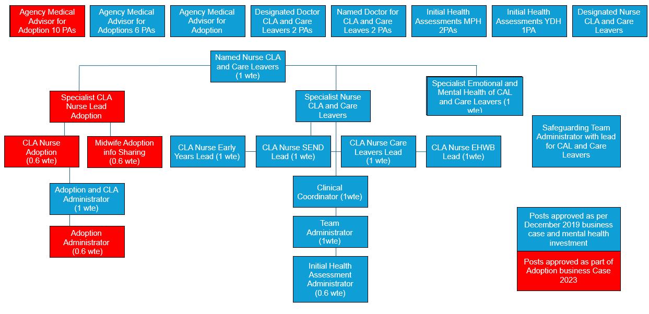

6 Governance and Statutory Arrangements

6.1 NHS Somerset ICB are the lead commissioner for local health services and are responsible for safeguarding quality assurance, including assurance for CLA and Care Leaver health services through contractual arrangements for the services which they commission.

6.2 Designated Professionals, as clinical experts and strategic leaders are a vital source of advice to the ICB, NHS England, the Local Authority and to partners through the Somerset Corporate Parenting Board and its subgroups which in turn reports into the Somerset Safeguarding Children Partnership. They also provide advice, support and supervision to multi-agency professionals across Somerset and engage in regional professional networks and assurance groups to share good practice and develop wider best practice initiatives.

6.3 In common with safeguarding children the ultimate accountability for CLA and Care Leavers sits with the Chief Executive Officer of the ICB. The Chief Executive Officer of the ICB has formally delegated authority for safeguarding, (including CLA and Care Leavers) to the Chief Nurse who is also the Executive Lead for Safeguarding. The Chief Nurse is responsible for ensuring that the health services’ contribution to safeguarding and promoting the welfare of children is discharged operationally and effectively across health via local commissioning arrangements, although ultimate responsibility remains with the Chief Executive Officer of the ICB.

6.4 The Designated Nurse for CLA and Care Leavers continues to report quarterly to the ICB Quality Committee, which has delegated powers from the ICB’s Board.

6.5 Throughout 2024/2025 the Designated Nurse for CLA and Care Leavers has provided clinical supervision to the Named Nurse for CLA. Both the Designated Nurse and Designated Doctor for CLA have accessed safeguarding children and CLA supervision from the Designated Doctor for Safeguarding Children and the Designated Doctor and Designated Nurse CLA have met regularly for peer supervision. The Designated Nurse also receives peer supervision from the South West Regional CLA Designated Nurses.

6.6 Both Designated professionals have also provided ad hoc advice and supervision to members of the wider CLA and Care Leavers multi agency system in respect of health needs, health outcomes, signposting to health services and escalating individual cases on an ad hoc basis.

7 Somerset corporate parenting board

7.1 The role of the Somerset Corporate Parenting Board, (CPB), is to ensure that Somerset Council, as a unitary authority, fulfil its duties towards CLA and Care Leavers corporately and in partnership with other statutory agencies, including the NHS and Police. The Corporate Parenting Strategy 2022 - 2025 sets out how Somerset intends to fulfil its responsibilities against the Principles of Corporate Parenting in a way that puts children and young people at the centre of improvements in the planning, delivery and evaluation of services.

The revised and refreshed 2025-2028 Corporate Parenting Strategy was published in March 2025. The Corporate Parenting Board worked with Children and Young People through the Somerset in Care Council to develop a pledge to those in our care. It includes a number of promises for how we will look after and communicate with them across seven themes:

- Listening, informing
- Where I live
- Contact with important people
- Care planning, information and health
- Looked after reviews
- Leaving care and preparation for independence
- Sorting out problems and making complaints

7.2 The Somerset Corporate Parenting Board feeds into the Somerset Safeguarding Children Partnership, (SSCP), via the CPB Business Manager’s attendance at the SSCP Business Planning Group

7.3 The Somerset Corporate Parenting Board met four times in 2024/2025. The Designated Nurse for CLA and Care Leavers attended each meeting, providing a report and progress on the overarching Health and Wellbeing Subgroup Action Plan. The CPB reviews the work plan and feedback from each of the following subgroups:

    - Leaving Care
    - Health and wellbeing
    - Education
    - Voice of the Child
    - SICC (Somerset in Care Council)
    - SLCC (Somerset Leaving Care Council)

Corporate Parenting Board Health and Wellbeing Subgroup

7.4 The CPB Health and Wellbeing Subgroup is chaired by the Designated Nurse for CLA and Care Leavers. The function of this group is to facilitate multi-agency collaboration in meeting the health and wellbeing needs of CLA and Care Leavers. The current sub-group objectives, which will be reviewed in 2025 are as follows:

- Maintain a multidisciplinary forum to monitor operational and strategic performance in the provision of better outcomes for Children Looked After and Care Leavers, including unaccompanied asylum-seeking children.
- Receive and analyse information in relation to Children Looked After and Care Leavers, mapping progress against national standards and performance indicators.
- Work together to agree and implement a multi-agency action plan to meet the health and wellbeing needs of Children Looked After and Care Leavers.
- In relation to the health and wellbeing of Children Looked After and Care Leavers ensure new statutory requirements are implemented.
- Consider the views of Children Looked After, Care Leavers, and their parents or carers in how their health and wellbeing needs are being met.
- Disseminate and celebrate good practice in relation to Children Looked After and Care Leavers’ health and wellbeing.
- Influence partnership commissioning decisions by identifying needs and gaps in services that safeguard and promote health and well-being for Children Looked After and Care Leavers

7.5 The Health and Wellbeing Subgroup action plan is aligned with the Somerset Children and Young People’s Plan 2024-2030. The plan has been created with significant input from children and young people through the Somerset Youth Parliament and Advisory Group, the SSCP Youth Forum, Young Somerset, 2BU, local youth groups and specific workshops and events.

7.6 Young people wanted priorities that were important to them to be central to the plan, these include key issues such as living healthy lives to include mental and physical health, having a positive experience in education, living in safe communities, building great relationships and preparedness for adulthood.

7.7 The plan sets out a shared vision to keep children and young people in Somerset safe and ensure they can grow up in a child friendly county that supports them to be happy, healthy and prepared for adulthood.

7.8 During 2024/2025 the following Health and Wellbeing Subgroup action plan workstreams have been facilitated and progressed:

- Ensure that all Children Looked After have robust statutory health assessments which are completed in a timely way by the right Health professional, are included in the child’s care plan and are considered at each CLA Review meeting.

  - In 2024 a weekly Initial Health Assessment (IHA) assurance meeting was developed to review each newly looked after child to ensure timeliness of their planned IHA. As part of this assurance the CLA Health team to investigate overdue health assessments as well as contacting all relevant parties to prepare and ensure attendance.
  - A deep dive into Review Health Assessments was also undertaken to explore the with the aim of providing additional assurance to the Corporate Parenting Board in relation to performance of this statutory health assessment.
  - All parts of the process were scrutinised to include notification, allocation, information gathering, attendance, care planning and the three-month review. The Deep Dive identified the excellent performance in relation to children placed in Somerset, as well as the positive relationships between the Somerset Foundation Trust and Somerset Council teams.
  - Children placed out of area continue to impact on performance data due to the processes and workforce capacity issues. Mitigation is currently in place as for those children placed in bordering local authorities will be seen by the Somerset team if required. Cases are also escalated on an individual basis by both the Named and Designate Nurses.

- Ensure that the emotional and mental health needs of Children Looked After and Care Leavers are recognised, prioritised and addressed.

  - Following extensive work with system partners to identify the best use of remaining transformation CLA and Care Leavers Mental Health investment, in September 2024 recruitment commenced for full time Specialist Mental and Emotional Health Nurse within the CLA Nursing Service. The post was appointed to, and the successful candidate commenced her role in February 2025. The role will provide early assessment, signposting and referral to existing services as well as providing an interface between the CLA Health Service and CAMHS.

7.9 The Care Leavers Counselling Service was recommissioned following an escalation at the Health and Wellbeing subgroup following concerns that the service was not going to be further commissioned. Following this escalation the Designated Nurse was able to advocate to Commissioners the importance and value of this service and as a result joint commissioning with Somerset Council has been agreed for a further year.

- Ensure that Children Looked After and Care Leavers have access to Dental Services and Oral Health Promotion initiatives.

  - Dental performance has been closely monitored monthly through the Corporate Parenting Dashboard. The Designated Nurse worked with the Head of Pharmacy, Optometry and Dentistry to develop a CLA Dental Recovery Action Plan which was presented to Corporate Parenting Board in August 2024 detailing the work planned and currently underway to improve access to dentistry for CLA in Somerset.

7.10 There is currently a regional escalation process for CLA who have been unable to access an NHS Dentist. Individual escalations for children have been supported by the Designated Nurse throughout 2024-2025.

- Monitoring of the impact of Unaccompanied Asylum-Seeking Children (UASC) on Health Services in Somerset. This continued throughout 2024-2025.

  - To date the number of UASC have remained in small numbers and the existing commissioned health services have been able to meet their needs. The Designated Nurse and Named Doctor for Children Looked After are active participants in the UASC network, alongside the CLA health service UASC champions.

  - In 2024 the UASC Initial Health Assessment pathway was finalised and launched. The Named Doctor alongside the Designated Nurse provided a training session for Somerset GP’s with an aim of raising awareness of the health needs that these young people may had and explore many of the barriers they experience in accessing health care. Work began on reviewing the provision of immunisations and delivering a bespoke sex education package in partnership with education.

- Ensure that CLA and Care Leavers are offered appropriate support in transition and beyond in respect of their health and wellbeing needs.

  - In 2024 the Designated Nurse joined the Corporate Parenting Board Leaving Care Subgroup to provide health representation and lead any health-related work.
  - Work on the NHS Universal Family Programme progressed in 2024-2025 with four more workshops being delivered to facilitate Care Leavers employment within the NHS. Extensive evaluation has been competed following delivery and programme amended led by feedback from Care Leavers who had participated.
  - The Designated Nurse has been an active member of the Transitions professional forum to ensure that the needs of CLA and Care Leavers are considered within service development and transition planning.

8 MONITORING ACTIVITY AND PERFORMANCE OF SOMERSET PROVIDERS

8.1 All health providers are required to have safe and effective arrangements in place to safeguard and protect children, including those who are looked after by the Local Authority and those young people who have left care. Commissioning arrangements for providers must include appropriate systems and processes to support safeguarding duties and responsibilities.

8.2 Improving the robustness of commissioning arrangements for Children Looked After and Care Leaver health services continues to be a priority workstream for the Designated Nurse, working closely with ICB Finance, Contracts and Commissioning colleagues. This work has included:

- Ensuring contractual arrangements accurately reflect the services required to be provided and delivering relevant Service Development and Improvement Plans to further drive effective change
- Attendance at the six weekly Operational Management Committee with both Health and wider multi-agency Operations Managers to scrutinise and challenge performance data and monitoring for quality assurance

- Working with health providers and contracts colleagues to gain consensus for an extensively updated Integrated CLA Service Specification and a new integrated Service Specification for CLA Medical Services
- In partnership with health providers refining and embedding the comprehensive Activity and Performance Dashboard
- Providing detailed briefings for both the ICB Board and Directors meetings to ensure Executive Leads are fully cited on commissioning gaps and risks
- Progress is monitored at the Health and Wellbeing subgroup, the ICB Quality Committee, and the ICB Safeguarding Assurance meeting.

Children Looked After and Care Leavers element of contractual arrangements

8.3 There is no specific Schedule in standard NHS contracts for CLA and Care leavers as these vulnerable groups are covered by the overarching Safeguarding Children and Young People Standards:

Standard 1: Governance and Commitment to Safeguarding Children & Young People
Standard 2: Policies, Procedures and Guidelines Adults
Standard 3: Training, Skills and Competences
Standard 4: Supervision and Reflective Practice
Standard 5: Multi-Agency Working
Standard 6: Reporting Serious Incidents
Standard 7: Engaging in Serious Case Reviews
Standard 8: Safe Recruitment and Retention of Staff, including Volunteers
Standard 9: Managing Safeguarding Children Allegations against Members of Staff

8.4 However, a number of local requirements for CLA and Care Leaver services are included in Schedule 4C of Provider contracts:

- Provision of evidence to demonstrate Service User Experience: Children Looked After satisfaction and experience of the service
- Provision of annual provider audit of documentation including assessments to an agreed set of quality standards to evidence the quality of the Children Looked After health service
- Annual report, to include issues of planning, strategy and an audit of quality standards in relation to health services for Children Looked After
- Performance data in respect of Initial and Review Statutory Health Assessments, dental assessments, immunisations and Strengths and Difficulty Questionnaires

8.5 Designated Professionals are continuing to work with Providers and Contracts Teams to continuously improve contractual arrangements and to ensure a robust service specification is agreed for 2025/2026.

Quality Assurance and Audit

8.6 The Somerset NHS Foundation Trust Named Doctor for CLA quality assured 51 completed Initial Health Assessments in 2024/2025 using an agreed benchmarking tool. The quality assurance of IHA’s highlighted variability in IHA quality due to access to health and social care information, presence of family or social workers at the appointment, and age of the child. Positively recognising ongoing efforts to improve report completeness, standardisation, and alignment with best practice, alongside positive feedback from external agencies.

8.7 The CLA Nurse Team quality assured 136 completed Review Health Assessments via peer review, (this is compared to 185 in the previous year 2023/2024 using an agreed benchmarking Quality Assurance Tool, (Somerset CCG 2019) and their clinical expertise. Service Specification negotiations agreed that 20% of Initial and Review Health Assessments would be quality assured in 2024/2025. This process illustrated a steady improvement in assessment quality during the year evidenced in the improved quality of health information available for other related processes including the Multi-Agency Children’s Complex Case Panel, Education and Health Care Plan statutory reviews, and for the adoption process.

8.8 An audit completed this annum ‘Consent on RIO for Children Look After (CLA) Re-audit’. The purpose of this re-audit was to establish the compliance of updating the consent on RIO demographics page, within a month following the undertaking of a health assessment, which is a record keeping expectation of the CLA Health Team within the Trusts ‘Record Keeping Policy’ and ‘Data Protection and Information Governance Policy’. The CLA Health Team need to adhere to the Data Protection Act 2018 and GDPR. Results showed that consent is not currently being updated consistently by CLA Nurses or Admin staff within a month of the health assessment being completed. Staff will need to embed correct processes, and this has been reinforced at Team Meetings and at Supervision where staff will be supported to embed this process. A clear action plan has been completed, and this will be re-audited within the next 2 financial years.

8.9 A further audit was completed this year by Somerset Foundation Trusts Safeguarding Service which the CLA Health Service participated in. A Re-Audit of Practitioner Practice of 'Child Not Brought to Appointments’. This audit aligned with the Trusts Safeguarding Non-Attendance (Child Not Brought CNB) No Response Standard Operating Procedure (SOP). Ten randomly selected child clinical records were audited to ensure that the SOP standards and professional curiosity for the reasoning of CNB were upheld by CLA Nurses undertaking RHAs. In place of the RHA for those CNB, a Brief Health Summary and Health Care Plan is completed on behalf of the CLA but without their engagement. The learning was shared with CLA Nurses as part of a 1 hour training session and embedded as best practice relating to this process, ensuring that alerts regarding CNB status are added to clinical health records, that the Brief Health Summary includes information sourced from multiple electronic health systems, the social worker and the carer, that the voice of the child is considered their educational and safeguarding information is documented and that the child health care plan is SMART. All Brief Health Summaries are uploaded to the child's electronic health record and distributed to the GP, social worker, IRO and carer.

Year-end performance

8.10 Tables 4-7 illustrate the performance recorded by the Local Authority in respect of CLA and Care Leaver Health activity in 2024/2025.

Table 4: Number and percentage of children who became Looked After and received an Initial Health Assessment within 28 days, (20 working days), in 2024/2025 (Target 90%)

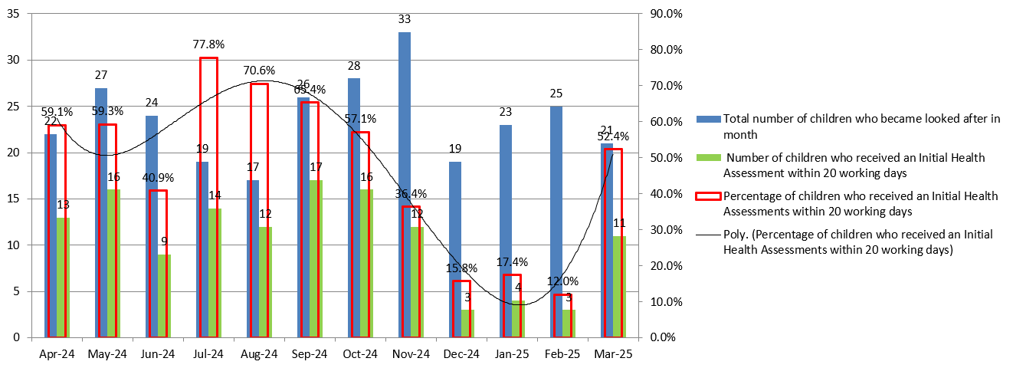

Table 5: Number and percentage of children who received a Review Health
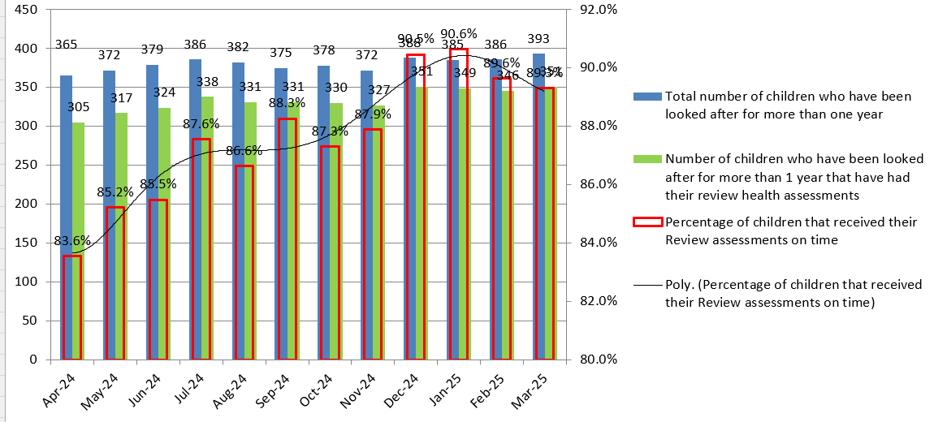
Assessment in 2024/2025 (Target 90%)

Table 6: Number and percentage of children who have been looked after for more than one year who received a dental assessment in 2024/2025 (Target 90%)

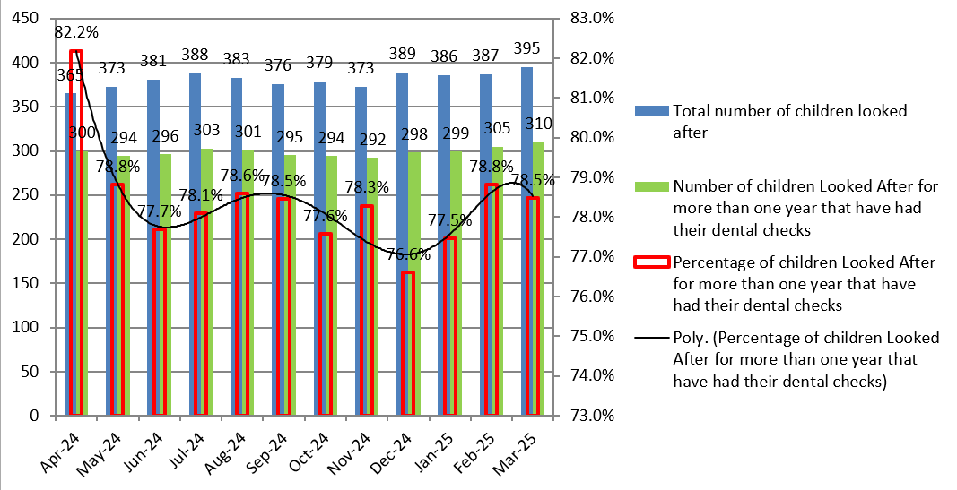

Table 7: Number and percentage of children aged 4 years plus who have been Looked After for more than one year who have an SDQ score recorded (Target 90%)
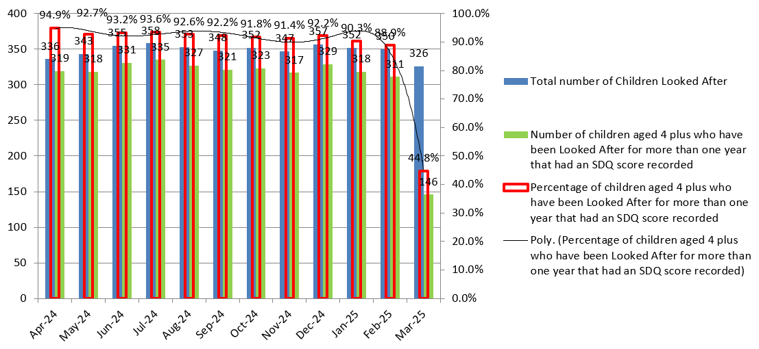

8.11 November 2024 saw a peak in the number of children who became looked after, (Table 4). There did not appear to be any pattern to this and although there were some larger family groups included in these figures Somerset Council are unable to categorically explain why.

8.12 Initial Health Assessment performance also fluctuated throughout the year. Performance was impacted by workforce challenges, late notifications and in particular children not being brought to their agreed appointments. Work was undertaken in 2023/2024 to review the actions taken by both Health and Somerset Council to facilitate the Initial Health Assessments. This was with the aim of addressing the notification, consent, booking, and attendance issues that continue to account for most delayed assessments. Paperwork was revised and refreshed and rolled out in December 2024, however there were significant challenges in relation to IT and Social Worker training which has resulted in a significant number of late notifications of children coming into care. This will require further partnership working with Somerset Council to address performance issues in 2025.

8.13 Review Health Assessment (RHA) performance, (Table 5), rose throughout 2024/2025 from 86.3% in April 2024 to 90.6% in January 2025.

8.14 From January 2025 all Review Health Assessments for children under 5 will be allocated to Specialist CLA Nurses, who will liaise with the Public Health Nursing (Health Visitor) colleagues to consider a joint visit to undertake the assessment together. This new process, which has been piloted by the CLA Health adoption team ensures a timely, high-quality, robust assessment is completed, bringing together all the health information relating to the child and their development. This new way of working also ensures there is a lack of duplication for carers.

8.15 Review Health Assessment Clinics were introduced in November 2024 and of the 443 RHA’s completed in 2024-2025 64% were completed within the child’s home and 16% were completed in a clinic setting.

8.16 Dental assessment performance, (Table 6), has fluctuated throughout 2024/2025 with a high of 82.25 of children who have been in care for over a year receiving their annual dental check, to a low of 76.6%.

8.17 The Designated Nurse worked with the Head of Pharmacy, Optometry and Dentistry to develop a CLA Dental Recovery Action Plan which was presented to Corporate Parenting Board in August 2024 detailing the work planned and currently underway to improve access to dentistry for CLA in Somerset. NHS Somerset is currently working on a dental bespoke care pathway for CLA and Care Leavers.

8.18 Strengths and Difficulties Questionnaires, (SDQs), (Table 6), performance overall was high throughout 2024/2025. Performance dipped to 44.8% in March 2025 and will require close monitoring through 2025. Support for children with high SDQ scores is available through CAMHS and the Somerset Council Emotional Health and Wellbeing team.

9 ADOPTION

9.1 As part of the ongoing work to improve the health offer to the adoption pathway NHS Somerset ICB has taken forward the following actions in 2024/2025:

- Facilitation of the weekly multi-agency health offer to adoption meeting, which continues to be a vital platform for effective adoption planning. Key activities include- reviewing children under parallel planning for adoption, managing requests for medical reports, tracking available information to ensure compliance with adoption regulations, allocating workstreams to Agency Medical Advisors to include meetings with prospective adopters.

- The management of post-adoption health records is a complex process that requires coordination across all Trust digital systems, including updating alerts and supporting adoption order processes. A collaborative approach is adopted, supported by a multi-agency tracking meeting held fortnightly to ensure continuity of care.

- Proactive transition planning for children with a plan for adoption to ensure seamless care.

- Regional and national engagement to include attending South West Adoption Consortium meetings at a regional level and networking with adoption nurses across the UK to support peer supervision at a national level.

9.2 In June 2024 NHS England published a briefing in relation to the management of adoption records in health. The briefing highlighted that when a child is adopted and given an NHS number, their medical records should be merged with the new post-adoptive details where possible across all health records. Information governance and data principles must be enhanced to prevent any information breaches. Whilst the changes have been straightforward to implement in Primary Care, due to the amount of IT systems and their functions in Secondary Care we have yet been able to fully implement the guidance. This is a national issue which has been escalated to NHS England by the Southwest Designated Nurses. The Somerset NHS Foundation Trust lead Nurse for Adoption will be implementing Gold Quality Improvement training for post adoption record management.

10 RISK AND AREAS OF CHALLENGE

10.1 Risks and challenges were identified and addressed in 2024/2025 as per Table below. Those listed on the ICB’s Corporate Risk Register include the risk score calculated on 31 March 2025:

CHALLENGE | solution
Children looked after health services not being delivered within statutory time frames  Risk 318  Score 15 | Children Looked After Provider Nursing team is fully funded and fully staffed  Improved scrutiny of health assessment pathway and targeting of assessments that are likely to be late  Improved accuracy in performance data  Improved multi agency collaborative working  Multi agency operational and strategic groups meet regularly  Additional Health and Social Care meetings taking place to address specific process issues  Scrutiny of Children Not Brought to appointments as part of refresh of trust wide processes  Escalation processes in place if children placed out of area do not receive a health assessment within statutory timescales
Risk of poor dental access for CLA and Care Leavers  Risk 547  Score 12 | Agreed regional escalation pathway in place.  Dentistry has now been delegated to ICBs’ and work is underway to improve access to CLA and CL. The Designated Nurse is working with Pharmacy; Optometry and Dental leads to develop plans for how this can be achieved.  Oral health prevention services prioritise children looked after in somerset and will also offer one off assessments  Somerset Council in their role as corporate parent will pay for private dental assessments and treatment if all other options have been explored and dismissed. However, this is a pathway that we are working to improve in 2025.
Risk the ICB is unable to deliver its obligations regarding the adoption pathway  Risk 576  Score 12 | Working to migrate medical records from one NHS number to the other. ICB is working with the system to support the migration. Primary care.  SFT's Adoption lead nurse is meeting with digital and information governance regularly to ensure the risk of any information breaches are mitigated and any progress can be made on the new guidance on managing adoption records. - Gap  ICB are supporting the strengthening of the Adoption Medical Advisor Workforce.  The Designated Doctor is working in a flexible way to better meet demand whilst resources are reduced. Senior Managers are meeting with staff to discuss roles and responsibilities to meet demands and ensure quality is upheld.
11 progress against Objectives for 2024/2025

11.1 The following objectives were identified for completion 2024/2025:

  - Progress work to ensure Children Looked After and Care Leavers receive an up-to-date dental assessment and continue work with Somerset ICB Commissioners to improve access to dental assessment and treatment for Children Looked After and Care Leavers – ACHIEVED AND ONGOING
  - Strengthen the CLA Health Service’s offer to children with emotional and mental health needs – ACHIEVED AND ONGOING
- Recruit into a Specialist CLA Nurse post for Mental and emotional health – ACHIEVED.
- Undertake a Review Health Assessment deep dive to review the actions taken by both Health partners, Somerset Council and Public Health Nursing to facilitate the Review Health Assessments of children and young people with the aim of addressing any issues in relation to notification, booking and attendance issues that might account for delayed assessments – ACHIEVED.
- Strengthen the partnership working between Health and Education partners to meet the needs of Children Looked After – ONGOING.
- Continue to monitor the health needs of Unaccompanied Asylum-Seeking Children and ensure that these health needs are met. Finalise the Unaccompanied Asylum pathway – ACHIEVED AND ONGOING.
- Develop a local plan to allocate the NHS England Universal Family Programme investment to implement the Care Leaver Covenant within the Somerset system – ACHIEVED AND ONGOING.

12 OBJECTIVES FOR 2025/2026

12.1 The following objectives have been identified for completion 2025/2026:

- Progress work to ensure Children Looked After and Care Leavers receive an up-to-date dental assessment and continue work with Somerset ICB Commissioners to improve access to dental assessment and treatment for Children Looked After and Care Leavers
- Strengthen the CLA Health Service’s offer to children with emotional and mental health needs.
- Strengthen the partnership working between Health and Education partners to meet the needs of Children Looked After.
- Development of a Somerset Health Offer to Adoption Strategy.
- Roll out of revised Initial Health Assessment paperwork.
- Regional work to agree a revised process for Adoption Medical Advisors supporting Adoption Panel.
- Develop an options paper in relation to free prescriptions for Care Leavers.
- Work with Somerset NHS Foundation Trust and Digital leads to further implement the NHSE briefing in the management of Adoption records.
- Succession planning in partnership with Somerset Foundation NHS Trust in relation to the CLA Health Service medical team.
- Work with multi-agency partners to drive system-wide reforms for Children Looked After, ensuring alignment with the Children’s Social Care National Framework (Dec 2023), Keeping Children Safe, Helping Families Thrive (Nov 2024), and the Children’s Wellbeing and Schools Bill, pending parliamentary approval.

13 CONCLUSION

13.1 On 1 April 2025, the government announced a major NHS reform programme. As ICBs move to a more strategic commissioning model, functions supporting Children Looked After will be affected, and some ambitions for improving outcomes may change.

13.2 The ICB’s statutory responsibilities for Children Looked After must remain central to all strategic decisions. Any changes in responsibilities or resources should be carefully assured to avoid gaps in oversight, weaken multi-agency collaboration, or negatively impact Children Looked After. Continuity, clarity, and accountability in these arrangements are essential for legal compliance and for maintaining trust in the ICB’s ability to support our most vulnerable children.

13.3 NHS Somerset Integrated Care Board are requested to note the contents of this report.

