

PAN DORSET AND SOMERSET CHILD DEATH OVERVIEW PANEL (CDOP)

Annual Report from 1 April 2022 – 31 March 2023

**PAN DORSET AND SOMERSET CHILD DEATH OVERVIEW PANEL (CDOP)**

**Annual Report from 1 April 2022 to 31 March 2023**

# Introduction

The purpose of this report is to provide Child Death Review partners and members of the Pan-Dorset and Somerset Safeguarding Children Partnerships with an update for the last twelve-month period during 2022/23 in relation to the work of the Child Death Overview Panel (Hereafter referred to as CDOP).

The Child Death Review partners for the Child Death Overview Panel geography are:

* Bournemouth, Christchurch, and Poole Council (hereafter referred to as BCP).
* Somerset County Council.
* Dorset Council.
* NHS Somerset ICB.
* NHS Dorset ICB.

A Child Death Review is undertaken for all deaths of children aged 0-17. Once a notification is received, information is collected from professionals who knew the child and family and once investigations are finalised a child death review meeting is held. After this meeting, the case is anonymised and presented at the Child Death Overview Panel. The purpose of a review is to identify any matters relating to the death, or deaths, that are relevant to the welfare of children in the area or to public health and safety, and to consider whether action should be taken in relation to any matters identified.

# Child Death Overview Panels

The panel continues to consist of members from Dorset and Somerset, focused on meeting statutory requirements in relation to Child Death Reviews (CDRs) in accordance with Working Together and Child Death Statutory and Operational Guidance.

The panel is currently chaired by a Dorset representative with a Somerset representative vice-chairing. This will continue until September 2023 when it will rotate. We have embedded the change in meeting structure to include all four Designated Doctors for child death as part of each panel as this has provided increased scrutiny and peer review during discussions as well as support.

The Child Death Overview Panel (CDOP) core members are:

* + Designated Doctors for child death (2 attending for each county),
  + Social Care representatives (2 Local / Unitary Authority representatives 1 for each county),
  + Police Force representatives (1 each from Dorset and Avon and Somerset)
  + NHS Dorset ICB / Somerset ICB Designated Nurses Safeguarding Children
  + Public Health representative
  + NHS Dorset ICB / Somerset ICB Primary Care representative
  + Nursing representative
  + Midwifery representative for Neonatal cases
  + Obstetric representative for Neonatal cases

|  |
| --- |
| **The Panel’s Shared Purpose**  Our shared purpose is to provide high standard child death reviews and to ensure maximum impact of learning, which is shared in line with agreed governance structures within both counties.   * We will work together to professionally scrutinise every child death within Dorset and Somerset. * We will ensure the voice of the family is heard in the reviews, key learning is shared and embedded into practice, and recommendations made in line with local policy. * We will also feed into national networks to share data and help identify potential themes which can only be identified at scale. |

Since Covid-19 restrictions were initially in place and the panels were facilitated virtually using Microsoft Teams software, we reverted back to face to face panels as soon as Covid-19 restrictions allowed. This was at the request of the panel who felt that the positives of a face to face meeting vastly outweighed the negatives.

Learning: As a panel we now incorporate remote participation for those providing expert input and attending for a single case. We are also confident we have an effective method to deliver the panel remotely if a major incident should require this in future.

# CDOP Data

The CDOP panel has met 8 times in 2022/23 and reviewed **69** deaths: **37** Pan-Dorset deaths (18 Dorset and 19 BCP) and **32** Somerset deaths.

In **38** (55%) of these cases there were modifiable factors identified. This compared to last year’s figures where 47 cases were reviewed, and modifiable factors were identified in 40% of cases. We await the annual National Child Mortality Database (hereafter referred to as NCMD) report due in November to compare where these sit against national figures and we will produce an appendix report to communicate this

The panel also reviewed cases that meet the LeDeR criteria. LeDeR is a process set up to review the lives and deaths of people with a learning disability and autistic people. A LeDeR review is required for children over the age of 4 years who died with a diagnosed learning disability and/or autism. The focus of LeDeR is to improve services, reduce inequalities in health and to reduce premature death. For these cases, a LeDeR representative is invited to attend the Local Child Death Review Meetings and the Child Death Overview Panel meeting to facilitate collaborative working.This is changing for the CDOP year 2023/24 and there is no longer a requirement to notify LeDeR of child deaths but we will continue to share learning from LeDeR cases.

# Child Deaths – Notifications (01.04.22 to 31.03.23)

Child Death Overview Panel (CDOP) has been notified of a total of 37 deaths of Pan

Dorset residents and 19 deaths of Somerset residents during this twelve-month period. In addition there was 1 notification of an Out of County child, resident elsewhere who died within our area – this death will be reviewed and recorded by their home Local Authority.

# Number of Child Deaths notified to CDOP by Local Authority

The graph below shows child deaths by local authority, year on year. Over the last 5 years, child deaths were at their lowest in 2021-22 and highest in 2019-20. There is no specific reason for this and there is no current increasing or decreasing trend in child death numbers either in Pan-Dorset and Somerset or at Local Authority level.

# Reported Child Deaths with Joint Agency Responses

The Pan-Dorset total number of deaths (37) is made up of 15 reported in Bournemouth, Christchurch and Poole, 22 in other areas of Dorset. Out of the 37 deaths, 16 were neonatal. In the previous reporting year 7 neonatal deaths were reported.

The Somerset total number of deaths (19) included 5 neonatal deaths, compared to the previous year (2021-22) in which 11 of the 19 deaths reported were neonatal.

Within both Dorset and Somerset, the majority of deaths were expected and did not require a Joint Agency Response. The graph below shows the distribution of these across the footprint.

NOTE: It is no longer a requirement that we categorise deaths into expected and unexpected cohorts for the national data return. But we are still aware of unexpected deaths as they will initiate a Joint Agency Response (previously known as a Rapid Response) and for the deaths during 2022/23 there were 12/37 where one was commenced in Dorset, and 8/19 where one was commenced in Somerset.

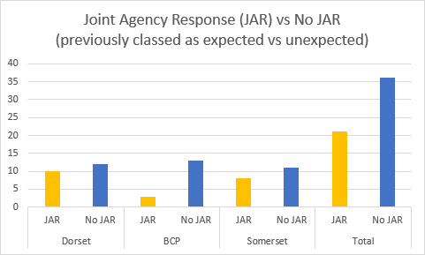

The following 2 graphs show further information relating to child death profiling. The highest volume of child deaths are in the 0-27 day-old category. This is expected as it includes those born with signs of life but often with life limiting conditions or extreme prematurity. They also show that there were more male vs female deaths. This reflects the 2021-22 national gender picture. This year we have an increased proportion of deaths in the 28–365-day subgroup. This is caused by the unusual proportion of 6 currently unexplained deaths in the past year (2022/23). Local reviews have not occurred yet for these deaths as post-mortem reports are still awaited. Any themes that come out of these reviews will be reported as they evolve.

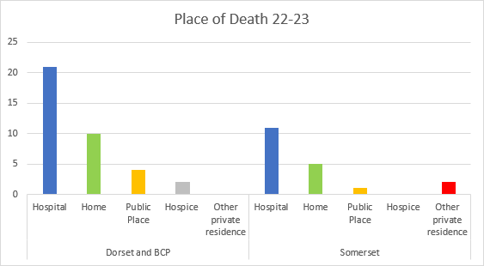

The distribution is reflected similarly in the most recently published national statistics for place of death.

# CDOP Cases reviewed

The table below shows the amount of cases reviewed by CDOP by categories of death, of Dorset and Somerset children and out of area children over the last 5 years.

Data for 2018-19 was combined from individual Pan Dorset and Somerset panels prior to conception of the joint panel in July 2019.

Lower figures represented in years 2020-21 and 2021-22 related to the COVID-19 pandemic in which led to a delay in inquests and thus cases to review. The delayed cases along with historic neonatal cases submitted in bulk from a Tertiary Centre led to the significant increase in cases reviewed by CDOP in 22-23.

Categorisation of Dorset and Somerset cases reviewed by the Pan-Dorset and Somerset CDOP in the last 5 years:

|  |  |  |  |  |  |  |
| --- | --- | --- | --- | --- | --- | --- |
| **Category** | **2018/19** | **2019/20** | **2020/21** | **2021/22** | **2022/23** | **Total** |
| 1. Deliberately inflicted injury, abuse, or neglect. | 0 | 0 | 0 | 1 | 0 | 1 |
| 2. Suicide or deliberate self-inflicted harm. | 4 | 0 | 5 | 4 | 5 | 18 |
| 3. Trauma and other external factors, including medical/surgical complications/error. | 7 | 7 | 0 | 5 | 4 | 23 |
| 4. Malignancy. | 9 | 3 | 2 | 8 | 4 | 26 |
| 5. Acute medical or surgical condition. | 4 | 9 | 1 | 2 | 4 | 20 |
| 6. Chronic medical condition. | 1 | 1 | 1 | 2 | 4 | 9 |
| 7. Chromosomal, genetic, and congenital anomalies. | 16 | 7 | 11 | 6 | 14 | 54 |
| 8. Perinatal/neonatal event. | 17 | 17 | 11 | 12 | 27 | 84 |
| 9. Infection. | 1 | 7 | 6 | 3 | 2 | 19 |
| 10. Sudden unexpected, unexplained death. | 4 | 3 | 4 | 6 | 5 | 22 |
| **Total number of deaths reviewed by CDOP** | **63** | **54** | **41** | **49** | **69** | **276** |

# Modifiability

CDOP is required to assess the preventability of each death by considering whether there were factors which may have contributed to the death of the child and if so, whether these could be “modified” to reduce the risk of future child deaths. During 2022/23 CDOP identified modifiable factors in 38 of the 69 (55%) deaths reviewed.

In 2022/23 the modifiable factors shown in the graph below were identified across CDOP deaths.  Where appropriate, panel members were given actions to highlight certain modifiable factors for learning and practice implications within agencies.

The largest proportion of modifiable factors in 2022/23 fell under the category of “quality of service delivery”.  Cases 1-3 on page 10 of this report demonstrate some examples of the learning, actions and service improvement resulting from the identification of some of the service delivery modifiable factors in CDOP cases.

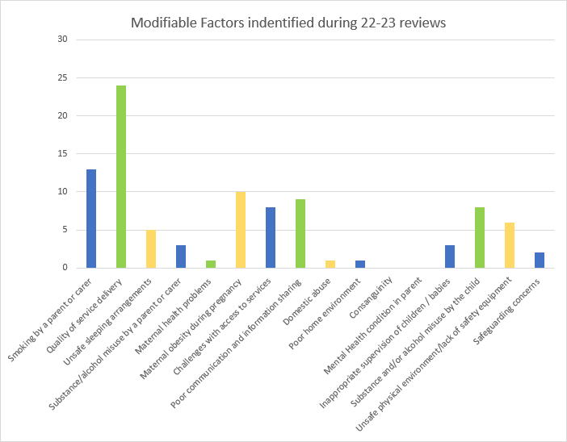

# Analysis of Child Death Themes

Suicide: Between April 2022 and March 2023, the CDOP reviewed 5 deaths which were categorised as ‘suicide or self-inflicted deliberate harm.’ Modes of death were all hanging.

For each of these reviews, the CDOP has sought specialist psychiatrist input from CAMHS and multi-agency work has been carried out immediately after each death under the Joint Agency Response process to identify peers and siblings, ensuring that they are supported and not also at risk of dying by suicide, Implementing the suicide contagion protocol devised following CDOP review last year.

SUDI: During this CDOP year, we have reviewed 5 SUDI deaths. Health visiting were invited to attend panels where SUDI cases were being discussed.

# Learning and Outcomes

Below is a selection of some of the recommendations, actions in progress or outcomes of cases discussed this year:

|  |  |
| --- | --- |
| **Case 1 – Herpes Simplex Virus**  The panel reviewed the case of a 11 day old baby readmitted to hospital with HSV.  As a result of this case the Dorset protocol was updated and shared with Somerset professionals. | The protocol for neonatal sepsis has been updated and specifically includes guidance about HSV infection and treatment. The PIER guidelines re HSV are also used and referenced in Dorset County Hospital’s guidance. |
| **Case 2 – Antepartum Haemorrhage**  The panel reviewed the case of a baby born at 27 weeks. Baby developed severe metabolic acidosis.  Panel felt there were many similarities between this case and a previous case and there were concerns that changes had not been implemented following previous learning. | The concern was fed back to the LMNS safety group in the integrated care system this death occurred and they confirmed that there is now an established Consultant Lead for Foetal Monitoring to support Quality Improvement in this acute setting. |
| **Case 3 – Cannabis use in pregnancy**  The panel reviewed the case of a baby whose death was recorded as unascertained. Mother smoked cannabis during and following pregnancy.  The panel requested exploration of resources for parents around cannabis use in pregnancy. | There is an ongoing piece of work with NICU and Paediatrics for both Somerset hospitals to develop a parental pathway. This information will be shared with Dorset hospitals. |
| **Case 4 – Children Looked After**    CDOP identified potential links between 4 cases (3 child deaths and 1 Rapid Review) which involved Children Looked After with emotional health and wellbeing needs and placement instability.  The panel requested that these 4 cases, were reviewed by the Dorset and Somerset Designated nurses for safeguarding children and Children Looked After (CLA), to identify themes to be fed back to CDOP and the local safeguarding children partnerships. | There is an ongoing piece of work to review the impact of the statutory reviews that were undertaken. |

# Other Outcomes

* Escalation to NHS England (NHSE) regarding the guidance for use of antibiotics in pre hospital care for neonates. Awaiting outcome from NHSE.
* On 20th April 2023, Dorset held a CDOP Learning Event, invites were sent to a multi-agency audience. The event covered the following:
  + The Contribution of Newborn Health to Child Mortality across England
  + Gold Standard Care – examples of local case management
  + Educational Psychology team – offer of support to schools
  + The role of Dorset’s End of Life Nurses
  + The role of the Medical Examiner in Paediatrics

The CDOP learning event feedback was sought retrospectively. The feedback was unanimously positive, with consistent requests for future similar events including the topic of adolescent mental health.

* JAR training was delivered by the Designated Doctors Child Death and Avon and Somerset Police for Somerset Paediatricians based within one hospital setting. Another event will be held later this year. These are held in recognition of the numbers of staff joining Paediatrics and to ensure continued awareness of statutory Child Death Review protocols.
* Both Dorset and Somerset audited their 5-year history of modifiable factors. This was carried out to explore whether there were any patterns or trends that hadn’t previously been highlighted, the audit showed no themes and this exploration is now carried out through the NCMD.
* Two additional neonatal panels were held this reporting year, this was due to the number of neonatal deaths and also receiving forms for backlogged cases where the reviews had been held by a Tertiary Centre.
* We have strengthened the membership of the Neonatal panels with the recruitment of a Dorset Obstetrician to complement the Somerset Obstetrician representation. The Dorset Deputy Director of Maternity and Perinatal services will also be attending enhancing specialist knowledge and impact of learning across the system.
* CDOP reviewed an out of area CDR which focused on individual instead of system learning, clarity was sought to ensure all information was available to the reviewer. The panel highlighted the importance of system based learning which CDOP had identified and wasn’t apparent from the local review. This challenge demonstrates the maturity and ethos of the panel.
* CDOP reviewed a case following CSPR in which the national shortage of paediatric pathologists and the availability of only one Bone Pathologist Nationally led to prolonged delays in identifying forensic fractures and thus the delayed escalation of safeguarding concerns. The CSPR author requested this be highlighted within the CDOP annual report.
* The following learning was shared across both Somerset and Dorset:
  + Somerset shared the information for the Support for New Fathers project which offers new fathers a 30 minute session with a health coach within the first four weeks of becoming a father. This is a pilot project.
  + Dorset suicide contagion protocol was shared with Somerset.
  + Somerset pre birth standard operating procedure was shared with Dorset.
  + Highlight the use of unsupervised saturation monitors and explore issues such as appropriate warnings to parents. This case was presented at the Somerset Paediatric Improvement Group and learning shared with Dorset professionals.

# Future Developments

* NCMD released updated pro forma’s and guidance which will allow a much more detailed breakdown and analysis of contributory factors in child deaths. This will make it easier to identify patterns and trends going forward.
* Dorset are partaking in a Perinatal Mortality Review Team (PMRT) / CDOP merger pilot. This will eradicate duplication for babies who also fall under the PMRT remit and the software will facilitate the PMRT data to auto-populate the CDOP reporting and analysis forms. This will improve efficiency and ensure a streamlined review for babies in this remit.
* Linking with the South West CDOP Regional Chairs Network to share learning and aim towards a more standardised process and reporting for CDOPs across the region incorporating national good practice.

**Prepared By:**

Sam Abdollahian and Patsy Temple, CDOP Chair and Vice Chair.

Emma Porter and Zoe Hiett Child Death Review Co-ordinator’s.

**Date:** 05.10.23