Care Home UTI Assessment Tool
Patient: ………………………….……………..
DoB: ……………………….............................
Care home: ……….…………………………...
Date:…………………Carer: …………….…...
Older patients (>65) with suspected UTI (urinary tract infection)
Guidance for care home staff
- Complete 1) to 4) and patient details and forward to GP – original to patient notes
- DO NOT PERFORM URINE DIPSTICK – Not recommended in pts >65
- CLEAR URINE – UTI highly unlikely
- Send MSU particularly if treatment failure or >2 signs of infection (especially dysuria, temp >38c or new
incontinence)
1) Catheter Y / N Reason for catheter …..……………………………………………………………………………………………..

2) Signs of any other infection source? Y / N If yes, circle any NEW symptoms
Cough Shortness of breath Sputum production Nausea/vomiting Diarrhoea Abdominal pain Red/warm/swollen area of skin

catheter…………………………………………………………………………………………………..

3) Can patient communicate symptoms Y / N |  |  |  | 4) Record for all patients:
New onset sign/symptom | What does this mean? | Tick if present |  | Sign/symptom | Tick if present
Dysuria | Pain on urinating |  |  | Temp above 38c or below 36c or shaking chills (rigors) in last 24 hrs
Urgency | Need to pass urine urgently/new incontinence |  |  | Heart rate >90 beats/min
Frequency | Need to urinate more often than usual |  |  | Respiratory rate >20 breaths/min
Suprapubic tenderness | Pain in lower tummy/above pubic area |  |  | Diabetic?
Haematuria | Visible blood in urine |  |  | If not diabetic – blood glucose >7.7mmol/L
Polyuria | Passing bigger volumes of urine than usual |  |  | New incontinence
Loin pain | Lower back pain |  |  | New onset or worsening confusion or agitation
Any other information …………………………………………………………………………………………………….……………………………………………………………………………
5) GP to Action – circle all which apply: e) Antibiotic prescribed: (please document)
a) Patient visit required
b) Uncomplicated lower UTI
c) Mid-stream urine specimen (MSU) required (if 2 or more signs of infection)
d) Pyelonephritis (dysuria, temp >38c or new incontinence) or failed treatment f) Any other actions:

Has care home been contacted with clinical decision: Yes No Signed:………………………………………………… Date: ………………
v. 1 102023
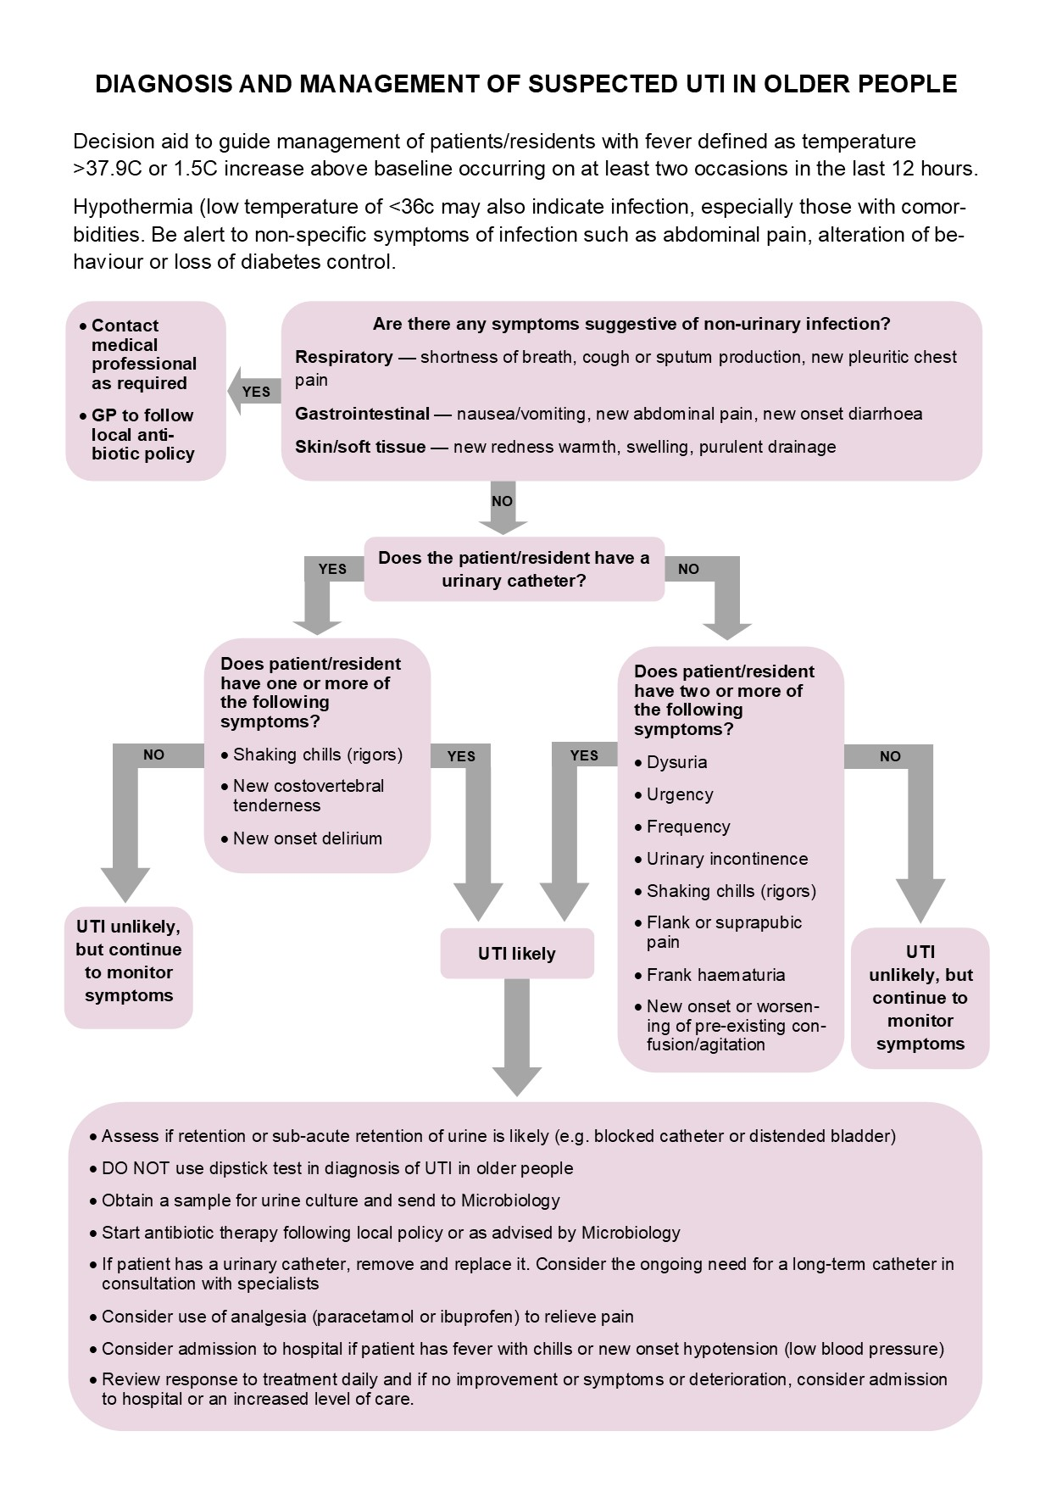
]
For Primary Care Use only
URINE CULTURE IN WOMEN AND MEN >65 YEARS

- Do not send urine for culture in asymptomatic elderly with positive dipsticks
- Only send urine for culture if two or more signs of infection, especially dysuria, fever >38c or new incontinence
- Do not treat asymptomatic bacteriuria in the elderly as it is very common
- Treating does not reduce mortality or prevent symptomatic episodes, but increases side effects & antibiotic resistance

URINE CULTURE IN WOMEN AND MEN WITH CATHETERS

- Do not treat asymptomatic bacteriuria in those with indwelling catheters, as bacteriuria is very common, and antibiotics increase side effects and antibiotic resistance
- Treatment does not reduce mortality or prevent symptomatic episodes but increase side effects & antibiotic resistance
- Only send urine for culture in catheterised if features of systemic infection. However, always:
  - Exclude other sources of infection
  - Check that the catheter drains correctly and is not blocked
  - Consider need for continued catheterisation
  - If the catheter has been in place for more than 7 days, consider changing it before/when starting antibiotic treatment
- Do not give antibiotic prophylaxis for catheter changes unless history of symptomatic UTIs due to catheter change

UKHSA
UTI Prevention and Awareness toolkit

Diagnosis tools
Diagnosis of UTIs – quick reference tool for Primary Care

References: Nina S et al (2014). Investigation of suspected urinary tract infection in older people. BMJ 349
October 2023 Kind acknowledgement to NHS Bath and North East Somerset, Swindon and Wiltshire ICB Mandy Slatter/Elizabeth Beech

