 Learning Brief - Contractures |  |  |  | 
The LeDeR programme aims to improve care, reduce health inequalities and prevent early deaths of people with a learning disability and autistic people.
Email us at somicb.leder@nhs.net for further information.
A contracture is a permanent tightening of the muscles, tendons and nearby tissues that causes the muscle to shorten and the joint to become very stiff. Contractures can arise because of:
- Not moving a limb through its full range (independently or with assistance)
- Static positions for a prolonged period eg sitting in a wheelchair or lack of assistance to change position
- Increased muscle tone
Common areas for contractures include inside of thighs, back of knees, calves, biceps, wrists, and fingers.
Contractures can have a significant impact on:
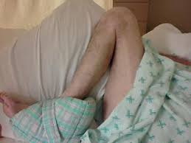
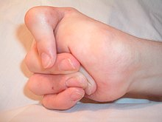
- Ability to complete personal care
- Skin integrity
- Breathing and an individual’s risk of a chest infection
- Pain and discomfort for the individual
- Being able to sit in a chair and / or upright
- Participating in activities of daily living
- Quality of life
Case Study 1 – Findings from LeDeR Review  John had a mild learning disability (LD) and lived in the community with relatively little support from care agencies for most of his life. John’s deteriorating mobility was not effectively managed in his supported living environment. His mobility was very poor, joints very stiff and he was often in pain. This culminated in a hospital admission with cellulitis and sacral sore.  He was discharged to the community hospital for rehabilitation however he found it difficult to engage. When he was discharged from the hospital to a nursing home his mobility had not improved and he had significant contractures of his left leg. He lost the ability to stand and transfer, developed several pressure wounds and experienced significant unplanned weight loss.  He did not receive timely intervention and despite input from LD Physiotherapy, his contractures and chronic pain worsened. He became increasingly confined to his bed because he could not sit safely due to his contractures. This impacted on his wider physical health, wellbeing and quality of life as John had been very sociable man who liked to interact with others.  The LeDeR review found that John's health had been deteriorating for some years however this was not proactively monitored or managed adequately, taking account of his LD. It was suggested that patient deterioration tools including the monitoring of symptoms of contractures are key to proactively monitoring health and care needs. |  | Case Study 2 – Findings from LeDeR Review  Jane had a learning disability, a stroke and a diagnosis of vascular dementia. She had been living in a mainstream care home for 14 years prior to her death. Appropriate postural equipment and management had not been implemented by the home and she developed severe contractures.  Contractures were first documented in 2014 when she was unable to weight bear and was described as being "bed bound". Specialist advice regarding this was not sought by the care home or by other professionals involved with her care until 2021.  By that time she needed full assistance of two care staff with all activities of daily living and personal care. Due to the severity of contractures in her arms and legs, even when a specialist assessment was sought, she was not able to sit in any specialist seating chair or bathing equipment.  The LeDeR review highlighted the need for increased awareness and training across the system about the risks of contractures and the impact of these on an individual's quality of life and care needs. It also suggested that the use of screening tools should be promoted to aid assessment and management of contractures including to guide timely referrals to specialist services.  Note: names have been changed to protect confidentiality.
Reflections  These case studies are two of many examples of people who were referred too late to Physiotherapy with severe contractures.  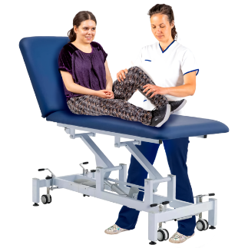  Contractures can significantly impact an individual's physical health, mental well-being, and quality of life. In severe circumstances, secondary complications can result in hospital admissions and contribute to an individual’s death.  Contractures are often preventable.  We can reduce the risk of them  developing and worsening through  positioning / movement care plans  provided by Physiotherapy. |  | Making a Referral  Early referral to Physiotherapy is vital. The Contracture Risk Assessment Tool and / or Postural Care Tool (details below) can be used to aid decision-making about whether a referral is needed.  Referrals for people with a learning disability should be emailed to the Community Team for Adults with Learning Disabilities via CTALDHealthReferrals@SomersetFT.nhs.uk  Mainstream Physiotherapy services can be accessed from the Community Rehabilitation Service (CRS) via: Community rehabilitation service (CRS) - Therapies (somersetft.nhs.uk)  Concerns should also be discussed with the person’s GP.
Practice
- The Observational Risk Assessment for Contractures- Longitudinal Evaluation (ORACLE) is a risk assessment tool for contractures currently being piloted by Dorset Healthcare University NHS Foundation Trust (DHUFT): Development, Validation, and Evaluation of a Risk Assessment Tool for Contractures: the ORACLE Study - Full Text View - ClinicalTrials.gov
- Contracture Risk Assessment Tool (CRAT): 200318-A-tool-to-prevent-and-manage-contractures-in-care-home-residents.pdf (emap.com)
- Changing Our Lives - Postural Care Tool: Tool for health professionals, families and carers.
Knowledge
- Prevention of Contractures leaflet - Northern Health and Social Care Trust (NHSCT)
- Contractures Awareness Training (DHUFT):
https://www.youtube.com/watch?app=desktop&v=aITUZ63khr0

- 7 Minute Learning - Dorset and Bournemouth & Poole Safeguarding Adults Boards:
PowerPoint Presentation (bcpsafeguardingadultsboard.com)
- LeDeR Postural Care Fact Sheet:
https://www.bristol.ac.uk/media-library/sites/sps/leder/2096_PosturalCare_PDF.pdf
- The Chartered Society of Physiotherapy:
Addressing the cost of contractures | The Chartered Society of Physiotherapy (csp.org.uk)
Patient Information  - Your contracture prevention passport - The Royal Wolverhampton NHS Trust: MI_4448314_28.06.22_V_2_Public.pdf (rwt.nhs.uk)  - It is recommended that bespoke patient-specific accessible information is provided for people with a learning disability where appropriate. |  |  |  |  | 
Processes
A Positioning / Movement Care Plan written by a Physiotherapist must never be discontinued, changed or transcribed into another format without consultation with a Physiotherapist.
somicb.leder@nhs.net |  |  | Issue no 5 July 2024

