Learning from the Lives and Deaths of People with Learning Disabilities and Autism (LeDeR)
Newsletter – 11th edition – December 2023

Please remember to notify LeDeR when someone dies
It helps us all to have a better understanding of the needs of people with a learning disability and autistic people; helps improve services in Somerset and provides an opportunity to shout about good practice! If you provide care or support to someone with a learning disability, or an autistic person,
are a GP or other health professional, a family member, friend or carer we need you to notify us if someone dies.  It’s very simple to do and will only take about 10 minutes. Here is the link to the form Report the death of someone with a learning disability (leder.nhs.uk). | 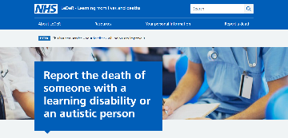

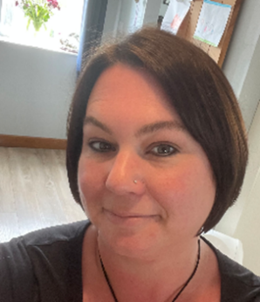 | Welcome to Lauren Newcombe who joins us as our Senior Reviewer. Lauren is a Speech and Language Therapist who has been working within specialist learning disability health teams for 14 years. Lauren started working in a residential home for people with learning disabilities and autism while studying to become an SLT. Since then, she has been passionate about supporting people with a learning disability to live good lives. She is looking forward to a new challenge within the LeDeR team.

Learning Disability and Dementia  Rosie’s film – supporting a good life for someone with a learning disability and dementia - YouTube | 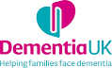
Someone with a learning disability is more likely to develop dementia than the rest of the population, sometimes at a younger age, and it may get worse more quickly than for someone without a learning disability. This short film shares what works to support timely diagnosis and a good life at home in the community, hearing from Rosie and some of the people involved in Rosie’s care and support.

For more information, please visit:
Learning disabilities and dementia - Dementia UK | LeDeR - Resource Bank | Specialist support to families facing dementia - Dementia UK | Empowering people with learning disabilities | MacIntyre (macintyrecharity.org)

Dementia webinar for Health and Social Care staff supporting people with a Learning Disability | 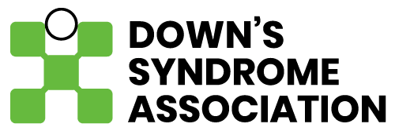
Julian Hallett from the Downs Syndrome Association will be delivering a number of webinars in the new year to provide staff supporting adults who have Down's Syndrome to understand the importance of recognising the possible signs of the onset of dementia and the need to take a differential diagnosis approach. Is it, in fact, dementia or what other possible causes of changes in individuals’ functioning and wellbeing need to be considered?

Learn about the ‘philosophy of good care’ and practical strategies to ensure that individuals are well supported, and their changing care needs are addressed.

Click here for further details of content, dates and booking links.

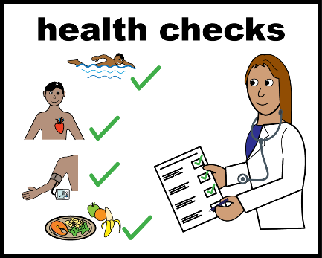 | Cancer screening  NHS England have produced a short video presented by Jodie, who has a learning disabilities about what to expect from a cervical screening appointment, and why it’s important to go.  Accessing cervical screening with the right support for people with a learning disability - YouTube  And biggerhouse films have released a short film made by and for women with learning disabilities about attending breast screening - do the test! | biggerhouse film

Annual Health Checks –  in their own words  A group of Experts by Experience have produced a video explaining what a good quality Annual Health Check looks like. It is underpinned by 10 Principles by which people would like to be treated, which have also been written by people with a learning disability who live in Somerset. The video and the Principles were showcased at the recent Registered Care Providers Association (RCPA) Conference. The Experts – Glen, Kimberly and Alexandra - were presented with certificates in recognition of their hard work by Paul Coles, Service Director of ASC Commissioning and Eelke Zoestbergen, NHS Somerset’s Quality Lead for Mental Health, Learning Disability and Autism (back row). | 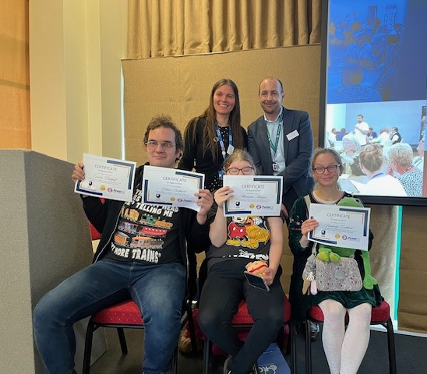  Watch the video here  Annual Health Check Principles - YouTube

Somerset Independent Living Centres  Jennie Hallett, NHS Somerset’s Quality Facilitator for Mental Health, Learning Disability and Autism, recently visited the Yeovil Independent Living Centre. It’s one of several across the county – there are others in Shepton Mallett and Wellington – which are now open for free pre-booked appointments where people can talk to their Adult Social Care Occupational Therapy-led team and try out equipment and technology to make daily living easier.  These Centres are a key part of Somerset Council’s prevention approach helping people to help themselves, either through providing the equipment as part of their appointment or people purchasing items themselves to help make daily living easier.  These are some of the suppliers they use:  Medequip Somerset | Brain in Hand | OMI Interactive Projectors | Home Library Service | Somerset Independence Plus | 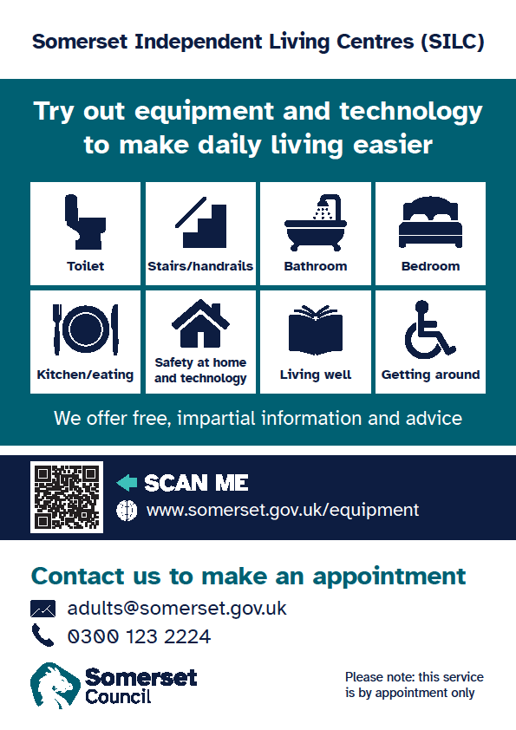

Obstructive Sleep Apnoea (OSA) can be common in people with a learning disability, and in particular people with Down’s syndrome.

Untreated OSA can impact on mental health as well as causing significant risks to physical health. OSA can be life-threatening if the risks of non-compliance with continuous positive airway pressure (CPAP) treatment are not understood by individuals and their carers.

NHS England have produced these resources for people with a learning disability, their carers and healthcare professionals.

NHS England » Continuous positive airway pressure (CPAP) resources for people with a learning disability
NHS England » Continuous positive airway pressure (CPAP) resources for carers
NHS England » Continuous positive airway pressure (CPAP) resources for healthcare professionals

Personalised Safety Plans
Many of the teams at Somerset Foundation Trust (SomFT) create personalised safety plans for patients which can be used to help someone navigate suicidal feelings and urges, as well as self-harm. Now their Clinical Psychologists are taking that one step further for people with learning disabilities by creating interactive and visual safety plans that are more easily accessible.

Most safety plans, while still created specifically for the individual, are often typed up and printed out on a page. But for people with a learning disability, a written, printed safety plan can be difficult to use – and for people who struggle to read or write, it’s almost impossible.
Personalised Safety Plans can also be useful for carers to use when a person is experiencing a time of crisis, and even just the process of creating them has been somewhat therapeutic for people.  “Many of the patients we’ve worked with on the plans have come away with a real sense of pride and find the process enjoyable.” Clinical Psychologist and Learning Disabilities Specialist, Dr Laura Day. Find out more about how they do it here. | 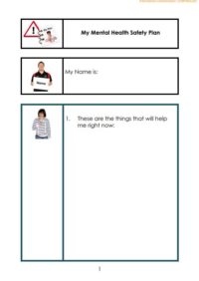

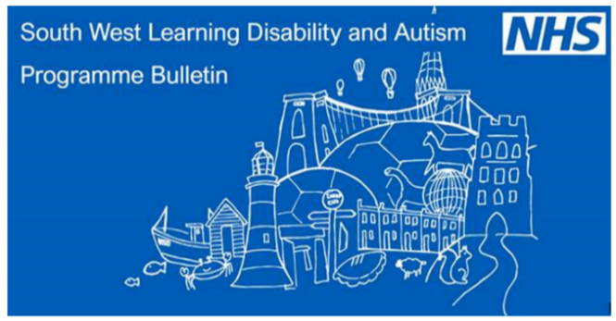  england.learningdisabilityandautism-sw@nhs.net  Email this address if you would like to keep up to date and be added to the distribution list. | The latest issue includes articles on  - the recently-launched Winter Vaccines Communications Toolkit for people with a learning disability  - new guidance on Service Specifications and Best Practice for Professionals, NHS Commissioners, Health and Social Care professionals and service providers.  - the dangers of constipation in individuals with a learning disability – a subject coming up in our ongoing series of Learning Briefs.

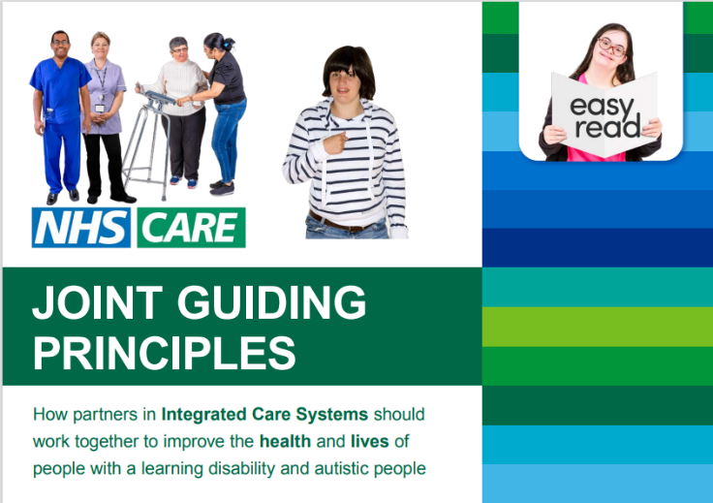 | NHS Joint Guiding Principles – now available in Easy Read  This document sets out how partners in health and social care should work together to improve the health and lives of people with a learning disability and autistic people  Joint-guiding-principles-for-integrated-care-systems--learning-disability-and-autism-easy-read-version.pdf (england.nhs.uk)

Do you use Fingertips?
Fingertips is a great source of public health data, delivered by the Office for Health Improvement & Disparities. Here you will find a wealth of information to support or dismiss any questions you may have about our populations. Data is organised into themed profiles covering a wide range of health conditions, including child and maternal health | dementia | health inequality | learning disability | mental health | NHS health checks | palliative and end of life care | physical activity.

It also has a handy tool for Local Authority Health profiles, so you can see what’s going on in other parts of the country, or you need to compare similar workstreams.

Find out more here Public health profiles - OHID (phe.org.uk)

Contact Us
If you would like to contact our LeDeR team with any questions or queries please do so using the email address somicb.leder@nhs.net - we would love to hear from you.
And if there is anything you’d like to see included in a future newsletter, please let us know.

Images used in this newsletter are Copyright Leeds and York Partnership NHS Foundation Trust 2017 and Photosymbols

