 | Learning from the Lives and Deaths of People with Learning Disabilities and Autism (LeDeR)
Newsletter – 7th edition – June 2022
Welcome back!
Take a look at our latest LeDeR newsletter – we’ve had a bit of a break from the newsletter and have lots to share with you.

 | 2021 updates to LeDeR
- There is a new national policy and LeDeR website where you will find lots of background information about LeDeR leder.nhs.uk/about. This is also where you report the death of someone with a Learning Disability.

- The LeDeR programme now includes people with autism without a learning disability and these deaths should also be reported via the LeDeR website

- We are now able to do either an Initial Review or a more detailed Focused Review of the lives and deaths of people with a learning disability. Which type of review is carried out is decided by our team although NHS England has asked that people with autism and certain other groups of people must always have a focused review.

- Our team has changed and grown since the new LeDeR policy came into effect last year – meet the team on page 4.

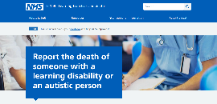 | Making a notification
It’s important to remember that anybody can notify a death to the LeDeR programme – GPs, health and social care staff, family members, friends and carers.

Timely and detailed notifications help us to have accurate information and to carry out prompt reviews. The reviews are a chance for us to highlight what has worked well for the person as well as influencing where services may need to improve.

This is the link to the webpage for Notifications: leder.nhs.uk/about.

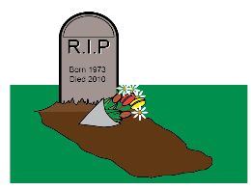 | LeDeR deaths in Somerset 2020-2021
Our most recent complete year of data is 2020-2021.
- 54 deaths were notified to LeDeR for Somerset
- 49 reviews were completed (with two waiting for other investigations/coroner reports)
- 3 were for children and young people aged 4 -18 years and are covered by a different review process
- 15 of those who died were female • 39 were male

27 died in their usual place of residence (residential / nursing home)
15 died in an acute hospital
5 died at home
7 died in other settings, including hospices, supported living, etc

In many of our reviews where Covid-19 has not been the cause of death, it is evident the Covid-19 restrictions in place at the time of the death had some impact on the person’s health and care experience at the end of their life.

The table below shows the most common causes of death in Somerset. The impact of Covid-19 on people with a learning disability, who are especially vulnerable, is evident.

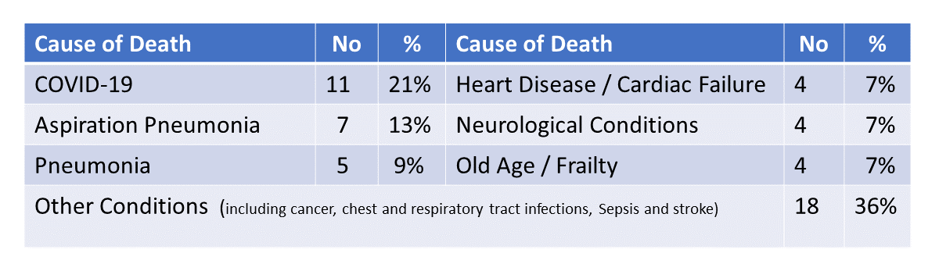
Images used in this newsletter are Copyright Leeds and York Partnership NHS Foundation Trust 2017

Other News
- The LeDeR team is continuing to raise the profile of the health needs of people with Learning Disabilities across the system.
- We are in the very early stages of working with Open Storytellers to help us understand and develop how we can engage service users in the LeDeR governance process.
- Biggerhouse Film is working with us to produce a film looking at supporting and encouraging people with learning disabilities’ conversations about death and dying.

Good Practice…..
Through the LeDeR reviews we identify areas of good practice as well as highlighting possible areas of service improvement. Below are examples of good practice we have found.
Care hours continued to be commissioned when the person is in hospital so they continue to have care from people who know them well and can speak up for them.
During the COVID-19 pandemic the GP practice were in weekly contact with the care provider and digital technology was used to assess patients with a virtual ward

A care provider who adapted a person’s living environment to enable her to remain and die at home as she had wanted.
Support from the GP, hospice, palliative care team and district nurses, including a 24/7 helpline for carers, with robust TEP in place to ensure a person’s end of life needs were met and a peaceful death achieved
Bespoke visual resources made to support a person’s understanding of his care plan.

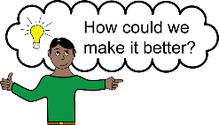 | … and Service Improvement  Below are some examples of service improvement work we are involved with:
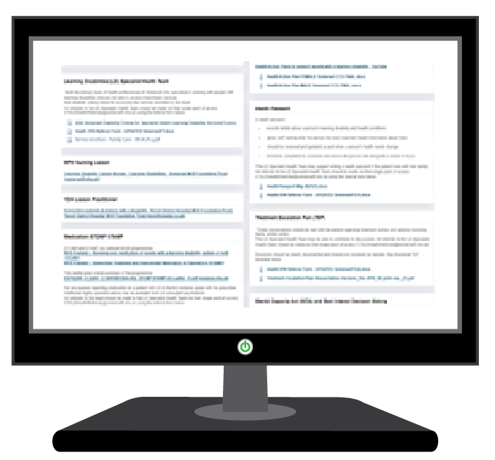 | TeamNet
The launch of a Learning Disability LeDeR page on the TeamNet platform and shared with GPs, primary care networks, health and social care staff and the public via this link https://teamnet.clarity.co.uk/Announcements/ViewItem/0fffd186-e2b6-46a4-89bb-ae3600c28282
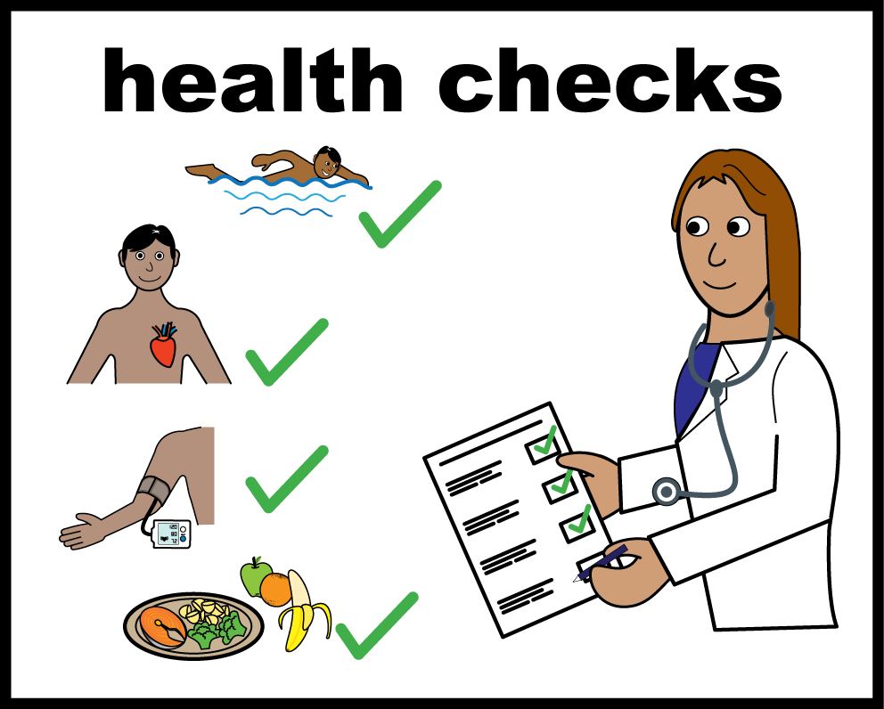 | The Annual Health Check Programme
To improve people’s experience and outcomes. This includes launching new pre-health check questionnaires – My Health Check – for men and women. Further consultation is going ahead with My Health Check for young people aged 14-18 years.
For more information see Learning Disability Annual Health Checks – Registered Care Providers Association (rcpa.org.uk)

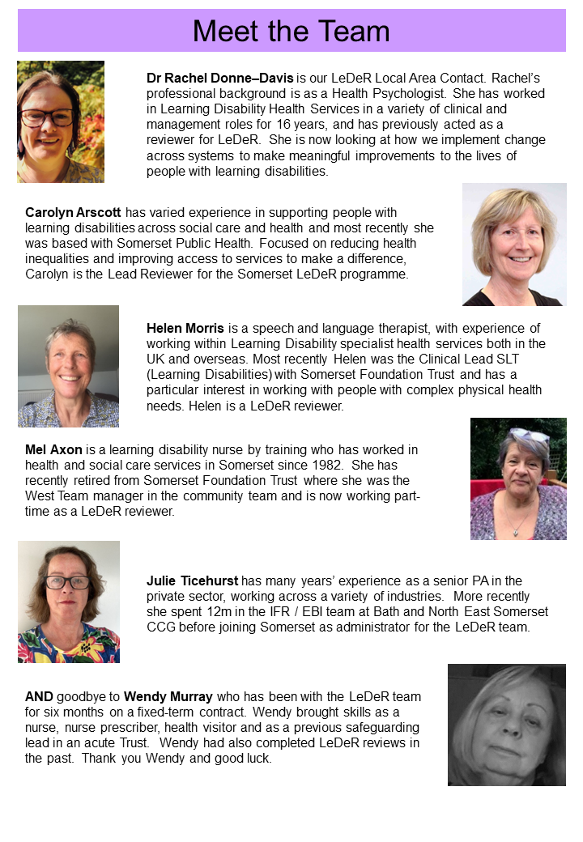
Contact Us
If you would like to contact our LeDeR team with any questions or queries, please do so using the email address somicb.leder@nhs.net - we would love to hear from you. And if there is anything you’d like to see included in a future newsletter, please let us know.

