


SAFEGUARDING SUPERVISION POLICY

Version: | 1
Ratified by: | Quality Committee
Date Ratified:
Name of Originator/Author: | Kerry Male, Deputy Designated Nurse Safeguarding Children  Louise Smailes, Deputy Designated Nurse Safeguarding Adults
Name of Responsible Committee/Individual: | Shelagh Meldrum, Chief Nursing Officer
Date issued: | February 2025
Review date: | February 2028
Target audience: | All staff employed within NHS Somerset Integrated Care Board.

SAFEGUARDING SUPERVISION POLICY

CONTENTS

Section |  | Page
SECTION 1 | INTRODUCTION | 1
SECTION 2 | LEGISLATION | 2
SECTION 3 | SCOPE AND PURPOSE | 2
SECTION 4 | ROLES AND RESPONSIBILTIES | 2
SECTION 5 | SAFEGUARDING SUPERVISION PROCESS | 5
SECTION 6 | MONITORING | 6
APPENDIX 1 | STAFF REQUIREMENTS FOR SUPERVISION
APPENDIX 2 | SUPERVISION CONTRACT
APPENDIX 3 | SUPERVISION MODELS

SAFEGUARDING SUPERVISION POLICY

VERSION CONTROL

Document Status: | Final draft
Version: | 1

DOCUMENT CHANGE HISTORY
Version | Date | Comments
1

Sponsoring Director:  Author(s): | Shelagh Meldrum, Chief Nursing Officer / Executive Lead for Safeguarding  Kerry Male, Deputy Designated Nurse SGC  Louise Smailes, Deputy Designated Nurse SGA
Document Reference:

SAFEGUARDING SUPERVISION POLICY

1 | INTRODUCTION
1.1 | NHS Somerset Integrated Care Board (hereafter referred to as ‘the ICB’) recognise the following:  - The importance of staff wellbeing  - The duty to protect and safeguard the welfare of children and adults at risk  - The responsibility to promote a culture of safety, equality, and protection.  - Professionals who work with traumatised children, families and adults are at risk of taking on some of the physiological, psychological and emotional consequences of the abuse. Otherwise known as Vicarious trauma..
1.2 | This Policy complies with all relevant legislation and local, regional and national policies, procedures and guidance which includes but is not limited to:  - Care Act 2014  - Children Act 1989  - Children Act 2004  - Working Together to Safeguard Children: A guide to inter-agency working to safeguard and promote the welfare of children 2023  - Safeguarding Children and Young People: Roles and Competencies for Healthcare Staff  - Adult Safeguarding: Roles and Competencies for Health Care Staff | Publications | Royal College of Nursing  - Looked After Children: Roles and Competencies of Healthcare Staff | Royal College of Nursing
1.3 | To effectively safeguard and promote the welfare of unborn babies, children and adults, staff need to feel confident, competent and supported in their safeguarding role. This includes having strong structures in place that provides opportunity for robust safeguarding supervision which enables constructive challenge, allows time to reflect on safeguarding practice and consider the development of safeguarding skills and knowledge. Local arrangements for safeguarding supervision must meet the needs of specific staff groups and support the effective discharge of statutory safeguarding duties in accordance with local and national legislation, policy and guidance.

2 | LEGISLATION AND GUIDANCE
2.1 | The ICB has a duty under Section 11 of the Children Act (2004) to ensure that their functions are discharged with regard to the need to safeguard and promote the welfare of children.
2.2 | Working Together to Safeguard Children (2023) provides the statutory framework for promoting the welfare of children and highlights the importance of safeguarding supervision.
2.3 | The Care Act (2014) provides the statutory framework for safeguarding and promoting the welfare of adults.
3 | SCOPE AND PURPOSE
3.1 | This aim of this policy is to define the supervision offer provided by the ICB Safeguarding Team to ICB employees and to safeguarding leads in ICB commissioned healthcare providers across the Somerset Health System, ensuring staff have access to high quality and effective safeguarding supervision.
3.2 | This Policy applies to and must be adhered to by all NHS Somerset ICB employees.
3.3 | All staff must receive effective safeguarding supervision according to the requirements of their job role (see appendix 1).
4 | ROLES AND RESPONSIBILITIES
 | Organisational Accountability
4.1 | The ICB must ensure that all staff have access to appropriate safeguarding supervision, including those designated as safeguarding leads in ICB commissioned healthcare providers.
 | The ICB will ensure that professionals providing safeguarding supervision are appropriately trained and supported and have up to date knowledge and understanding of safeguarding legislation, policy and guidance.
 | Line Managers
4.2 | Line Managers are responsible for ensuring staff are aware of and compliant with this policy. They are responsible for ensuring all staff they line manage have access to informal / ad hoc safeguarding supervision and relevant staff are provided with protected time to fulfil their formal safeguarding supervision requirements .

4.3 | Line managers are also responsible for:  - (Jointly with the ICB Safeguarding Team) Monitoring relevant staff’s attendance at formal safeguarding supervision. It is the responsibility of line manager to address any performance concerns or non-compliance of staff.  - Reinforcing safeguarding supervision requirements during the appraisal process.
 | Supervisor Responsibilities
4.4 | The ICB Safeguarding team, including Designated professionals and the Named Professional for Primary Care and POD services will deliver the role of safeguarding supervisor to ICB Staff. They will provide expert advice, support and safeguarding supervision to safeguarding leads of ICB commissioned services who provide health services to the local population.
4.5 | All safeguarding supervisors will ensure they:  - Have received training in safeguarding supervision skills  - Have up to date knowledge in legislation, policy, guidance and research relevant to safeguarding unborn babies, children, young people and adults  - Have joint responsibility with line manager for arrangements of safeguarding supervision  - Have joint responsibility with line managers for monitoring attendance at safeguarding supervision for those roles that require mandatory safeguarding supervision  - Receive regular safeguarding supervision themselves  - Share knowledge and skills with supervisee  - Are accountable for the safeguarding support and advice that they provide  - Conduct safeguarding supervision in a safe, confidential, and uninterrupted environment, creating a psychological safe space to ensure any learning can be identified  - Identify where they do not have skills to safely address issues raised and redirect supervisee accordingly  - Discuss management of individual safeguarding cases to explore and clarify management and thinking relating to the case.  - Provide clear feedback to supervisee  - Clarify with the supervisee who is responsible for implementing any required actions resulting from safeguarding supervision, including escalation  - Demonstrate professional curiosity and if required, constructively challenge any identified areas of concern  - Will keep clear records of those who attend safeguarding supervision.
 | Individual / Supervisee responsibilities
4.6 | Safeguarding supervision is underpinned by the principle of practitioners remaining accountable for their own practice; as such they should take responsibility for accessing safeguarding supervision either formally or informally, according to their job role. Safeguarding supervision does not replace nor delay an individual’s responsibility to act upon safeguarding concerns or make a referral to statutory agencies or emergency services as and when needed if they are concerned about the immediate welfare of an individual.
4.7 | A supervisee has certain responsibilities to ensure they receive the most effective and timely support:  - Familiarise themselves with ICB Safeguarding Supervision Policy, which is to be used in conjunction with other ICB Safeguarding policies  - Ensure they are up to date with the correct level of safeguarding training for their role  - Understand their responsibilities in relation to safeguarding  - Access advice, support and ad-hoc supervision from ICB Safeguarding team as and where required  - Ensure they receive safeguarding supervision within the required time scales if in a role that requires mandatory safeguarding supervision  - Complete any agreed actions from safeguarding supervision within jointly agreed timeframes  - If supervision is facilitated virtually, supervisors and supervisees are responsible for ensuring they have access to a camera and microphone and utilise them throughout the supervision session, ensuring they are in a private space  - Maintain and securely store accurate, meaningful, and contemporaneous records and documentation of any active case discussions  - For reflective case discussions, supervisees are responsible for writing their own reflective accounts and summaries  - Supervisees should prepare for safeguarding supervision identifying relevant safeguarding issues for exploration  - Be responsible for accessing any development requirements identified through safeguarding supervision.  - Be prepared for constructive challenge and feedback  - Develop skills in reflective practice.

4.8 | In addition to the ICB safeguarding team proving formal safeguarding supervision to ICB Employees; they offer safeguarding supervision to Primary Care and Safeguarding Leads for ICB commissioned health care providers (outlined in appendix 1).
5 | SAFEGUARDING SUPERVISION PROCESS
5.1 | Safeguarding supervision can be undertaken on a one-to-one basis, or within a group. Safeguarding supervision is a planned discussion that promotes reflection and learning on safeguarding, although there may be times when ICB staff seek ad-hoc supervision for live issues.
5.2  5.3 | The frequency of safeguarding supervision offered is outlined in Appendix 1. The frequency will be tailored to teams needs depending on whether the complexity of safeguarding cases they manage, whether they receive safeguarding supervision from other sources and aligning to the Intercollegiate Documents.  Safeguarding supervision may be undertaken face to face, or virtually. As safeguarding supervision is interactive and participatory, everyone involved must use to a camera and microphone if taking place virtually.
5.4 | Adequate and protected time must be allowed for effective supervision to take place; interruptions should only be allowed in urgent situations. A minimum of one hour should be allowed a planned supervision session.
5.5 | Formal safeguarding supervision sessions should be undertaken within a supervision contract (Appendix 2). For group supervision, these must be agreed and signed by either the supervisees or the line manager for the team.
5.6 | The purpose of this contract is to ensure:  - Clarity of expectations for both the supervisor and supervisee  - Roles and responsibilities are defined and understood  - Ground rules are explored and agreed  - Immediate risk management and escalation processes are agreed.
5.7 | A copy of the contract will be held both the supervisor and the supervisee. The supervisor will take responsibility for monitoring and reviewing the contract with the supervisee when job roles have been amended and/or when this policy is updated.
5.8 | Supervisees are responsible for contemporaneous documentation in patient clinical records for any live cases. The supervisee is responsible for writing their own reflective accounts for continuing professional development purposes.
5.9 | Safeguarding supervisors will keep a record of attendance at safeguarding supervision and share with line managers as required.
5.10 | Safeguarding supervision models can be utilised, inclusive of, but not limited to models outlined in Appendix 2.
5.11 | Supervisors may access supervision through a formal offer from a Safeguarding Supervisor, ‘Peer Supervision’ which is a joint offer with other safeguarding professionals and/or access supervision ‘out of area’ through colleagues equivalent to their role in other ICBs.
6 | MONITORING
6.1 | This policy will be reviewed three yearly or earlier if indicated. Compliance with the policy will be monitored and reported to the ICB Safeguarding Assurance Meeting and escalated by exception to the ICB Quality Committee.

Element of policy for monitoring | Section | Monitoring method -  Information source (e.g. audit)/ Measure / performance standard | Item Lead | Monitoring frequency /  reporting frequency and route | Arrangements for responding to shortcomings and tracking delivery of planned actions
Database of those attending safeguarding supervision | 4.4 /  Appendix 1 | All attendees of safeguarding supervision will be monitored through the safeguarding supervision dashboard  Review of compliancy of staff in roles requiring mandatory safeguarding supervision using the safeguarding supervision dashboard | Designated / Deputy Designated Nurses for Safeguarding Adults, Children and Children Looked After / Named Professional for Safeguarding in Primary Care and PODs. | Minimum of once yearly | Compliancy report to ICB Safeguarding Assurance Meeting (SAM). Escalation to Quality Committee by exception.
Mandatory roles attending safeguarding supervision
Training and competencies requirements | 4.4 / 4.5 / Appendix 1 | Collation of data for mapped training compliance and competencies | Designated / Deputy Designated Nurses for Safeguarding Adults, Children and Children Looked After/ Named Professional for Safeguarding in Primary Care and PODs. | Yearly | Annual Report  Compliancy reporting to ICB Safeguarding Assurance Meeting (SAM). Escalation to Quality Committee by exception.

STAFF REQUIREMENTS FOR SAFEGUARDING SUPERVISION

Staff Role | Required supervision frequency | Individual / Group | Supervisors
Designated Professionals | 3 monthly | Both | Peer / out of area
ICB Safeguarding / LeDeR Team | Quarterly | Group | Peer
GP / POD  Safeguarding Leads | 3 monthly | Both | Named Professional for safeguarding in Primary Care and PODS / Safeguarding Professional
Named Professionals for Safeguarding (long form contracts) within provider trusts | Quarterly | Both | Designated Professionals
Safeguarding leads (short form contract services) | 6 monthly | Group | Deputy Designated professionals
Deputy Named Professionals within provider trusts | 3 monthly | Both | Deputy Designated Professionals
Continuing Health Care (CHC) Identified Roles | 6 weekly | Group | Deputy Designated Professionals
SEND Team | Quarterly | Group | Deputy Designated Nurse for Safeguarding Children
Complex Care Team | Quarterly | Group | Named Professional for Safeguarding in Primary Care and PODS / Safeguarding Professional
ICB roles that support complex cases | Quarterly | Group | Designated/ Deputy Designated Professionals
Other ICB roles | Ad-hoc | As required | ICB Safeguarding Team

SAFEGUARDING (SG) SUPERVISION CONTRACT

SUPERVISOR: | Somerset Integrated Care Board
SUPERVISEE:

1 Aims of the SG supervision process:

- To safeguard and promote the welfare of unborn babies, children, young people and adults at risk
- To ensure that the professional is clear about his/her roles and responsibilities in relation to safeguarding unborn babies, children, young people and adults at risk.
- To provide support and advice in relation to the safeguarding work undertaken by the supervisee
- To assist in the supervisee’s professional development in relation to safeguarding.
- To be a source of safeguarding advice and support for the supervisee.
- To provide regular feedback on practice related to local and national safeguarding national legislation, national, regional and local policies, procedures and protocol.
- To provide a forum for updating the supervisee on any changes to local and national SG arrangements.

The supervision agreement will be reviewed annually

- Arrangements agreed for Supervision

Frequency: Quarterly

Length: Minimum 1 hour

Location: Wynford House

- Recording of Supervision

- When specific cases are discussed as part of the session the professional presenting the case will record in the person’s records (and any relevant family members if applicable) that a supervision discussion took place and will include any agreed actions.
- The Supervisor will keep a record of who attended the safeguarding supervision session

- How will the focus of the supervision session be agreed?

- Supervisees to bring key issues to discuss in supervision and at the beginning of supervision, the supervisor and supervisee will then agree which issues will be prioritised.

- Content and focus of supervision will be based on:

- Agreeing and monitoring actions agreed at a previous session regarding a specific case
- Development of the supervisee’s skills and knowledge base in relation to safeguarding.
- Facilitation of any escalation required regarding a specific safeguarding issue.
- Providing opportunity to reflect more generally on experiences of, and feelings about safeguarding issues.
- Case studies from within practice wherever possible.

- A shared commitment to safeguarding (SG) supervision

The Supervisor and Supervisee will commit to:

- Keep all information revealed in the supervision sessions confidential
- If anything is to be taken out of the supervision session, this will be agreed by all parties.
- If all parties do not consent to information being taken out of the supervision session, the caveat is that the need to safeguard an individual child or adult will be the priority.
- Identify if the session is not meeting supervisees needs and agree how it can be changed to better facilitate this.

The Supervisor will commit to:

- Prioritise facilitation of planned SG supervision sessions
- Offering advice, support and supportive challenge to enable you to reflect on your safeguarding practice.

The Supervisee will commit to:

- Actively participating in SG supervision sessions
- Identifying issues for reflection and appropriate discussion
- Prioritising attendance at planned SG supervision sessions

Supervisor Name:
Signed:
Date:

Supervisee Name:
Signed:
Date:

SUPERVISION MODELS

Supervision models and styles may vary. Supervision can be considered as a ‘swingometer’ (see graph1) (resource available here Research in Practice), noting that functions of supervision may vary or compete with each other. Supervisors and supervisees need to be aware of competing functions and needs to ensure it does not impact quality of supervision.
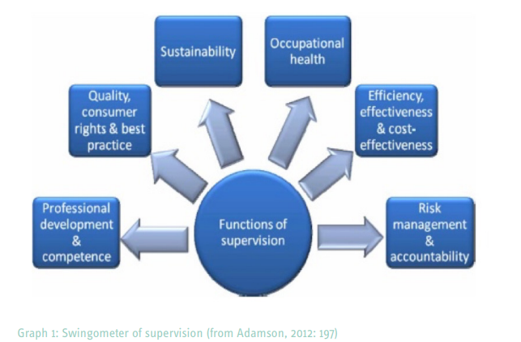
There are a number of models of supervision available, e.g. Gibbs Reflective Cycle, Kolb’s experiential learning cycle and the 4x4x4 Model. Models for supervision can be used through one to one or group supervision. Supervisors can utilise different models to support supervision.
The 4x4x4 Model (available through: Research in Practice; Models for supervision) (see Graph 2) is an integrated model of supervision:
Four functions of supervision:

- Competent, accountable performance (managerial function)
- Continuing professional development (development/ formative function)
- Personal Support (supportive function)
- Engaging the individual with organisation (mediation function)
Four stakeholders of supervision:

- Service Users
- Staff
- Organisation
- Partners

Four stages of supervision cycle:

- Experience (what happened?)
- Reflection (what was it like?)
- Analysis (what does this mean?)
- Plans and actions (what next?)
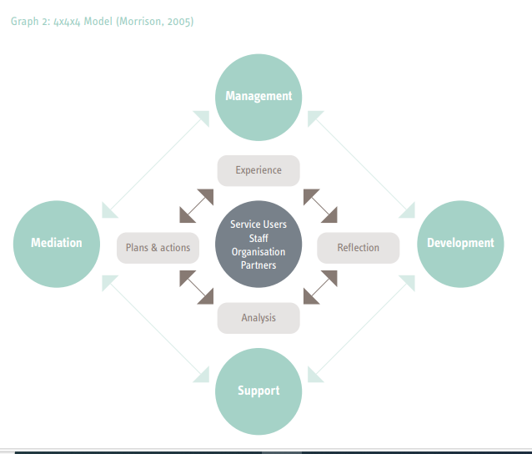
Effective supervision should:

- Patient focused, considering the voice of the child/adult
- Provide a dedicated space for practitioners to be able to reflect on their safeguarding practice
- Be open and supportive
- Support practitioners to critically reflect on their decisions and practice
- Strengthen practitioners’ analysis to improve safe practice
- Promote prevention and early identification of concerns and put appropriate interventions in place
- Provide a psychologically safe environment for staff to share stresses that can be associated with safeguarding work
- Promote Think Family approach, considering safeguarding across the life span
- Create environment that is conducive to constructive challenge with the ability to escalate if required.

NSPCC Research Briefing Vicarious trauma: the consequences of working with abuse
- Safeguarding Children and Young People: Roles and Competencies for Healthcare Staff
- Safeguarding Children and Young People: Roles and Competencies for Healthcare Staff - Adult Safeguarding: Roles and Competencies for Health Care Staff | Publications | Royal College of Nursing - Looked After Children: Roles and Competencies of Healthcare Staff | Royal College of Nursing

