SAFEGUARDING CHILDREN
ANNUAL REPORT
2022 - 2023

August 2023

SAFEGUARDING CHILDREN (SGC) ANNUAL REPORT 2022 to 2023

CONTENTS

1 | PURPOSE OF THE REPORT | 4
2 | DELIVERY OF statutory SAFEGUARDING FUNCTIONS | 4
3 | safeguarding assurance | 7
4 | progress against PRIORITIES for 2022 – 2023…………... | 8
5 | PRIORITIES FOR 2023 - 2024 | 10
6 | CONCLUSION | 11

Author | Marie Davis Designated Nurse SGC
Developed in conjunction with | Deputy / Designated Professionals for Safeguarding Children (SGC)
Sponsor | Shelagh Meldrum
Role | Chief Nursing Officer / Executive Lead for Safeguarding
Date | August 2023

- PURPOSE OF THE REPORT

1.1 This report covers the period of 1st July 2022 to 31st March 2023 and is the first Safeguarding Children annual report for NHS Somerset Integrated Care Board (Thereafter referred to as ‘the ICB’). This report provides assurance to the ICB Board and members of the public that the ICB has fulfilled its statutory responsibilities to safeguard and promote the welfare of children.

1.2 The narrative throughout this report gives an overview and summary of assurance against our statutory functions and the shared local priorities of safeguarding partners. This report will conclude by looking forward to the year ahead identifying key priorities for 2023-2024.

1.3 In accordance with statutory guidance the ICB’s core business is to safeguard and promote the welfare of children, through the provision of high-quality and effective support, with agencies, frontline professionals and practitioners commissioned by the ICB being clear about their own and each other’s roles and responsibilities and how we work together to safeguard children and their families.

- DELIVERY OF STATUTORY SAFEGUARDING FUNCTIONS

2.1 Somerset Safeguarding Leadership and Accountability

    - The accountability for safeguarding rests with the Chief Executive of the ICB, as the accountable officer. The safeguarding children team are part of the ICB strategic safeguarding team, which is led by the Associate Director of Safeguarding, Mental Health, Learning Disabilities and Autism. The Designated Professionals for Safeguarding Children report via the Associate Director of Safeguarding, Learning Disability, Autism and Mental Health to the Chief Nursing Officer / Executive Lead for Safeguarding.

    - As part of a well-established integrated approach quarterly safeguarding assurance reports are provided to the ICB Quality Committee from a safeguarding adult, safeguarding children and children looked after and care leavers perspective. These are reported by exception to the Integrated Care Board. The Integrated Care Board receives the Safeguarding Children annual report alongside separate Child Death Review arrangements and Children Looked After and Care Leavers annual reports.

    - The ICB strategic safeguarding children team structure incorporates the statutory roles of Designated and Deputy Designated Nurses, Designated Doctor, Named Professional for Safeguarding in Primary Care and Pharmacy, Optometry and Dental services (hereafter referred to as ‘PODs’), and administrative staff. The reporting structure in Table 1 below demonstrates the safeguarding children governance arrangements:
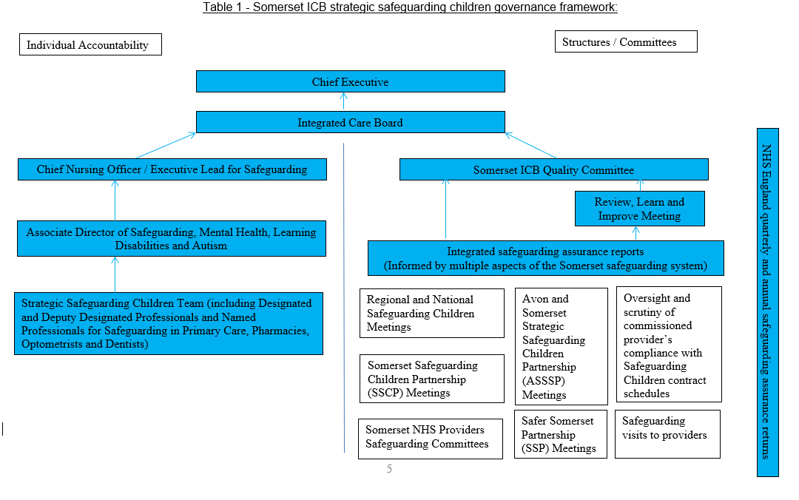
  - Discharging Statutory Safeguarding Children duties

2.2.1 Accountability: There is a clear line of accountability for safeguarding children reflected in the ICB governance arrangements as described in Table 1 above. The NHS Safeguarding Accountability and Assurance Framework (SAAF) was revised in July 2022 and clearly sets out the roles and responsibilities of all individuals working in providers of NHS funded care settings and NHS commissioning organisations. Substantial assurance on how the ICB has met its statutory roles and responsibilities in relation to safeguarding children has been provided to NHS England South West safeguarding team from 1st July 2022 to 31st March 2023 through the following:
- Provision of quarterly Safeguarding Assurance reports.
- Safeguarding Commissioning Assurance Toolkit (SCAT) submissions
- System updates provided to the South West safeguarding steering group.
- System updates provided to and through the South West Designated Professionals forums.
- A safeguarding visit to the ICB by the NHS England South West safeguarding team in February 2023.

2.2.2 Policies and Procedures:. The ICB’s Safeguarding Children policy sets out our commitment and approach to safeguarding children and was updated in February 2023. The policy structure was changed to better support staff in quickly accessing sections on What to do if they are concerned about a child. Updates also included:

- New local and national safeguarding guidance e.g. Child Was Not Brought, Pre-Birth Protocol and Perplexing Presentations / Fabricated or Induced Illness in a Child.
- Inclusion of new statutory duties in relation to Serious Violence and Domestic Abuse.
- A strengthened safeguarding supervision section.

The policy has been shared with NHS providers, ICB staff and GP practices as several practices then adopt this policy as their own.

2.2.3 Safeguarding Training: In partnership with the wider strategic safeguarding team an all-day training event has been provided virtually to GP safeguarding leads and ICB staff in September 2022. This was in addition to training opportunities provided by the Somerset Safeguarding Children Partnership (SSCP) training team, and Safer Somerset Partnership. Feedback from the training event included the following:

“Real world discussion of individual cases was very useful and a good learning experience. It was also useful to have professionals from different disciplines at the meeting.”

“Good day, very useful and comprehensive thank you.”
“Thank you to the organisers, that was a very helpful training event”.

2.2.4 Safeguarding Supervision: The ICB’s strategic safeguarding children team provide formal and informal safeguarding supervision to Primary Care staff, strategic safeguarding leads in providers commissioned by the ICB, staff and teams within the ICB and safeguarding peers within partner agencies. Feedback from supervision sessions delivered in 2022 to 2023 included the following:

“Thank you so much for your support.”
“Thank you so much for talking this through with me tonight..”

“Thank you so much, that was really interesting.”

“Very very informative, thanks so much”
“Thank you so much for all this useful information.”

Thank you for always being so supportive. I really admire your compassion

2.2.5 Information Sharing: The ICB newsletter ‘The Safeguard’ has evolved further and is now routinely contributed to and shared with Primary Care staff, staff within the ICB, the Local Medical Committee and the NHS provider safeguarding team. Due to staff sickness and team capacity during July 2022 to March 2023 the Safeguard newsletter was temporarily replaced with a weekly safeguarding update email to ensure key safeguarding information was disseminated to a wide audience in a timely way.

- safeguarding assurance

  - In 2022 to 2023 the ICB continued to regularly receive assurance on how the services we commission have met their statutory safeguarding children responsibilities. In partnership with Somerset NHS Foundation Trust (SFT) and Yeovil District Hospital (YDH) NHS Foundation Trust’s Integrated Safeguarding Service the joint safeguarding dashboard has been revised; with key changes including additional metrics related to safeguarding practice in maternity services and domestic abuse.

  - Safeguarding assurance in relation to the services we commission has also been provided because of scrutiny and oversight of their engagement in the work of the local and regional statutory arrangements. In 2022 to 2023 there has been a huge amount of work undertaken to further develop systems and processes associated with these arrangements, including:
- Somerset Safeguarding Children Partnership (hereafter referred to as ‘the SSCP’).
- Pan Dorset and Somerset Child Death Review arrangements
- Avon and Somerset Strategic Safeguarding Children Partnership
- Safer Somerset Partnership (hereafter referred to as ‘the SSP’).

  - In the SSCP 12 monthly report for 2022 to 2023 the Independent Scrutineer is clear that in spite of the Covid 19 pandemic and the level of change we have experienced “…safeguarding in Somerset is strong, and the Partnership is working well...”. As we moved into the recovery/restoration phase of the Covid 19 pandemic, face to face contact as part of the work of the SSCP became a priority.

  - In 2022 to 2023 the ICB strategic safeguarding team and services we commission actively contributed to the “deep dive” of Multi Agency Risk Assessment Conference (MARAC) undertaken by Safe Lives on behalf of Somerset County Council. This has led to a series of recommendations and subsequent change to the MARAC operating model.

  - Additional safeguarding assurance in relation to the health system and partner agencies provided through the multi-agency Bi-Monthly Safeguarding Forum has ceased and has been replaced by the work of the ICS and safeguarding steering group.

  - In 2022 to 2023 assurance on safeguarding systems, processes and practice within primary care was sought through the GP safeguarding annual report. The report template was developed with support from the Somerset Local Medical Committee and was sent out to practices for completion in March 2023.

  - In 2022 to 2023 the ICB SG team have been represented on the Primary Care Operational Group providing safeguarding input into assessment of practices causing concern. The team are also supporting these organisations to improve their safeguarding practice through targeted interventions.

- progress against 2022 – 2023 objectives

4.1 The following priorities were identified for completion in 2022 to 2023:

Continue to work collaboratively with local and regional safeguarding children partnerships; to improve quality and strengthen safeguarding children and child death review arrangements. | Members of the ICB strategic safeguarding team have actively engaged with local, regional and national safeguarding partnerships and forums to improve and strengthen safeguarding children and child death review arrangements.
Ensure the ICB and the services we commission fulfil our statutory safeguarding children functions. | In March 2023 the revised safeguarding schedules for the ICB’s short and long form contracts were agreed.
Develop a shared understanding of safeguarding risks within the Somerset Integrated Care System. | The ICB, individual partner agencies and the local safeguarding partnerships and board shared information on each other’s safeguarding risks as part of the Somerset ICS and safeguarding steering group.
Contribute to the identification and agreement of short, medium and long terms goals related to joint safeguarding workstreams overseen by the Somerset ICS safeguarding steering group. | Members of the Somerset ICS and safeguarding steering group agreed the top 3 priorities for the local safeguarding system January 2023.
Completion of the Health Safeguarding System Representative (HSSR) project funded by the Department for Education (DfE. | The DfE project was completed following a short extension funded by the ICB. The end of project report October 2022 clearly demonstrated the benefit of the HSSR post, both to the health system and to partner agencies.
Identification of recurring funding for Health Safeguarding System Representative (HSSR) within the Somerset multi-agency triage and Multi-Agency Safeguarding Hub (MASH) | The ICB supported the NHS provider in identifying and repurposing existing funding provided by the ICB required for a substantive HSSR post.
Support the development of streamlined Child Safeguarding Case Review systems and processes in Somerset; including methodologies, tools and templates to be used. | The ICB strategic safeguarding team actively contributed to the development of a comprehensive Methodologies Framework for practice reviews which has now been published on the SSCP website..
Implementation of sustainable and measurable learning from Child Safeguarding Case Reviews utilising a Quality Improvement (QI) methodology. | With the support of the Quality improvement in safeguarding lead officer, the SSCP reviewed how QI methodology can be applied to case reviews.
Streamline oversight and scrutiny arrangements in relation to recommendations and action plans arising from Child Safeguarding Case Reviews. | Significant work was undertaken in relation to outstanding actions from reviews. Further work is to be done to establish a robust evaluation process, to critically analyse if there is evidence that actions completed have led to necessary changes in systems and practice.
Develop and evaluate how health professionals are involving fathers and male carers in support for families including supporting the work of the SSCP Forum Legacy Group. | This work was part of a Non Accidental Injuries multi-agency task and finish group which ran until March 2023. The subsequent report and associated recommendations is currently being written.
Recruit to substantive Designated Doctor Safeguarding Children post once Case for Change secondment is completed. | In September 2022, following a successful secondment, a substantive Designated Doctor for Safeguarding Children (5 PAs a week) post was recruited to.
Explore alternative recruitment solutions to Named GP for Safeguarding post if it remains vacant. | A successful Case for Change led to the development of a fulltime Named Professional for Safeguarding in Primary Care and PODs post. The recruitment process is underway.
Implement the Domestic Abuse project to address existing risks and concerns in relation to information sharing between Avon and Somerset Police and Primary Care regarding high-risk Domestic Abuse incidents involving children. | The project was launched in January 2023. A transfer of the project to the Somerset NHS Foundation Trust’s integrated safeguarding service is scheduled for April 2023.
Support the development of a trauma informed approach across the Somerset system to enable more targeted support and understanding of children and families’ needs. | Work was undertaken with multi-agency partners at a local and regional level to ensure that Somerset were able to achieve Trauma Informed Awareness level.
Support the development of a national template for safeguarding assurance of Termination of Pregnancy (ToP) providers. | As part of a small working group under the National Network of Designated Health professionals the ICB strategic safeguarding team developed a safeguarding assurance template for ToP services.
Develop a Termination of Pregnancy (ToP) pathway for Under 13s with NHS providers and partner agencies in Somerset. | A Somerset service for ToP in Children under 13 has been commissioned and a system wide policy has been developed.
Develop a Child Protection Medical pathway with NHS providers and partner agencies in Somerset. | In August 2022 the ICB quality committee approved the Referral Pathway for Child Protection Medicals for Children and Young People.
Develop a sustainable safeguarding training package, including Back to Basics and Child Death Reviews. | Training for paediatric staff on Joint Agency Response to child deaths scheduled September 2022 was cancelled due to staff capacity. An alternative date is currently being arranged. Back to Basic training for primary care staff is scheduled to start

Feedback received in 2022 to 2023 by the ICB strategic safeguarding team from colleagues across the safeguarding system; including Primary Care, Children Social Care, Somerset NHS Foundation Trust and the National Network of Designated Health Professionals (NNDHP):
“Thank you for your time last week. Such a useful exercise and I am grateful for your constructive feedback.”

“Wow thank you so much”

“Thanks very much from us all for a very solid and comprehensive document”

5 Priorities for 2023 - 2024

5.1 The ICB strategic safeguarding children team will continue to work collaboratively, engaging with partners in work streams to improve the quality of and strengthen safeguarding children and child death review arrangements in relation to the following priorities:
- Develop an ICB safeguarding training strategy.
- In partnership with strategic safeguarding team colleagues develop a rolling programme of safeguarding training for Primary Care staff and ICB staff, including a focus on ‘Back to Basics’.
- Devise a Safeguarding Quality Assurance (QA) visit programme to selection of GP practices to further explore safeguarding related activity as a result of data analysis of 2021/22 GP safeguarding annual report submissions.
- Work with multi-agency partners to agree the final report and associated recommendations arising from a Non-Accidental Injuries multi-agency task and finish group.
- Work with Information Governance and safeguarding leads within Avon and Somerset Police and the ICB to agree next steps in the Domestic Abuse project – expanding the project to include Domestic Abuse incidents involving adults with no children the household.
- Identify potential digital solutions to police sharing information with GPs for high and medium risk domestic abuse incidents with GP practices.
- Work with Somerset Council / Public Health to support GP practices in engaging with MARACs (Multi-Agency Risk Assessment Conferences) where their patients are being discussed.
- To ensure that assurance processes are aligned across the lifespan for Safeguarding Children, Adults and Children Looked After for 2023-2024.
- In partnership with Public Health and Maternity Services complete an audit into implementation of the Pre-Birth Standard Operating Procedure (SOP) revised in January 2023.

- Implement a fixed term project providing post birth support for fathers, funded by the Local Maternity and Neonatal System.
- Work with multi-agency partners and GP practices to agree how GPs can meaningfully engage with Channel Panel and Topaz, to ensure information is shared regarding their patients that are at high risk of exploitation and / or radicalisation.
- Review the Pan Dorset and Somerset Child Death Review arrangements in place and streamline systems and processes where possible.
- The Police, Crime, Sentencing and Courts Act 2021 introduces a new Serious Violence duty. In partnership with multi-agency partners explore how the ICB can meets its statutory duties in relation to the Serious Violence Duty.

6 CONCLUSION

6.1 Commissioners of health services have a duty to ensure that all NHS Trusts recognise the importance of having robust and effective arrangements in place to safeguard and protect children and young people across Somerset, and to provide assurance that they are fulfilling their statutory responsibilities for Safeguarding Children under Section 11 of the Children Act 1989 (2004).

6.2 The 2023 to 2024 priorities will continue to take forward the progress that has been made this year to fulfil our statutory and strategic objectives.

6.3 NHS Somerset Integrated Care Board are requested to note the contents of this report.

Working together to safeguard children - GOV.UK (www.gov.uk)
A child under the Children Act 1989 is defined as anyone who has not yet reached their 18th birthday. In this document, ‘Children’ therefore means ‘children and young people’ throughout.
Safeguarding Competences for Healthcare Staff: Intercollegiate Document 2019
NHS England » Safeguarding children, young people and adults at risk in the NHS: Safeguarding accountability and assurance framework
https://nhssomerset.nhs.uk/health/safeguarding-adults-and-children/safeguarding-children

