

Safeguarding Children

Annual Report 2024/25

Author | Marie Davis
Job title | Designated Nurse Safeguarding Children
Executive Sponsor | Shelagh Meldrum, Chief Nursing Officer / Executive Lead for Safeguarding
Version | 1
Date | September 2025

Contents
1. Executive Summary 1
2. Introduction 2
3. Statutory Responsibilities 2
4. Progress against 2024/25 priorities 2
5. Ambitions for 2025/26 2
6. Conclusion 2

Executive Summary
The safeguarding of children, young people and adults who are at risk is a fundamental obligation for everyone who works in the NHS and its partner agencies. 2024/2025 has seen significant changes across our healthcare system and across the wider safeguarding system, the impact of which is outlined within this report.

As this report was being written consideration had to be given to the implementation of the Children’s Social Care Reforms, the impact of Working Together to Safeguard Children published in December 2023, government strategy and revised legislation for multi-agency safeguarding arrangements.

This report relates to the work of the Safeguarding Children Team in the ICB and the following:
- Details the arrangements in place to safeguard children within Somerset and the services commissioned by NHS Somerset (ICB).
- Sets out the context for safeguarding children arrangements in the Somerset ICB.
- Demonstrates how the ICB is fulfilling the statutory safeguarding children responsibilities.
- Reports on governance and accountability arrangements within the ICB, and the ICB’s role in the local and regional statutory Safeguarding Partnerships and their subgroups.
- Highlights achievements and identifies current safeguarding children risks in provision within health services.
- Provides assurance on the progress of the safeguarding children 2024/2025 objectives.
- Identifies the ICBs safeguarding children ambitions for 2025/2026.

The NHS Somerset Integrated Care Board is asked to note the content of this report, which will then be considered by the Somerset Safeguarding Child Partnership.

Introduction
  - This report covers the period of 1st April 2024 to 31st March 2025 and provides assurance to the NHS Somerset Integrated Care Board (Hereafter referred to as ‘the ICB’) and members of the public that the ICB has fulfilled its statutory responsibilities to safeguard and promote the welfare of children.

  - The narrative throughout this report gives an overview and summary of assurance against our statutory safeguarding children functions and the shared local priorities of safeguarding partners. This report will conclude by looking forward to the year ahead identifying ambitions for 2025/2026.

  - As this report is being written consideration was given to the implementation and impact of the following:

    - The Children’s Social Care National Framework published in December 2023
    - The statutory Working Together to Safeguard Children published in December 2023
    - Whole system reform of the children’s social care system outlined within Keeping Children Safe, Helping Families Thrive published in November 2024.
    - The introduction of the Children’s Wellbeing and Schools Bill in 2024.
    - The Families First Partnership Programme Guide for safeguarding partners in England published in March 2025

Statutory Responsibilities
3.1 Amendments made by the Children and Social Work Act 2017 to the Children Act 2004
placed new duties on the police (the Chief Constable for police for a police area), Integrated Care Boards (ICBs) and the local authority as statutory safeguarding partners. Those duties include putting in place multi-agency arrangements to work together to safeguard and promote the welfare of all children in their area, which since 2019 has been known as the Somerset Safeguarding Children Partnership (Hereafter referred to as ‘the SSCP’).

3.2 The ICB’s Chief Executive holds the statutory accountability for safeguarding and is supported by the Chief Nursing Officer as Executive Lead for Safeguarding. Statutory responsibilities are delegated to the ICB’s Safeguarding team, which is led by the Associate Director of Safeguarding, Mental Health, Learning Disabilities and Autism and includes designated and named professionals (nurses and doctors) that undertake the delivery of statutory functions related to safeguarding children and child death reviews.

3.3 There are bespoke arrangements in place for statutory responsibilities related to children looked after and care leavers and these will be detailed via a separate annual report which will be located here once published.

3.4 Working Together to Safeguard Children 2023 defines child death review partners as “local authorities and any ICB for the local area as set out in the Children Act 2004 (the Act), as amended by the Children and Social Work Act 2017. Sections 16M–Q of the Children Act 2004 and Sections 24–28 of the Children and Social Work Act 2017 clearly outline the ICB’s statutory responsibility to put in place arrangements for the review of each death of a child normally resident in the area. For Somerset residents this is undertaken through the Pan Dorset and Somerset Child Death Overview Panel (Hereafter referred to as ‘the CDOP’). A separate annual report is provided by the Pan Dorset and Somerset Child Death Review partners in relation to the work of the CDOP which can be found here.

3.5 The safeguarding team structure, which includes Safeguarding Children and Child Death Review professionals is outlined in Table 1 below:

3.5.1 Table 1: ICB Safeguarding Children Team Structure 2024 to 2025
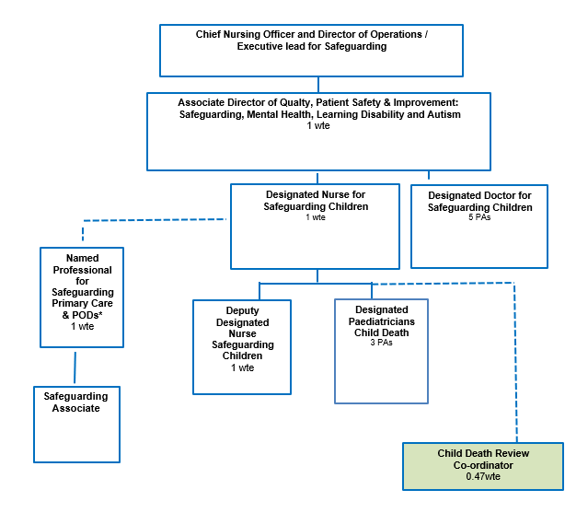

Somerset health system leadership and accountability

3.6 There is a clear line of accountability for safeguarding children and child death review
workstreams reflected in the ICB governance arrangements outlined in Table 2 below. We have achieved compliance against the requirements of the NHS Safeguarding Accountability and Assurance Framework (SAAF) and substantial assurance on how the ICB has met its statutory roles and responsibilities in relation to safeguarding children and child death reviews has been provided to NHS England (Hereafter referred to as ‘NHSE) National and South West safeguarding teams from 1st April 2024 to 31st March 2025 through the following:
    - Quarterly Safeguarding Assurance reports.
    - Quarterly Safeguarding Commissioning Assurance Toolkit (SCAT) submissions
    - System updates provided to the South West safeguarding steering group.
    - System updates provided to the South West Designated Professionals forums.
    - Data submissions through the Safeguarding Integrated Data Dashboard (SIDD)

3.6.1 Table 2: Somerset ICB Safeguarding Children Governance Framework

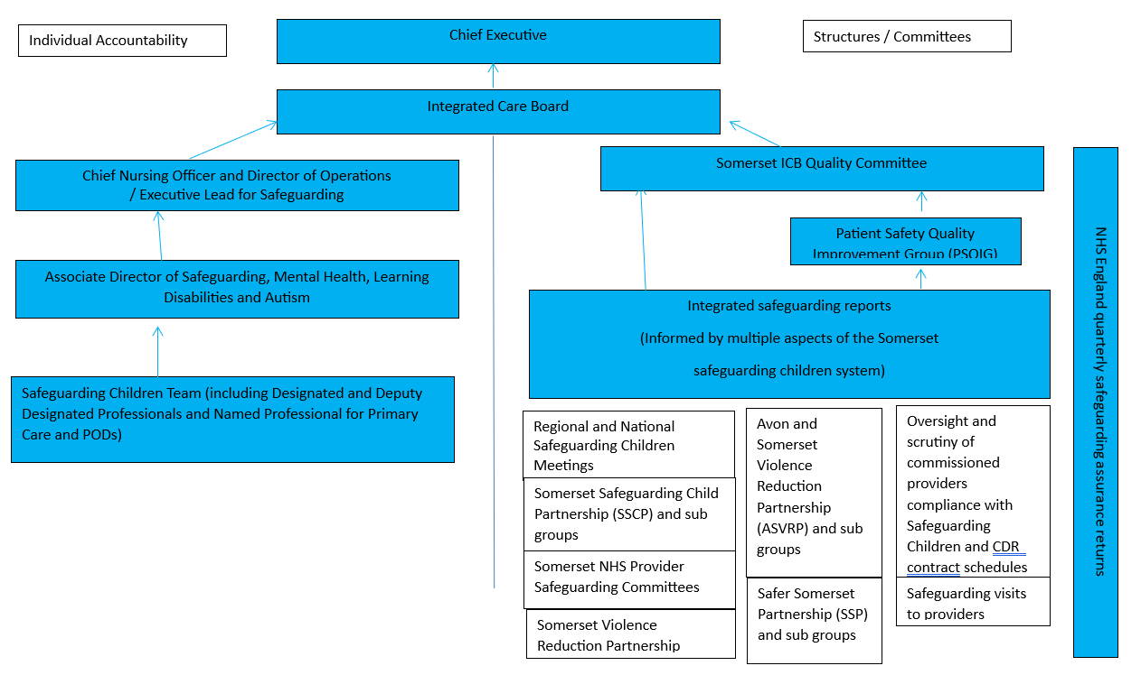
ICB Safeguarding Assurance Meeting

3.7 Discharging our Statutory Safeguarding Children and Child Death Review duties

3.7.1 Inspections: Joint Targeted Area Inspections (JTAIs) are multi-agency inspections carried out by Ofsted, the Care Quality Commission (CQC), HM Inspectorate of Constabulary and Fire & Rescue Services (HMICFRS), and HM Inspectorate of Probation (HMIP). They look at how local services work together to safeguard children. A JTAI inspection of the multi-agency response to Serious Youth Violence and Child Exploitation in Somerset took place in May 2024. The ICB provided system leadership for the health safeguarding system, which included but wasn’t limited to the following:

- Representing health services at a strategic level in the partnership meetings with inspectors.
- Coordinating the health system’s contribution to the JTAI, collating evidence from providers, and presenting a clear picture of safeguarding arrangements across health services.
- Coordinating appropriate health system representation at tracking meetings and site visits during the JTAI.
- Facilitating where needed health professional’s prompt response to safeguarding concerns raised by inspectors
- Sharing inspection findings and recommendations providers.
- Leading and contributing to post-inspection action planning to strengthen safeguarding practice for the health system, as well as the wider safeguarding system.

The letter, was published in July 2024 and outlined the inspectorate’s findings in relation to the effectiveness of the multi-agency response to children aged 10 and over who are at risk of or affected by serious youth violence and/or criminal exploitation. The ICB safeguarding children team contributed to the written statement of proposed action, which is overseen by the Somerset safeguarding Children Partnership and the Safer Somerset Partnership. The ICB safeguarding children team are responsible for the following:
- Participating in JTAI workshops with statutory partners to monitor and review progress within the Somerset JTAI action plan.
- Coordinate the health system response to the action plan.
- Monitor NHS provider’s progress with the action plan, identifying any challenges or delays and supporting providers to address these.
3.7.2 Statutory safeguarding children partnerships: Somerset ICB provides strategic safeguarding leadership for the health system and, as a statutory partner, is actively engaged with the:
- Somerset Safeguarding Children Partnership (SSCP)
- Safer Somerset Partnership (SSP), including the newly developed Somerset Violence Reduction Partnership and Strategic Exploitation Group
- Avon and Somerset Violence Reduction Partnership

The safeguarding children team works collaboratively with health and multi-agency partners to strengthen partnership working and strategic planning to safeguard and promote children’s welfare. Deputy / Designated Nurses and Doctor chair and contribute to a range of subgroups across the safeguarding partnerships. A key achievement in 2024 to 2025 was the development and implementation of a rolling programme of Insight Visits to safeguarding partners, with an inaugural visit to NHS Somerset Foundation Trust led by a member of the ICB Safeguarding Team. The visit evidenced improved recognition and response to Serious Youth Violence and Exploitation, supported by a strong culture of quality improvement. This commitment was visible across the organisation, from leadership to frontline staff.

3.7.3 Strategic Safeguarding Portfolios: In addition to being statutory partners in local safeguarding children arrangements outlined above, the ICB safeguarding children team provide strategic leadership to the health system in relation to the following strategic safeguarding priorities:
- Serious Violence Duty; The ICB is one of the specified authorities and a statutory member of the local and regional Serious Violence Reduction Partnerships (SVRPs). A key achievement in 2024 to 2025 was the provision of health system data than informed the local profile and the regional strategic needs assessments.
- Child Protection Information Sharing: The safeguarding children team supported the rollout of the Child Protection Information Sharing system across the health system. An integral part of the next Phase is to embed CPIS across primary care settings.
- Statutory and non-Statutory child safeguarding reviews: ICB’s are the statutory lead for the Somerset health system and are required to participate in all statutory safeguarding reviews; including Rapid reviews (RRs) and Local Child Safeguarding Practice Reviews (LCSPRs) as outlined in legislation. The ICB contributes to all reviews via the safeguarding children team and as statutory partners of the review panel processes. Learning from these reviews has informed system level development and improved outcomes for our population.

3.7.4 Safeguarding Children Assurance Visits: Throughout 2024 to 2025 the ICB Safeguarding Team undertook quality assurance visits to GP practices to explore safeguarding practice and support the identification of any areas for learning and development. Fewer visits took place during winter due to primary care pressures, but they continued throughout the year. Selection for 2024–2025 visits was based on the 2023–2024 safeguarding returns, including practices that identified gaps in safeguarding practice and those that reported they had robust safeguarding arrangements in place.

3.7.5 Policies and Procedures: Between March and June 2024 a member of the ICB safeguarding team led in the development of a National Network of Designated Health Professionals (NNDHP) Position Statement on Free Birthing, as well as a partnership protocol for the management of Termination of Pregnancies (TOPs) in children under 13 years. In March 2025 guidance for Primary Care in relation to the following was created:
- Safeguarding alerts, coding and uploading of safeguarding documents to GP records
- Identification and response to, as well as statutory responsibilities regarding, Female Genital Mutilation.
The ICB’s Safeguarding Children policy sets out our commitment and approach to safeguarding children. It requires updating but a refreshed policy is currently on hold considering the move to an ICB cluster, pending legislative changes, and potential impact of the whole system changes outlined in section 2.3 of this report. The current versions of all policies related to safeguarding children are located here: https://nhssomerset.nhs.uk/health/safeguarding-adults-and-children/safeguarding-policies-guidance/.

3.7.6 Safeguarding Training: During the reporting period the Designated Professionals for Safeguarding Children and Child Death delivered the following training:
- The first ever joint Pan Dorset and Somerset CDOP learning event; alongside CDOP members from Pan Dorset and Somerset Council.
- New Dads Supporters Training.
- Supporting children questioning their Gender; alongside ICB colleagues.
- Safeguarding children updates to Somerset GP Education Trust (SGPET)
In partnership with the wider safeguarding team three all day safeguarding training events were provided to GP safeguarding leads and ICB staff throughout 2024/2025; one on the theme of Domestic Abuse and two on the theme of Exploitation and Serious Youth Violence. In Winter 2024 the rolling programme of Back to Basic Safeguarding lunch and learn sessions delivered by the strategic safeguarding team was tailored back, in recognition of winter pressures on frontline staff which was reflected in the drop in attendance rates. However, sessions on ‘Safeguarding in the Pre Birth period’ and ‘Female Genital Mutilation’ (Hereafter referred to as ‘FGM’) were provided during 2024/2025, as learning related to safeguarding unborn in the pre-birth period featured as part of child safeguarding reviews and there was an increase in the numbers of FGM cases being reported. The above training was in addition to training opportunities provided by the Somerset Safeguarding Children Partnership (SSCP), and Safer Somerset Partnership (SSP). Feedback from the training events referenced above and provided by the ICB safeguarding team included the following:
- “Excellent, highly informative day as usual.”
- “Thank you! What a brilliant day and I have learnt so much.”
- “I think this was effective and it was good to see the join up between the CSPR process and the CDOP process.”
- “Thank you for a well organised and informative event. I enjoyed the break out session as felt more confident speaking in a smaller group, would have liked more time in smaller groups”.
- “A good overview and update of this complex topic. Good guidance aimed at GPs especially relating to how to manage a very sensitive subject, private providers and their requests for shared care”.

3.7.7 Safeguarding Supervision: In November 2024 the ICB’s safeguarding team revised the formal and informal safeguarding supervision on offer and alongside safeguarding adults colleagues, the safeguarding children team now provide formal safeguarding supervision to GP safeguarding leads, GP safeguarding admin (including Care Coordinators), Continuing Health Care and SEND teams, Complex Care team, the ICB Freedom to Speak Up leads and Champions, safeguarding leads from across the health system (South West Ambulance Service, HUC, Public Health Nursing, NHS Somerset Foundation Trust) and safeguarding leads from all Short Form contracts commissioned by the ICB. Alongside safeguarding adults colleagues, the ICB safeguarding children team are currently exploring an offer of formal and / or informal safeguarding supervision to those professionals within Pharmacies, Optometry and Dental services (PODs) who require it, in accordance with the current Intercollegiate Document for Safeguarding Children. Feedback from safeguarding supervision sessions delivered in 2024 to 2025 included the following:
- “The sessions align with the think family approach and provide an opportunity to analyse what we know and don’t know about a case and consider next steps that are relevant and proportionate to the risk being explored.”
- “The supervision is reflective, inclusive and provides a safe place for safeguarding professionals to explore and unpick complex safeguarding cases.”

3.7.8 Information Sharing: The ICB Safeguarding bulletin is routinely contributed to and shared with Primary Care staff, staff within the ICB, the Local Medical Committee, and the main NHS providers safeguarding teams. As planned, in 2024/2025 the safeguarding team established clear links with all safeguarding leads in acute and community contracts held by the ICB, and the Safeguarding bulletin is now routinely shared with them. The Safeguard Bulletin is also shared with Pharmacies, Optometrists and Dental Services (PODs).
3.7.9 Risks: During this reporting period the ICB safeguarding team regularly provided advice and support to the ICB related to safeguarding risks associated with the GP collective action. In addition, the following seven risks were recorded on the ICB risk register relating to Safeguarding Children and Child Death Reviews:
Risk |  | Score
554 | Risk of not meeting statutory safeguarding duties due to ongoing demand and capacity issues | 9
580 | Risk to children subject to a child protection plan due to lack of child protection conference reports from GPs | 12
612 | Risk to children of health information not being provided to strategy discussions by GP practices | 10
614 | Risk to victims of domestic abuse due to the lack of information sharing and engagement between MARAC and GPs | 10
625 | Risk of regulatory and reputation damage to ICB due to non-compliance of statutory Anti-Social Behaviour (ASB) duties | 12
648 | Risk that ICB is breaching its statutory duties in relation to safeguarding training | 6
693 | Risk that ICB will breach its statutory duties in relation to Child Death Review arrangements | 12

Progress against 2024/25 ambitions
  - The ICB Safeguarding Children team have continued to work collaboratively with services commissioned by the ICB and multi-agency partners at a local, regional and national level, to improve the quality of safeguarding children practice, strengthen statutory and non-statutory Safeguarding Children reviews, develop statutory Safeguarding Children and Child Death Review (CDR) arrangements and where required, worked together to mitigate organisational and partnership risks. The following objectives were worked on in 2024/2025:
To develop closer links with safeguarding leads in acute and community contracts. | Complete
To develop a safeguarding self-assessment template that can be utilised across primary care, PODs, acute and community contracts and others. | Complete
To provide safeguarding children training data for ICB staff | Ongoing
In partnership with Electronic Staff Record (ESR) colleagues the strategic safeguarding team will look at how evidence of additional learning required for level 3 safeguarding adults and children can be uploaded to ESR. | Ongoing
To establish effective pathway for Primary Care involvement within domestic abuse Multi Agency Risk Assessment Conference (MARAC) process | Complete
To expand police notification information sharing process to primary care to include notifications where there are no children involved | Ongoing
To work with multi-agency colleagues across Somerset to better understand the needs of children transitioning to adult’s services | Complete
Develop a Female Genital Mutilation (FGM) policy to support primary care with statutory responsibilities regarding safeguarding women and children at risk of / experienced FGM. | Complete
Work alongside ICS Workforce Inclusion to establish freedom to speak up processes across health | Complete
Work with ICB workforce to ensure the ICB fulfils its commitment to taking and enforcing a zero-tolerance approach to any unwanted, inappropriate and/or harmful sexual behaviours within the workplace | Ongoing
Ensure ICB fulfils its statutory duties in relation to Anti-social behaviour case review process through input into the multi-agency development of information sharing agreement and shared process | Ongoing
To improve Primary Care engagement with Child Protection Conferences through development and implementation of a new report template, targeted support and audit. | Complete
To implement project to support new fathers across Somerset. This project was highly commended in the South West integrated and personalised care awards. | Complete

  - Feedback received in 2024/2025 by the ICB safeguarding team from colleagues across the safeguarding system:
- “You are doing a fantastic job in keeping us all on track and informed and spinning lots of plates. It’s very much appreciated.” (Related to JTAI inspection)
- “Thank you this is an amazing piece of work.” (Related to support provided to a Practice due to be inspected by CQC)
- “I want to thank you for all your help with this. You have been able to break this down in a way that really makes sense, and all your comments have been valid and can only benefit us going forward. I am so glad I contacted you for guidance.” (Related to support provided to a Short Form Provider regarding their safeguarding annual report).
- “I just wanted to drop a line and say thank you for listening and supporting me.” (Related to support provided to a safeguarding lead)

Ambitions for 2025/26
- Alongside statutory Child Death Review partners in Dorset, Bournemouth, Christchurch, Poole and Somerset undertake a review of the Pan Dorset and Somerset child death review arrangements, to ensure arrangements in place are sustainable and provide a consistently high quality child death review for children and their families resident in the geographical area covered by these arrangements.

- Align Child Death Review arrangements with the system priorities outlined within the Somerset Five Year Joint Forward Plan Refresh 2024 to 2029:
    - Finance and Resource Allocation – Consider the budget allocation for the Pan Dorset and Somerset Child Death Review (CDR) arrangements and how this could be transformed.
    - Workforce – Consider development of a Pan Dorset and Somerset-wide system workforce for CDRs, equipped with the right skills, behaviours, and values. Emphasis to be placed on person-centred care for bereaved families, and ensuring consistent, high-quality support for them throughout the Child Death Review process.
    - System Flow - Child Death Reviews highlight the importance of reviewing the entire pathway of care a child received prior to death. Consider how learning from deaths across multiple settings identify where care systems can be improved to better meet the needs of children and their families, and how effectively this learning is disseminated across the system.
    - Population Health Transformation - Implement broader population health goals including:
- Publication of revised Child Death Review arrangements once agreed by Statutory Child Death Review partners.
- Ensure learning from Child Death Reviews is shared across the system, while ensuring confidentiality.
- Collaborating across regional and national CDOP areas to identify wider patterns and prevent future deaths.

- Consider how revised Child Death Review (CDR) arrangements can directly support the priorities outlined within the Somerset Improving Lives Strategy 2019 to 2028:
    - Prevention and Early Intervention: CDRs identify social, environmental, and systemic factors contributing to child deaths, enabling targeted action to reduce future risks and improve outcomes for children and families.
    - Cross-System Leadership and Collaboration: High quality CDRs requires strong leadership and a coordinated, multi-agency approach—mirroring the strategy’s call for integrated public service delivery.
    - Equity and Inclusion: Learning arising from CDRs support the development of services that are inclusive and equitable, improving outcomes without disadvantaging specific population groups.
    - System Integration and Sustainability: Improved CDR processes contribute to a countywide infrastructure that connects health, care, safeguarding, and community systems—supporting long-term sustainability and better public service delivery.

- Contribute to ‘test and learn activity’ in relation to safeguarding children and child death review roles and responsibilities being undertaken within the new ICB cluster arrangement, which will include:
    - Defining our statutory safeguarding children duties in line with revised Model ICB plans issued as part of the governments NHS Reforms 2025.
    - In line with the Model ICB blueprint, retain and adapt the Somerset statutory child death review arrangements to ensure they are delivered at scale through the future ICB cluster and the Pan Dorset and Somerset CDR arrangements (including the Pan Dorset and Somerset Child Death Overview Panel), ensure residents in the geographical area covered by the joint arrangements all receive the same quality of care following their child’s death.
    - Oversight of delegated functions with proportionate assurance.

- Ensure that the ICB meets its statutory responsibilities in relation to the work of the statutory partnerships, which includes but is not limited to the following:
    - Somerset Safeguarding Children Partnership
    - Safer Somerset Partnership, including Somerset Violence Reduction Partnership
    - Avon and Somerset Violence Reduction Partnership
    - Pan Dorset and Somerset Child Death Overview Panel

- Clarify roles and responsibilities held jointly and separately by the ICB and the Central Commissioning Hub in relation to oversight and scrutiny of safeguarding children practice within Pharmacy, Optometry and Dental services.

- Actively contribute to further JTAI workshops scheduled; to scrutinise single and multi-agency actions within the JTAI Somerset system action plan and once completed consider how multi-agency partners can evaluate the impact of the action plan on practice in relation to serious youth violence and exploitation.

- Alongside multi-agency partners develop and implement whole system safeguarding children reforms directly linked to or outlined within the following:
    - The Children’s Social Care National Framework published in December 2023
    - The statutory Working Together to Safeguard Children published in December 2023
    - Keeping Children Safe, Helping Families Thrive published in November 2024.
    - The enactment of the Children’s Wellbeing and Schools Bill, once approved by the House of Commons and the House of Lords.

Conclusion

6.1 On 1st April 2025, the government announced a significant foundation for NHS reform. This programme of change will happen at pace and safeguarding functions within an ICB will be impacted as ICBs transition to a more strategic commissioning model. With that in mind, many of the safeguarding children ambitions outlined above may be subject to change.
6.2 The ICB’s statutory safeguarding role must remain a consideration throughout this transition, underpinning all strategic decisions. Any reconfiguration of responsibilities or resources should be subject to rigorous assurance to prevent gaps in oversight of safeguarding practice, a weakening of robust multi-agency collaboration, or increased risks to our most vulnerable populations. At a system level, continuity, clarity, and accountability in safeguarding arrangements are critical not only to legal compliance but also to sustaining trust in the ICB’s leadership and its capacity to protect those at greatest risk.

https://www.gov.uk/government/publications/keeping-children-safe-helping-families-thrive
The Families First Partnership (FFP) Programme Guide
https://www.england.nhs.uk/publication/executive-lead-roles-within-integrated-care-boards/
NHS England » Safeguarding children, young people and adults at risk in the NHS: Safeguarding accountability and assurance framework

