

Report to the NHS Somerset Integrated Care Board on 16/09/2024

Title: ICB Safeguarding Children Annual report | Enclosure

Version Number / Status: | [1.1]
Executive Lead | Shelagh Meldrum
Clinical Lead: | Maria Davis
Author: | Maria Davis

Summary and Purpose of Paper
Annual report on the work of the Safeguarding Children Team in the ICB

- Details the arrangements in place to safeguard children in the NHS Somerset Integrated Care System (ICS), and the services commissioned by NHS Somerset (ICB).
- Sets out the context for safeguarding children arrangements in the Somerset ICS/ICB.
- Demonstrates how the ICS/ICB is fulfilling the statutory safeguarding children responsibilities.
- Reports on governance and accountability arrangements within the ICS/ICB, and the ICS/ICB role in the Somerset Safeguarding Children Partnership (SSCP) and its subgroups.
- Highlights achievements and identifies current safeguarding children risks in provision within health services.
- Identifies the ICBs 2024/2025 safeguarding children objectives.
- Provides assurance that the safeguarding children 2023/2024 objectives were completed.

Recommendations and next steps

The NHS Somerset Integrated Care Board is asked to note the content of this report and the objectives for the safeguarding children team for 2024/2025.

The Somerset ICB Safeguarding children team will continue to work collaboratively at a local, regional, and national level to improve the quality of, and strengthen, safeguarding children and child death review arrangements, where necessary mitigating organisational and partnership risk.

This report, once approved by the ICB Board, will then be considered by the Somerset Safeguarding Child Partnership.

Impact Assessments – key issues identified

Equality | Commissioning and delivery of high quality and accessible statutory health services to meet the safeguarding needs of children and young people will ensure this cohort will not be disadvantaged in comparison with their peers who do not experience the same vulnerabilities.
Quality | This report reflects on the quality and impact of safeguarding children practice. The past year has been without precedent in terms of the scale and volume of challenges for the safeguarding system; with even more importance on the need to take stock and learn in order to influence the quality and outcome of children and families’ experiences of safeguarding children practice.
Safeguarding | Statutory safeguarding children responsibilities of the ICS/ICB and the services it commissions are considered throughout this report.
Privacy | Information sharing processes are already established; there are no breaches of privacy are expected.
Engagement | Meeting statutory safeguarding children requirements is a shared responsibility. The safeguarding children team works closely with ICS/ICB colleagues, the services commissioned by the ICB and all key partners of the Somerset Safeguarding Children Partnership (SSCP) and the Safer Somerset Partnership (SSP) to ensure these are met.
Financial /  Resource | Resources required to implement and support statutory safeguarding children requirements are in place.
Governance or Legal | The provision of statutory safeguarding children requirements are governed by the following legislation and statutory guidance:  - Children Act 1989  - Children Act 2004  - The Children and Families Act 2014  - The Children and Social Work Act 2017  - Data Protection Act (2018)  - Working Together to Safeguard Children 2023  - Safeguarding children, young people and adults at risk in the NHS: Safeguarding Accountability and Assurance Framework 2024  - Child Death Review Statutory and Operational Guidance (England) 2019  - Intercollegiate Document: Safeguarding children and young people: roles and competences for health care staff, (RCPCH) 2019  - Domestic Abuse Act 2021  - Mental Capacity Amendment Act (2019)
Sustainability | Working with all our partners in the local, regional and national safeguarding system, the safeguarding children team aims to deliver a sustainable and effective healthcare system for Somerset, which routinely includes the need to safeguard and promote the welfare of children.  The Children and Young People Plan informs the work of the Somerset Safeguarding Children Partnership, of which the ICB and the services we commission are key partners. The plan embraces potential and actual synergies between the sustainability and health agendas.
Risk Description | Risk 580 - There is a risk to children subject to a child protection plan, due to lack of health information being shared with multi-agency  Risk 612 - There is a risk to children's health through lack of GP representation in urgent strategy discussions for children.  Risk 614 - There is a risk to victims of domestic abuse due to GP health information not forming part of the MARAC assessment.  Risk 554 – There is a risk that statutory safeguarding services will not be delivered due to ongoing demand and capacity issues.  Risk 575 - Risk of being unable to collate ICB safeguarding training compliance.  Risk 625 – There is a risk of regulatory and reputation damage to ICB due to non-compliance of statutory Anti-Social Behaviour (ASB) duties.  Risk 648 – The ICB is at risk of regulatory and reputational damage due to breaching statutory duties in relation to safeguarding training.
Risk Rating | Consequence | Likelihood | RAG Rating | GBAF Ref
580 | 3 | 5 | 15
612 | 2 | 5 | 10
614 | 2 | 5 | 10
554 | 3 | 3 | 9
625 | 4 | 3 | 12
648 | 2 | 4 | 8

Safeguarding Children

Annual Report 2023/24

Author | Marie Davis
Job title | Designated Nurse Safeguarding Children
Executive Sponsor | Shelagh Meldrum, Chief Nursing Officer / Executive Lead for Safeguarding
Version | 1
Date | September 2024

This page is intentionally blank

Contents

1. Introduction 1
2. Delivery of Statutory Safeguarding Functions 2
3. Safeguarding Assurance 2
4. Progress against 2023/24 priorities 2
5. Ambitions for 2024/25 2
6. Conclusion 2

Introduction

  - This report covers the period of 1st April 2023 to 31st March 2024 and is the second Safeguarding Children annual report for NHS Somerset Integrated Care Board (Hereafter referred to as ‘the ICB’). This report provides assurance to the ICB Board and members of the public that the ICB has fulfilled its statutory responsibilities to safeguard and promote the welfare of children.

  - The narrative throughout this report gives an overview and summary of assurance against our statutory safeguarding children functions and the shared local priorities of safeguarding partners. This report will conclude by looking forward to the year ahead identifying key priorities for 2024-2025.

2.3 In accordance with statutory guidance the ICB’s core business is to safeguard and promote the welfare of children , through the provision of high-quality and effective support, with agencies, frontline professionals and practitioners commissioned by the ICB being clear about their own and each other’s roles and responsibilities and how we work together to safeguard children and their families.

DELIVERY OF STATUTORY SAFEGUARDING FUNCTIONS
  - Somerset Safeguarding Leadership and Accountability

    - The accountability for safeguarding rests with the Chief Executive of the ICB, as the accountable officer. The safeguarding children team are part of the ICB strategic safeguarding team, which is led by the Associate Director of Safeguarding, Mental Health, Learning Disabilities and Autism. The Designated Professionals for Safeguarding Children report via the Associate Director of Safeguarding, Learning Disability, Autism and Mental Health to the Chief Nursing Officer / Executive Lead for Safeguarding.

    - As part of a well-established integrated approach quarterly safeguarding assurance reports are provided to the ICB Quality Committee from a safeguarding adult, safeguarding children and children looked after and care leavers perspective. These are reported by exception to the Board, along with separate annual reports for Child Death Review arrangements and for Children Looked After and Care Leavers.

    - The ICB strategic safeguarding children team structure incorporates the statutory roles of Designated and Deputy Designated Nurses, Designated Doctor, Named Professional for Safeguarding in Primary Care and Pharmacy, Optometry and Dental services (hereafter referred to as ‘PODs’), and administrative staff.

    - Due to an inability to recruit to the Named GP for Safeguarding post for over a year a Case for Change led to the reconfiguration of the role into a fulltime Named Professional for Safeguarding in Primary Care and PODs post. The postholder commenced in this role in September 2023.

    - The safeguarding children structure is outlined in Table 1 below:

Table 1: Structure Chart for ICB Strategic Safeguarding team
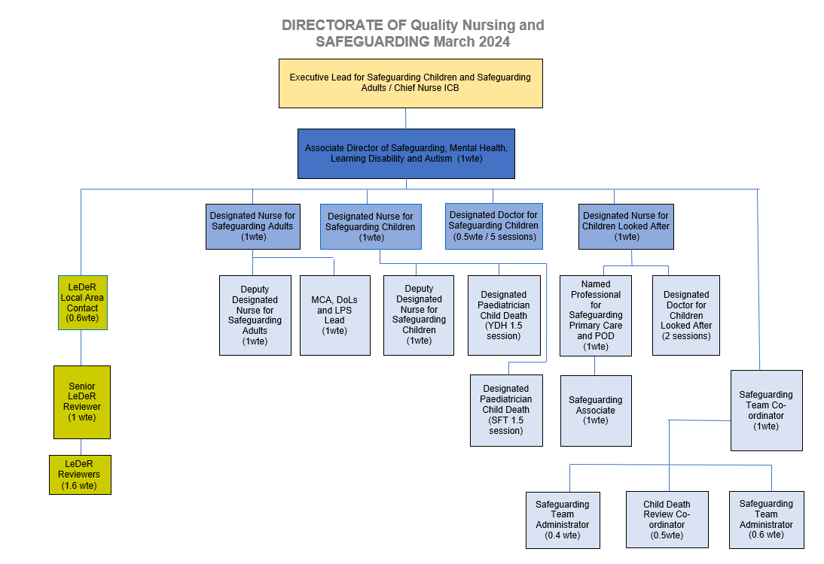

    - Table 2 demonstrates the safeguarding children governance framework.

Table 2: Somerset ICB Safeguarding Children Governance Framework
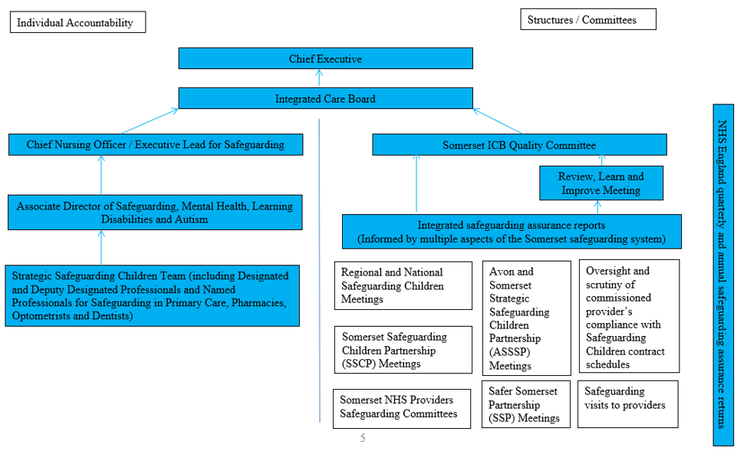

  - Discharging Statutory Safeguarding Children duties

    - Accountability: There is a clear line of accountability for safeguarding children reflected in the ICB governance arrangements as described in Table 2 above. We have achieved compliance against the requirements of the NHS Safeguarding Accountability and Assurance Framework (SAAF) and substantial assurance on how the ICB has met its statutory roles and responsibilities in relation to safeguarding children has been provided to NHS England South West safeguarding team from 1st April 2023 to 31st March 2024 through the following:
- Quarterly Safeguarding Assurance reports.
- Safeguarding Commissioning Assurance Toolkit (SCAT) submissions
- System updates provided to the South West safeguarding steering group.
- System updates provided to the South West Designated Professionals forums.
- A safeguarding visit to the ICB by the NHS England South West safeguarding team in February 2024.

2.2.2 Policies and Procedures:. The ICB’s Safeguarding Children policy sets out our commitment and approach to safeguarding children and is currently being updated to reflect recent legislative changes, publication of updated statutory guidance and the move from CCG to ICB status. The current version of this policy is located here: https://nhssomerset.nhs.uk/health/safeguarding-adults-and-children/safeguarding-children/
2.2.3 Safeguarding Training: In partnership with the wider strategic safeguarding team three all day training events were provided to GP safeguarding leads and ICB staff throughout 2023/2024 on the theme of Neglect and self neglect across the lifespan. In September 2023 a rolling programme of Back to Basic Safeguarding lunch and learn sessions was set up and delivered by the strategic safeguarding team. Sessions scheduled through to April 2024 included Strategy Discussions, Child Protection Conferences, Domestic Abuse, Supporting families with neglect and many others. This was in addition to training opportunities provided by the Somerset Safeguarding Children Partnership (SSCP) training team, and Safer Somerset Partnership. Feedback from the training events referenced above included the following:

“Great, interactive day. Really enjoyed working through the real case studies.”

“Excellent study day! The group session was extremely good.”
“Maintain – good balance of presenting then interacting”.

2.2.4 Safeguarding Supervision: The ICB’s strategic safeguarding children team provide formal and informal safeguarding supervision to Primary Care staff, strategic safeguarding leads in providers commissioned by the ICB, staff and teams within the ICB and safeguarding peers within partner agencies. Feedback from supervision sessions delivered in 2023 to 2024 included the following:

“I just wanted to say a massive thank you for all your help and support over the past few months.”

“.I just wanted to thank you for yesterday, I appreciate all that you shared with me and value your guidance.”
”

2.2.5 Information Sharing: The ICB newsletter ‘The Safeguard’ is routinely contributed to and shared with Primary Care staff, staff within the ICB, the Local Medical Committee and NHS provider safeguarding leads. In 2024/25 a priority is to establish clear links with all safeguarding leads in acute and community contracts held by the ICB, as well as routinely share The Safeguard with them.
2.2.6 Risks relating to Safeguarding Children Six risks were recorded on the ICB risk register during this reporting period.
Risk | Score
Risk 368 / ICB Strategic Safeguarding Service Provision | CLOSED
Risk 440 / Mandatory Prevent Training compliance in NHS Trusts | CLOSED
Risk 554 / There is a risk that statutory safeguarding services will not be delivered due to ongoing demand and capacity issues | 9
Risk 580 / Risk to children subject to a child protection plan due to lack of child protection conference reports from GPs | 15
Risk 612/ Risk to children of health information not being provided to strategy discussions by GP practices | 10
Risk 614 / Risk to victims of domestic abuse due to the lack of information sharing and engagement between MARAC and GPs | 10
Risk 625 / Risk the ICB is not compliant in relation to Anti Social Behaviour statutory duties | 12
Risk 635 / Risk that children in Somerset will not have access to historical Child Sexual Abuse medicals | CLOSED
Risk 648 / Risk that the ICB is breaching its statutory duties in relation to safeguarding training | 8

2.2.7 Risk 368 was closed due to the successful recruitment of vacant post within this reporting timeframe. Risk 635 was closed due to a contract put in place with the Sexual Abuse Referral Centre (SARC) in Bristol.

Safeguarding Assurance
  - Somerset ICB has continued to regularly receive assurance on show the services we commission have met their statutory safeguarding children responsibilities. Work has been completed to revise the joint safeguarding adults and children dashboard provided by Somerset NHS Foundation Trust. This involved removing data no longer required (assurance already gained and positive embedded changes evidenced) and the introduction of mutually agreed new metrics for monitoring directly related to contractual requirements and learning identified from multiple safeguarding children activities.

  - In 2022 to 2023 the ICB strategic safeguarding team and services we commission actively contributed to the “deep dive” of Multi Agency Risk Assessment Conference (MARAC) undertaken by Safe Lives on behalf of Somerset County Council. In 2023 to 2024 this has led to a series of recommendations and subsequent change to the MARAC operating model.

  - Additional safeguarding assurance in relation to the health system and partner agencies is provided through the work of the ICS and safeguarding steering group.

  - In 2023 to 2024 assurance on safeguarding systems, processes and practice within primary care was sought through multiple means:

      - Analysis of GP safeguarding annual reports: A report template previously agreed with the Somerset Local Medical Committee had been sent out to practices for completion in January 2023. In 2023/24 the returns were analysed with a view to identifying areas for development and which practices would be contacted as part of a deep dive into their responses. This included those who were confident they were meeting their statutory requirements and those that weren’t.

      - Safeguarding quality assurance visits: a rolling programme of safeguarding quality assurance visits was established, with the use of an ICB safeguarding quality assurance template to support an in depth discussion on safeguarding across the lifespan.

  - The ICB Safeguarding Assurance Meeting (SAM) was established in 2023 / 2024 to seek greater assurance from across the ICB that all directorates were considering safeguarding throughout the workstreams they lead on. This was developed out of the previous ICB Safeguarding Business meeting.

Progress against 2023/24 priorities
  - The following priorities were identified for completion in 2023 to 2024
Develop an ICB safeguarding training strategy. | Ongoing
In partnership with strategic safeguarding team colleagues develop a rolling programme of safeguarding training for Primary Care staff and ICB staff, including a focus on ‘Back to Basics’. | Complete
Devise a Safeguarding Quality Assurance (QA) visit programme to selection of GP practices to further explore safeguarding related activity as a result of data analysis of 2021/22 GP safeguarding annual report submissions. | Complete
Work with multi-agency partners to agree the final report and associated recommendations arising from a Non-Accidental Injuries multi-agency task and finish group. | Complete
Work with Information Governance and safeguarding leads within Avon and Somerset Police and the ICB to agree next steps in the Domestic Abuse project – expanding the project to include Domestic Abuse incidents involving adults with no children the household. | Ongoing
Identify potential digital solutions to police sharing information with GPs for high and medium risk domestic abuse incidents with GP practices. | Ongoing
Work with Somerset Council / Public Health to support GP practices in engaging with MARACs (Multi-Agency Risk Assessment Conferences) where their patients are being discussed. | Ongoing
To ensure that assurance processes are aligned across the lifespan for Safeguarding Children, Adults and Children Looked After for 2023-2024. | Ongoing
In partnership with Public Health and Maternity Services complete an audit into implementation of the Pre-Birth Standard Operating Procedure (SOP) revised in January 2023. | Complete
Implement a fixed term project providing post birth support for fathers, funded by the Local Maternity and Neonatal System. | Complete
Work with multi-agency partners and GP practices to agree how GPs can meaningfully engage with Channel Panel and Topaz, to ensure information is shared regarding their patients that are at high risk of exploitation and / or radicalisation. | Complete
Review the Pan Dorset and Somerset Child Death Review arrangements in place and streamline systems and processes where possible. | Ongoing
The Police, Crime, Sentencing and Courts Act 2021 introduces a new Serious Violence duty. In partnership with multi-agency partners explore how the ICB can meets its statutory duties in relation to the Serious Violence Duty. | Ongoing

4.2 Feedback received in 2023 to 2024 by the ICB strategic safeguarding team from colleagues across the safeguarding system.

“As a Somerset team you do us proud and are admired throughout the system, regionally and nationally as innovators, campaigners and passionate partners”
“I wanted to thank you both for all the support over the years, the opportunities to discuss all things safeguarding, and the humour that is needed at times to do this job!

“I am so glad I contacted you for guidance”

Ambitions for 2024/25

The ICB strategic safeguarding children team will continue to work collaboratively, engaging with partners in work streams to improve the quality of and strengthen safeguarding children and child death review arrangements in relation to the following priorities:
- To develop closer links with safeguarding leads in acute and community contracts.
- To develop a safeguarding self-assessment template that can be utilised across primary care, PODs, acute and community contracts and others.
- To provide safeguarding children training data for ICB staff
- In partnership with Electronic Staff Record (ESR) colleagues the strategic safeguarding team will look at how evidence of additional learning required for level 3 safeguarding adults and children can be uploaded to ESR.
- To establish effective pathway for Primary Care involvement within domestic abuse Multi Agency Risk Assessment Conference (MARAC) process
- To expand police notification information sharing process to primary care to include notifications where there are no children involved
- To work with multi-agency colleagues across Somerset to better understand the needs of children transitioning to adult’s services
- Develop a Female Genital Mutilation (FGM) policy to support primary care with statutory responsibilities regarding safeguarding women and children at risk of / experienced FGM.
- Work alongside ICS Workforce Inclusion to establish freedom to speak up processes across health
- Work with ICB workforce to ensure the ICB fulfils it commitment to taking and enforcing a zero-tolerance approach to any unwanted, inappropriate and/or harmful sexual behaviours within the workplace
- Ensure ICB fulfils its statutory duties in relation to Anti-social behaviour case review process through input into the multi-agency development of information sharing agreement and shared process
- To improve Primary Care engagement with Child Protection Conferences through development and implementation of a new report template, targeted support and audit.
- To implement project to support new fathers across Somerset.

Conclusion
6.2 Commissioners of health services have a duty to ensure that all NHS Trusts recognise the importance of having robust and effective arrangements in place to safeguard and protect children and young people across Somerset, and to provide assurance that they are fulfilling their statutory responsibilities for Safeguarding Children under Section 11 of the Children Act 1989 (2004).

6.2 The 2024 to 2025 priorities will continue to take forward the progress that has been made this year to fulfil our statutory and strategic objectives.

6.3 NHS Somerset Integrated Care Board are requested to note the contents of this report.

Safeguarding Competences for Healthcare Staff: Intercollegiate Document 2019
NHS England » Safeguarding children, young people and adults at risk in the NHS: Safeguarding accountability and assurance framework
https://nhssomerset.nhs.uk/health/safeguarding-adults-and-children/safeguarding-children

