**Electronic Somerset Treatment Escalation**

**Plan (eSTEP)**

*User Guide*

Contents

1. Introduction to e-STEP 3

2. Purpose of user guide 3

3. Local eSTEP processes for consideration 4

4. Launch SIDeR+ from your clinical system 5

5. Access the eSTEP 6

6. Create a new eSTEP 7

7. Add clinical information to the eSTEP 8

8. Save the eSTEP 10

9. Download or Print the eSTEP 11

10. Feedback 12

## **Introduction to e-STEP**

The Somerset Shared Care Record SIDeR+ (Somerset Integrated Digital e-Record) hosts the electronic Somerset Treatment Escalation Plan (eSTEP) form and will become a single source of the truth supporting a streamlined holistic patient journey to enable safer care and improving the patient experience. The eSTEP has been developed from the paper STEP form with involvement from multiple stakeholders across the county within a dedicated SIDeR Digital TEP Meeting.

There are clear benefits to having an electronic form, these include:

* Accessible to all organisations involved in a patient’s care.
* Clear digital footprint of the person completing.
* eSTEP can be updated in real time.
* One version of the truth for Somerset patients.
* Consistency of information and increased quality

Only staff who are trained to complete the eSTEP should make any changes after conversations with the patient and their families. The eSTEP is able to be transcribed on to SIDeR+.

## **Purpose of user guide**

This guide has been developed to show you how to access and use the eSTEP on SIDeR+.

It does not tell you:

* When you should use the eSTEP
* When you should print the completed form to give to the patient
* Whether you should print the completed form to add to your records
* What to do if there is an existing paper TEP in circulation

**These are all important issues that affect the end-to-end clinical pathway. They MUST be addressed and documented locally wherever the eSTEP is being used.**

**We are asking Early Adopters to consider these issues – and any others that may arise during use – and to make recommendations for their local area and for the county-wide programme.**

There is a feedback form at Section 10.

## **Local eSTEP processes for consideration**

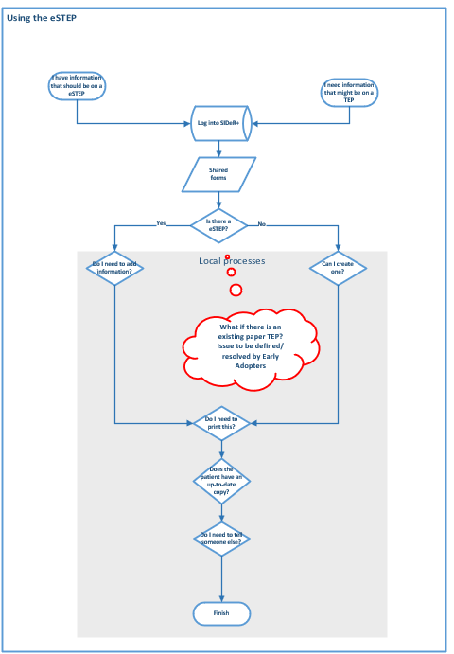

## **Launch SIDeR+ from your clinical system**

## 

**Launching SIDeR+ from your clinical system:**

* **EMIS** for GP practices and Weston Hospice
* **RiO** for Community and Mental Health staff
* **Trakcare** for Yeovil Hospital
* **Better** for Musgrove Park
* **SystemOne** for St Margaret’s

Guides for accessing and navigating SIDeR+ from within your clinical system can be found on your local Learning Management System

As SIDeR+ is for direct care only (which includes creation of a shared form/care plan on behalf of a clinician) the information box below will be displayed,

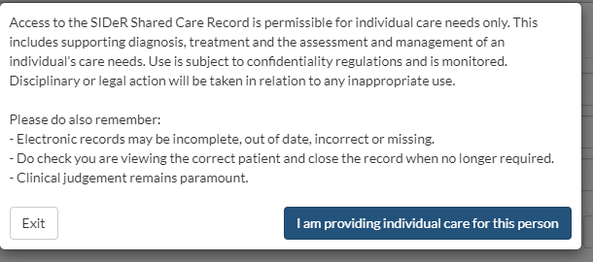

**\*click ‘I am providing individual care for this person’**.

SIDeR+ will launch for the same patient you are viewing in your clinical system and will launch on the summary page

## **Access the eSTEP**

The e-STEP can be found in the **‘Shared Forms’** tab under the patient demographic information.

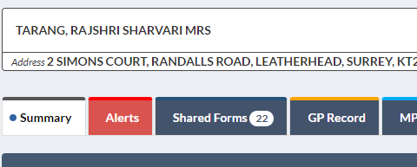

**\*Scroll down** **to the** ‘**eSTEP - Somerset Treatment Escalation Plan**’.

If the patient already has an eSTEP, the tab will be blue, and the right-hand icon will say ‘Edit’.



If the patient has not yet had an e-STEP created, the tab will be grey, and the icon will say ‘Create’.



**\*Click create to launch a new eSTEP**

## **Create a new eSTEP**

Under ‘Information before you proceed’,

**\* select** the **most appropriate** choice when creating the form for the first time

The **person’s GP practice details** will be **automatically populated** from their GP record. Every time the form is opened or amended, the system will check if any details have changed, ie address, and will automatically update them.

You will find further information to help you complete the eSTEP within the form itself

## **Add clinical information to the eSTEP**

## **A blue rectangle with white text Description automatically generatedSave the eSTEP**

Once you have completed the form,

\***click ‘Save’ in the bottom right**

**\*Click save in the view below.**

This will save the form on SIDeR+ AND send a pdf copy to the GP record



Click save again – this means the form is saving on SIDeR+ and a pdf copy is being sent back to the person’s GP record.

Once the fields have turned green,

**\* click on ‘Back to active session’**

This will return you to the SIDeR+ summary screen



## **Download or Print the eSTEP**

The eSTEP can be printed to ensure that the patient has the most up-to-date version or to add to paper records. Please refer to your local policy for more information for when you should do this.



**\*Go to Shared Forms>eSTEP**

**\*Click on Download PDF**

This will download a pdf copy of the form that you can open and print as you would normally.

Ensure that the downloaded copy of the eSTEP on your device is either deleted or filed appropriately after use.

If you have any issues accessing SIDeR+, please contact your IT Service Desk in the first instance. If you are a GP practice, please contact [support@blackpear.com](mailto:support@blackpear.com).

## **Feedback**

As Early Adopters, feedback from you is vital so that we can make the wider rollout of e-STEP a smoother process. We have drop in sessions available if you prefer to feedback face to face or you can email us at [somicb.sider@nhs.net](mailto:somicb.sider@nhs.net). Below is a table of things to consider when providing feedback:

|  |  |
| --- | --- |
| **Things to consider:** | **Comments:** |
| * Did the technical process of accessing SIDeR+ and locating the form work as expected? |  |
| * Did you encounter any errors or anomalies when trying to input into or save the form? |  |
| * Was the printout / pdf copy of the form as expected? Did it fulfil all needs? |  |
| * Was using SIDeR+ to complete the form electronically an easy process, did it avoid or cause duplication? |  |
| * Was the process easy to do with the person in front of you? |  |
| * Has the process been easy to embed? |  |
| * Did you receive any feedback from the patient when completing their eSTEP? |  |
| **Wishlist:**   * Are there any user requests for changes?   *Please note: The rationale for having a wish list is that anything a user requests a change we can add it to a list. The list will be reviewed during/towards the end of the pilot by the Digital STEP team. Any wishes accepted can go into the next iteration of the form and those not accepted can be informed that their wish had be discussed.* |  |